WAGE Competency Curriculum Guide

WAGE Competency C20: Listening to learn or understand.

NOTE: You will need to collect two additional documents that are similar in nature to the one provided in this lesson at Hook 1a. These should be collected from local employers that support your program. These two additional documents will be used in Hooks 2 and 3 and are not to be duplicates of the other two documents used in this lesson. DO NOT USE MATERIALS THAT ARE NOT RELEVANT TO THE WORKPLACE.

Hook 1a
Say, "Everyone do EXACTLY what I tell you...stand up...face your chair...push your chair up...put your hands to your sides...pull your chair out (if someone moves their arms, they are out)...bend your arms...pull your chair out...move to the side of your chair...push your chair up before you sit down. Confusing? It is supposed to be. You have to listen carefully to understand what I want you to do. To listen carefully requires skill. What do you think are the steps to listening to understand or learn? What would be the first step? The second, and so on?”
Record all responses on a flip chart and save for later use.
Coach students during a brainstorming activity but do not offer suggestions.

Bridge
Acknowledge the responses offered; question students further to generate additional responses.
Ask, “Do you believe that these are the only thinking steps that should be used?” Pause. “Could there be more?”
Say, “Isn't it nice to know what you are supposed to do? Isn't it nice when someone gives you clear, concise instructions so that you can understand what they are communicating to you? We must learn to listen to get all of the facts in order to understand or learn. Now we are going to go to our lessons and list the thinking steps we should know and use. When we have finished our work, we will compare your answers that I have recorded on the flip chart to the ones we have learned.”

Book
Select a lesson (or lessons) from the wage curriculum Matrix or other source that best supports your needs. Spend ample time in the chosen lessons until you believe that each learner has mastered the skill. As you move through each lesson, be sure to emphasize the thinking steps that a learner must use to correctly apply this skill. Ensure that all thinking steps are properly sequenced during the learning and that each learner has had opportunities to practice each step in the application of the skill. Write the thinking steps identified by the lesson(s) in the sequential order they are to be used; you will use these again in Hooks 1b, 2, and 3.
Say, "If your boss is not available, the caller or visitor will surely want to leave a message. What do you do in such a case? What do you say? What do you do if you don't understand the speaker or the message? What are the crucial elements when taking or giving a message? Anytime someone tells you something, you must be sure that you listen to understand what is being communicated to you."

Thinking Steps for Competency C20.
NOTE: I f your chosen lesson(s) indicates a different set of thinking than these listed here, substitute those that was presented in the lesson(s).

- Assess your present knowledge and training regarding listening.
- Am I a good listener?
- What can I do to become a good listener?

Hook 1b
Example: Create a scenario for competency C20 where students will discover a need to learn this skill.
Say, “It was confusing when we were moving our chairs up before we sat down, right? ___(Student)_________ would have sat in the floor if we had not have stopped him!!!!!! (Pick a student with a good sense of humor who was not good at following directions!)

Hook 2
Have two students to act out the phone conversation attached.
Ask, "Who called? To whom? When? What time? What did he/she say?"
Have two other students act out the second face-to-face conversation.
Ask, "Who was called on? What was the visitor's name? What was the visitor's phone number? What was it referencing or what was the topic? What was the message?"
If students answer poorly, have the students to redo the conversations and encourage the students to take notes as it is being read.
NOTE: Mastery of this competency is determined by the students’ work on Hook 2. Review or rework is necessary when a student has not demonstrated mastery at Hook 2. Mastery is defined as the task being performed correctly with zero mistakes. A WAGE certificate should not be granted without mastery on all competencies listed in the student’s Individualized Program Plan.

Hook 3
Compliment the class for all the good work done at Hook 2. Say, “For this last exercise, we will listening as it deals with answering machines. How many have an answering machine on your home phone? How many have gotten an answer machine when you were calling someone? This is a critical time for leaving a clear message. Communication can be broken if the message leaves questions for the recipient.
Say, “Let's try some examples...(you will need a tape recorder for this exercise)...
"You will say, "This is _____________, I am not in my office at the moment please leave your message after the signal."
Say, " You will choose from the list below which to do.
- You are not going to work today. Leave a message on the answering machine stating your reason:
  - You are ill in bed.
  - You have to travel out of town because of personal reasons. Explain.
  - You have just had an accident.
- Before you get into the office, you need to have the coffee pot turned on, the copy machine turned, and any incoming faxes from the night before put on your desk. Leave a message on the machine.
- Leave a message on the machine listing all students who were in class today. (Hint: Be sure to spell difficult names.)
Discuss the listening steps as you go over the exercises. Confirm that each student can use the steps in correct order. Have each student model the steps.
NOTE: When it is impossible to use teams at Hook 3, usually due to an open-entry, open-exit class format, you will want to use peer tutors, paraprofessionals, or yourself as a supplement to the team. When conducted correctly, the concepts of interdependence can be reinforced when there are only two people assigned to the task.

Evaluation for C20:
Have the students listen to the recorded messages and complete message forms.
Resource Listing for C20:
Millan, Ana Maria and Marisela Toselli, On the Job, McGraw-Hill, 1996, pp.49-60.
Copyright © by Pulaski County Special School District Adult Education WAGE Training Program
No part of this curriculum may be reproduced in whole or in part, stored in a retrieval system, or transmitted in any form or by any means, electronic, mechanical, photocopying, recording or otherwise, without written permission from WAGE Training Program.
For permission information contact: WAGE Training Program, 4300 Haywood, North Little Rock, AR 72114.

Dialogues
Dialogue One

R: Southern Mississippi Corporation. Good morning.
C: Good morning. Mr. Dean Jenkins, please.
R: I'm sorry, madam, Mr. Jenkins's not in. Would you like to leave a message?
C: Yes, please. Tell him I'm calling from Mr. Fillmore's office to confirm the appointment for tomorrow at 8:15a.m.
R: Could you repeat the time, please?
C: Tomorrow morning at 8:15.
R: All right, madam. I'll tell Mr. Jenkins as soon as he arrives.
Dialogue Two

S: Good afternoon, sir. May I help you?
V: I'd like to talk to Mrs. Johnson, please.
S: What is it about, sir?
V: About her life insurance.
S: I'm afraid she's busy at the moment, sir. May I have your name and phone number? She'll call you later in the evening.
V: David Holschtein, from F & F Insurance Ltd.
S: Could you spell your surname, sir?
V: H...O...L...S...C...H...T...E...I...N, Holschtein.
S: And your phone number?
V: 3309077.
S: 3309077. Is that correct?
V: Yes, madam. Please, tell her it's an urgent matter.
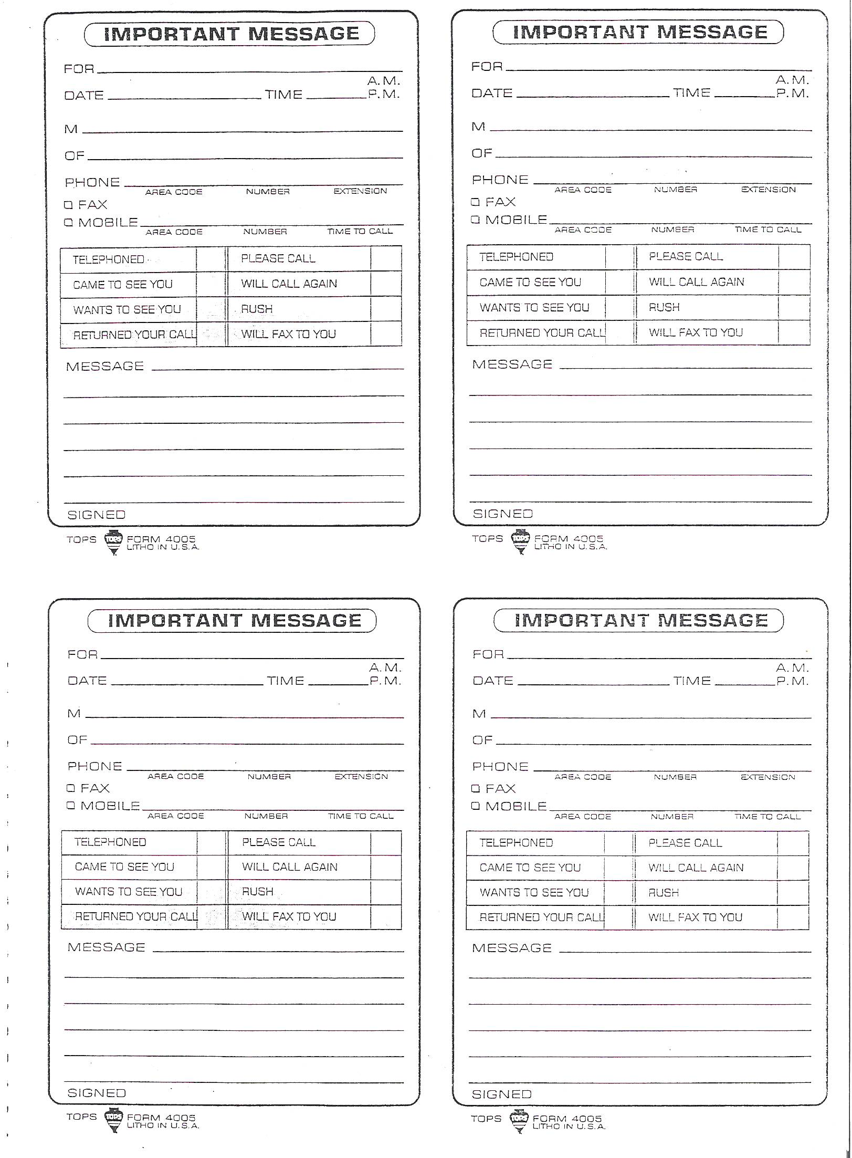
IMPORTANT MESSAGES

