WAGE Competency Curriculum Guide

WAGE Competency C30: Verifying comprehension by asking questions.

NOTE: You will need to collect two additional documents that are similar in nature to the one provided in this lesson at Hook 1a. These should be collected from local employers that support your program. These two additional documents will be used in Hooks 2 and 3 and are not to be duplicates of the other two documents used in this lesson. DO NOT USE MATERIALS THAT ARE NOT RELEVANT TO THE WORKPLACE.

Hook 1a
Display a bouquet of flowers similar to those sold at florists. If a bouquet is not available show a picture. Say, “Communication is an important aspect of our daily lives. We interpret what information is sent to us in different ways. One way is to restate or repeat what we have heard. Another is to ask questions. Like a detective we can verify comprehension by asking particular questions. What are some questions that you could ask to verify comprehension about an order for these flowers?”
Record all responses on a flip chart and save for later use.
Coach students during a brainstorming activity but do not offer solutions.

Bridge
Acknowledge the good solutions offered; question students further to generate additional responses.
Ask, “Do you believe that these are the only questions that can be used?” Pause. “Could there be more?”
Say, “Let’s begin our lessons and list the thinking steps we should learn to be better listeners. When we have finished our work, we will compare your answers that I have recorded on the flip chart to the ones we have learned.”

Book
Select a lesson (or lessons) from the wage curriculum Matrix or other source that best supports your needs. Spend ample time in the chosen lessons until you believe that each learner has mastered the skill. As you move through each lesson, be sure to emphasize the thinking steps that a learner must use to correctly apply this skill. Ensure that all thinking steps are properly sequenced during the learning and that each learner has had opportunities to practice each step in the application of the skill. Write the thinking steps identified by the lesson(s) in the sequential order they are to be used; you will use these again in Hooks 1b, 2, and 3.
For this lesson use the handout, Asking Specific Questions.

Thinking Steps for Competency C30.
NOTE: If your chosen lesson(s) indicates a different set of thinking than these listed here, substitute those that was presented in the lesson(s).

- Pinpoint what you need to know.
- Word your questions precisely to get the information you need.
- If possible, prepare your questions in advance.
- Ask questions using who, what, when, where, why, and how.

Hook 1b
Display the sheet of paper where you recorded learner responses in Hook 1a.
Say, “Let’s review what we have learned about asking questions. Look at the responses
you gave me. Now, let’s look at the thinking steps that the lesson recommended we
use.” Compare their responses to the given recommendations.
Example: Read Asking Specific Questions used with competency C30 to develop the skill needed to ask questions. Create a scenario that would help the learner visualize the situation and the need to learn the skill.

Say, “Now I am going to model for you the use of the thinking steps we learned as I follow the direction to complete the Practice section of our handout. As I say the thinking step, you help me apply the skill at each step. Do you understand what we are going to do?” Address any concerns before moving ahead.
Call out each thinking step and get the learners to assist you as you perform the task at each step.

Hook 2
Say, “Now that I have modeled the thinking steps we learned when performing this skill, are there any questions before you complete two more activities?” Address all concerns before moving ahead.
Hand out a copy of Getting Information Correct that you have chosen for this exercise to each student.
Say, “Here is another activity that is similar to the one I just used as a model. In this exercise, I want you to work alone and use the thinking steps you learned as you complete this assignment. When you have all finished, each of you will have a chance to model for the class the thinking steps we should use as we ask questions to verify comprehension. I will ask you to model the steps for the class and tell us what we should do as we go through each step. Are there any questions about your task?” Address all concerns before moving ahead.
When all have finished, ask for a volunteer to model the application of thinking steps to the task. Pay attention to the proper sequence, the learner’s ability to model, and the actions that must take place at each step. Allow all who want to model the steps an opportunity to do so before moving ahead. Have the students turn in all work to you. Review the work and address any exceptions noted with the learner.
NOTE: Mastery of this competency is determined by the students’ work on Hook 2. Review or rework is necessary when a student has not demonstrated mastery at Hook 2. Mastery is defined as the task being performed correctly with zero mistakes. A WAGE certificate should not be granted without mastery on all competencies listed in the student’s Individualized Program Plan.

Hook 3
Compliment the class for all the good work done at Hook 2. Say, “For this last exercise, you will work in teams, like they do at the workplace. In the workplace, workers know that people who are working together usually do the best work. By working together, they are able to combine their skills, share in the work, and complete the job in the proper amount of time.
“Now, I want you to move into teams of at least three people and no more than five people. Your team will need a leader, so select a leader now.” Make note of the leader in each team. Try to see that all learners have an opportunity to serve as leader during the course of their study.
Hand out the third document (or problem) selected for this exercise. Be sure to give only one copy to each team. Say, “Team leaders, I want you to assign the thinking steps to each member of your team. If there are more steps than members, give each member more than one step. Try your best to make your distribution of thinking steps as fair as possible.”
Say, “Working as a team, I want you to apply the thinking steps we learned to the task. Each of you will be doing a different step, so make sure to keep up with your work and your solutions. When all of your team members have completed their assignments, the team leader is to put all the work together into a completed task. Team leaders, you will present your team’s model of this task to the other teams in this class. Are there any questions?” Address all concerns before moving ahead.
When all the teams are finished, call for a volunteer leader to model the application of thinking steps to this task. Get the other teams to offer constructive criticism when appropriate. Strive to develop a level of competitiveness between teams. This will increase the bonds between team members and make the learning more fun. You might work up a recognition system for rewarding good work by each team. Be careful that your students do not get in the same team with each lesson.
NOTE: When it is impossible to use teams at Hook 3, usually due to an open-entry, open-exit class format, you will want to use peer tutors, paraprofessionals, or yourself as a supplement to the team. When conducted correctly, the concepts of interdependence can be reinforced when there are only two people assigned to the task.

Evaluation for C30:
Student will take the Say What: Assessment for Competency C30, 90% or better.
85% or better on worksheets.
Resource Listing for C30:
Instructor generated materials.
Instructors: Judy Giunta, Lil Williams

Copyright © by Pulaski County Special School District Adult Education WAGE Training Program
No part of this curriculum may be reproduced in whole or in part, stored in a retrieval system, or transmitted in any form or by any means, electronic, mechanical, photocopying, recording or otherwise, without written permission from WAGE Training Program.
For permission information contact: WAGE Training Program, 4300 Haywood, North Little Rock, AR 72114.

ASKING QUESTIONS

In your personal conversations, you probably ask questions automatically. You may ask vague questions, such as “How’s that?” or “Would you run that by me again?’
However, these questions may not be useful at your job. Your work environment requires more specific questions in order to get the job done right. Asking specific questions is a communication skill. For example, even if you listen carefully to directions, you still may not get all the information you need. Your boss or coworkers may give you incomplete instructions or use words you don’t understand. You can clear up any confusion immediately by preparing good questions. You can also find the most important points by asking questions beginning with the five Ws – who, what, when, where, why, and, of course, how.

- Pinpoint what you need to know.
- Word your questions precisely to get the information you need.
- Ask questions beginning with the five W’s – who, what, when, where, and how.

If you are a new employee, you will have a multitude of questions about your job and your place of employment. In this case you need to develop the following plan to insure success at the job.

- Prepare your questions in advance – write them down if necessary.
- Choose the best-qualified person to answer your questions.
- Be considerate of the other person’s work respon-sibilities. Ask that person to schedule a convenient time to talk.

▼Practice

Carla is a new employee and is eager to do a good job. Because she’s unsure of her job responsibilities, she frequently barges into her boss’s office and blurts out a question. The boss thinks she’s a nuisance rather than an overly conscientious worker. What steps should Carla take to change her boss’s perception of her? Refer to the guidelines above.

________________________________________________________________________________________________________________________________________________________________________________________________________________________________________________________________________________________________________________________
______________________________________________________________________________
______________________________________________________________________________

Name __________________________________ Date _______________

Getting Information Correct!

New reporters are taught to ask questions using the five Ws and how. You can use this information in your daily routine. For instance, when you are listening to the news or reading the newspaper, ask yourself the following questions:

- WHO?
- WHAT?
- WHEN?
- WHERE?
- WHY? and
- HOW?
You will clear up any misconceptions or unclear information by answering these simple questions. Practice with the activity below.

▼Practice

Have a volunteer read the news broadcast below out loud. Listen carefully. Answer the questions that follow.

The City Council of Monroeville passed a law Wednesday prohibiting city residents from keeping pit bulls as pets. One alderman remarked, “Pit bulls are a public menace. We need to prevent attacks from these vicious dogs.”

- Who passed a law? ________________________________________________
- What law was passed? _____________________________________________
- When was it passed? _______________________________________________
- Where was it passed? ______________________________________________
- Why was it passed? ________________________________________________

Similarly, asking questions beginning with the five Ws, as well as the word how, can help you get the facts you need.

▼Practice

- Suppose you are taking an order for flowers, write five questions you need to ask the customer.
- Imagine you trying to buy a new car. Write five questions you would want to ask a car dealer.

Name __________________________________ Date _______________

Taking Orders for Flowers

Lucile has been the service customer representative for Veteran’s Sweetheart Florist for 15 years. She is taking an order from one of her regular customers.

In this exercise, have two students role-play the parts of Lucile and the regular customer. From the flower catalogue sheet, have the “customer” select one of the arrangements and order it. “Lucile” will be responsible for taking the order and writing it on the telephone order form. Lucile is to ask questions to verify that he/she is placing the order for the correct flower arrangement.

Veteran’s Sweetheart Florist
#1 Sweetheart Lane

Upper Little Rock, AR 72214
501-257-1111
Customer Service Rep. Initials ____________ |  |  |  |  |  |  |  | Date_________ |  | Time _________
Product # ________________
Flowers: |  |  |  | Type_______________________ Color _________________________
Type of vase __________________________ Price listing ____________________________
Recipient: |  | Name_______________________________________________________
Delivery Address ______________________________________________________________
City _____________________ |  |  |  |  | State _____ |  | Zip_________ |  | Phone ________________
Home Address: (If different from delivery address)
Street Address_______________________________________________________________
City _____________________ |  |  |  |  | State _____ |  | Zip_________ |  | Phone ________________
Special Delivery Instructions: __________________________________________________
____________________________________________________________________________
Sender: | Name ___________________________________________________________
Delivery Address ____________________________________________________________
City _____________________ |  |  |  |  | State _____ |  | Zip_________ |  | Phone ________________
Cell # ____________________ |  |  |  |  | Work # _________________________ |  |  |  |  | Ext __________
Credit Card: |  |  | Type of Card _______________________________________________
Card # _______________________________ |  |  |  |  |  | Expiration Date _______________________

Veteran’s Sweetheart Florist
#1 Sweetheart Lane

Upper Little Rock, AR 72214
501-257-1111

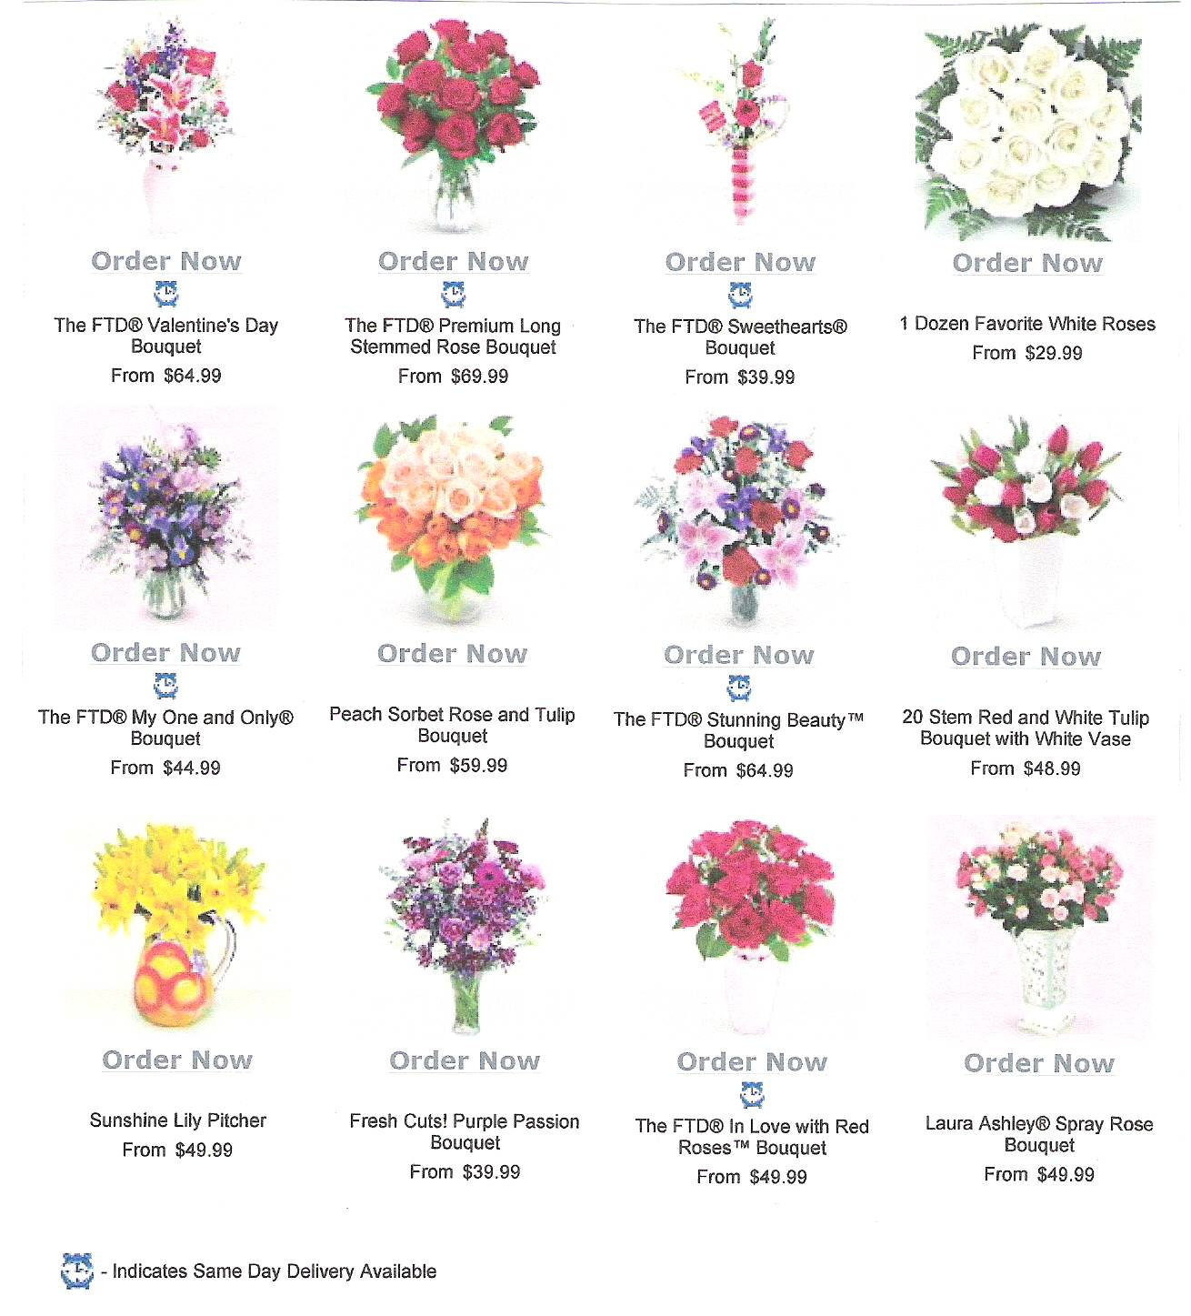
Catalogue for Flower Arrangements:

Name _________________________________ Date ________________

Say What?

Assessment for Competency C30

Ed is a new employee at an auto parts factory. Henry, his coworker, is explaining the parking lot policy.

Henry: The foreman told me that sometimes you’d be driving to work. You’ll need to fill out the parking lot form. Ask Clara in the main office for the form. She’ll give you an employee sticker to put on your windshield. You can park anywhere in the lot except in the spots marked HANDICAPPED PARKING ONLY and VISITORS ONLY.
Ed: Could you run that by me again?
Henry: Do you mean you want me to repeat the whole thing?
Ed: No. Does each employee have a reserved spot?
Henry: No, I just told you that you can park anywhere except for the specially reserved parking spaces.
Please answer the following questions in complete sentences. Use key words from the lessons.
- Was Ed listening carefully? How do his questions reveal that he wasn’t paying close attention? _____________________________________
________________________________________________________________________________________________________________________________________________________________________________________________________________________________
- Why is it important to ask the speaker specific questions?
________________________________________________________________________________________________________________________________________________________________________________________________________________________________
- If you were to rate Ed on his questioning skills, what would he score? Explain how you rated him.
________________________________________________________________________________________________________________________________________________________________________________________________________________________________

