WAGE Competency Curriculum Guide

WAGE Competency M10: Reading and writing decimals to one or more places to complete a task or subtask.

NOTE: You will need to collect two additional documents that are similar in nature to the one provided in this lesson at Hook 1a. These should be collected from local employers that support your program. These two additional documents will be used in Hooks 2 and 3 and are not to be duplicates of the other two documents used in this lesson. DO NOT USE MATERIALS THAT ARE NOT RELEVANT TO THE WORKPLACE.

Hook 1a
Ask, “Let’s imagine that you are working for a company that produces widgets. Each widget has to be no more than .005 bigger or smaller than the other widgets produced at the same time. Why do you think that could be important?”
Record all responses on a flip chart and save for later use.
Coach students during a brainstorming activity but do not offer solutions.

Bridge
Acknowledge the good solutions offered; question students further to generate additional responses.
Ask, “If someone were to ask you to read .005 could you name the decimal?””
Acknowledge any additional responses.
Say, “Now let’s imagine that you were working in our widget company as a manager. Every shift has to be accountable to the .005 standard. How would you teach your employees how beg or small that is?” Encourage the discussion.
Say, “Let’s look at how we could show our new employee to read and name decimals. Make sure that you incorporate the following thinking steps for this task.”

Thinking Steps
- Define the goal.
- Identify the steps one should follow.
- Name the items one needs to finish the task.
- Clear up any details not understood.

Book
Select a lesson (or lessons) from the wage curriculum Matrix or other source that best supports your needs. Spend ample time in the chosen lessons until you believe that each learner has mastered the skill. As you move through each lesson, be sure to emphasize the thinking steps that a learner must use to correctly apply this skill. Ensure that all thinking steps are properly sequenced during the learning and that each learner has had opportunities to practice each step in the application of the skill. Write the thinking steps identified by the lesson(s) in the sequential order they are to be used; you will use these again in Hooks 1b, 2, and 3.
Spend time defining the terms: place system, tens, hundreds, thousands, ten thousands, hundred thousands.
Thinking Steps for Competency M10:
NOTE: If your chosen lesson(s) indicates a different set of thinking than these listed here, substitute those that was presented in the lesson(s).
- Define the goal.
- Identify the steps one should follow.
- Name the items one needs to finish the task.
- Clear up any details not understood.

Hook 1b
Ask, “So if your shift produced widgets that were .007 and the standard is .003, are you within the acceptable margin of error of .005 bigger or smaller?”
Take note of answers and provide positive feedback.
Example: Lead a discussion on the importance of decimals. Create a scenario in which the learner will understand the importance of and need for learning this skill.
Say, “Now I am going to model for you the use of the thinking steps we learned as I follow the directions to complete Worksheet A. As I say the thinking step, you help me apply the skill at each step. Do you understand what we are going to do?” Address any concerns before moving ahead. Call out each thinking step and get the learners to assist you as you perform the task at each step.

Hook 2
Say, “That was great! Now that I have modeled the thinking steps we learned when performing this task, are there any questions before we move on?” Address all concerns before moving ahead. Hand out a copy of Worksheet B that you have chosen for this exercise to each student.
Say, “Here is another worksheet that is similar to the one I just used as a model. It will give you the opportunity to name decimals to at least two places that we just learned and practiced. In this exercise, I want you to work independently and use the thinking steps you learned as you work with money problems. Ask yourself if you could answer each question of the thinking steps. When you have all finished, each of you will have a chance to model for the class the thinking steps we should use for this skill. I will ask you to model the steps for the class and tell us what we should do as we go through each step. Are there any questions about your task?” Address all concerns before moving ahead.
When all have finished, ask for a volunteer to model the application of thinking steps to the task. Pay attention to the proper sequence, the learner’s ability to model, and the actions that must take place at each step. Allow all who want to model the steps an opportunity to do so before moving ahead. Have the students turn in all work to you. Review the work and address any exceptions noted with the learner.
NOTE: Mastery of this competency is determined by the students’ work on Hook 2. Review or rework is necessary when a student has not demonstrated mastery at Hook 2. Mastery is defined as the task being performed correctly with zero mistakes. A WAGE certificate should not be granted without mastery on all competencies listed in the student’s Individualized Program Plan.

Hook 3
Compliment the class for all the good work done at Hook 2. Say, “For this last exercise, you will work in teams, like they do at the workplace. In the workplace, workers know that people who are working together usually do the best work. By working together, they are able to combine their skills, share in the work, and complete the job in the proper amount of time.
“Now, I want you to move into teams of at least three people and no more than five people. Your team will need a leader, so select a leader now.” Make note of the leader in each team. Try to see that all learners have an opportunity to serve as leader during the course of their study.
Hand out the Worksheet C selected for this exercise. Be sure to give only one copy to each team. Say, “Team leaders, I want you to assign the thinking steps to each member of your team. If there are more steps than members, give each member more than one step. Try your best to make your distribution of thinking steps as fair as possible.”
Say, “Working as a team, I want you to apply the thinking steps we learned to the task. Each of you will be doing a different step, so make sure to keep up with your work and your solutions. When all of your team members have completed their assignments, the team leader is to put all the work together into a completed task. These exercises will be turned in so keep up with your work. Team leaders, you will present your team’s model of this task to the other teams in this class. Are there any questions?” Address all concerns before moving ahead.
When all the teams are finished, call for a volunteer leader to model the application of thinking steps to this task. Get the other teams to offer constructive criticism when appropriate. Strive to develop a level of competitiveness between teams. This will increase the bonds between team members and make the learning more fun. You might work up a recognition system for rewarding good work by each team. Be careful that your students do not get in the same team with each lesson.

NOTE: When it is impossible to use teams at Hook 3, usually due to an open-entry, open-exit class format, you will want to use peer tutors, paraprofessionals, or yourself as a supplement to the team. When conducted correctly, the concepts of interdependence can be reinforced when there are only two people assigned to the task.

Evaluation for M10:
85% on all worksheets

95% on Competency M10 Test.

Resource Listing for M10:
Frechette, Ellen Carley. Workplace Essential Skills: Math. Chicago: Contemporary Books. Public Broadcasting Service. 1999.

Huffman, Harry, Ruth Twiss, Harold Williams. Performance Guide for Math for Business Careers, 4th Edition. McGraw-Hill, 1977
Moore, Gary, Larry and Todd Sformo. Practical Problems in Mathematics for Automotive Technicians, Fifth Edition. New York: Delmar Publishers Inc. 1998.
Pre-GED Mathematics. Chicago: Contemporary Books. 1995.
Tussing, Ann K. U. (Ed.). Breakthrough to Math: Word Problems, Book 6. New Readers Press, 1978.

Copyright © by Pulaski County Special School District Adult Education WAGE Training Program
No part of this curriculum may be reproduced in whole or in part, stored in a retrieval system, or transmitted in any form or by any means, electronic, mechanical, photocopying, recording or otherwise, without written permission from WAGE Training Program.
For permission information contact: WAGE Training Program, 4300 Haywood, North Little Rock, AR 72114.

Name _________________________________ Date ________________

Worksheet A: Reading and Writing Decimals

In order to read and write decimals it is necessary to learn the place value of decimals. The number of decimal place value is unlimited but most of your work on the job will require you to use decimals only to the thousandths place. The number line below illustrates the different decimal place values as well as the whole number place values.

When you read a decimal number, say the number and place value of the last digit. The number shown is read as “two hundred fifty and nine thousandths.” How would you read the decimal 3.08?
WES Math, p.58

You are right if you said “three and eight hundredths.” Notice that the zero holds the 8 in the hundredths place.

Practice

Read each value below, then write it in number form.

- ten and fourteen hundredths _______________
- twenty-one and fourteen thousandths _______________
- one hundred five and six tenths _______________
- sixty-two and ten thousandths _______________
- fifteen hundredths _______________

Name __________________________________ Date _______________

Worksheet B

Write these numbers as decimals.

- nine-tenths _______________
- nine-hundredths _______________
- three-thousandths _______________
- thirteen-thousandths _______________
- five-tenths _______________
- sixty-five hundredths _______________
Write these decimals as words.
- .3 ____________________________________________________________________
- .03 ___________________________________________________________________
- .023 __________________________________________________________________
- .22 ___________________________________________________________________
- 6.565 _________________________________________________________________
- 5.075 _________________________________________________________________
- Find the decimal equivalent for the following drill bits. Use the chart shown.
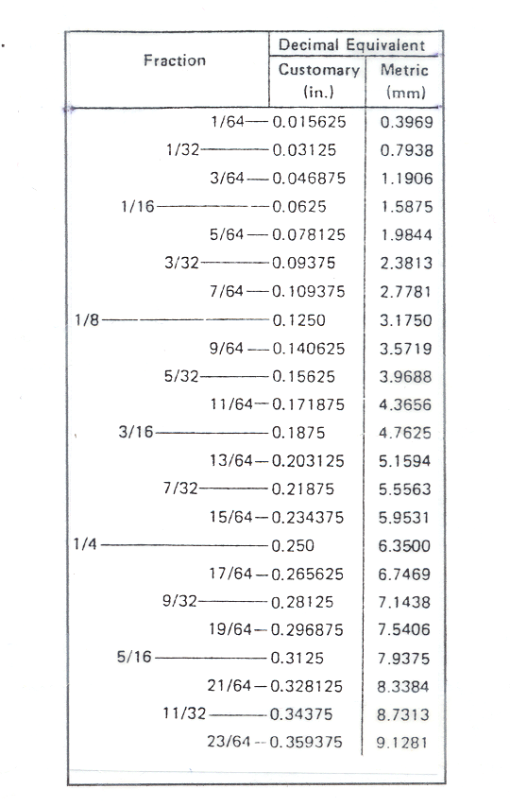
  - 1/32 _______________
  - 1/16 _______________
  - 3/32 _______________
  - 9/64 _______________
  - 1/4 ______________
  - 9/32 _______________
  - 21/64 _______________

Name _____________________________________ Date ____________

Worksheet C

As a quality-control technician on an assembly line that makes plastic parts for automobiles, you have to check parts to make sure they are up to company standards. Because no part is perfect it is necessary to set up tolerances, that is, each piece has to be within a certain range. For instance, side A has a tolerance of ± .25. To find the range you would add and subtract .25 as follows:

1.5 - .25 = 1.25 mm
1.5 + .25 = 1.75 mm

Measurements have to be between 1.25 mm and 1.75 mm.

The inspection sheet shown gives the tolerances for each side/hole.

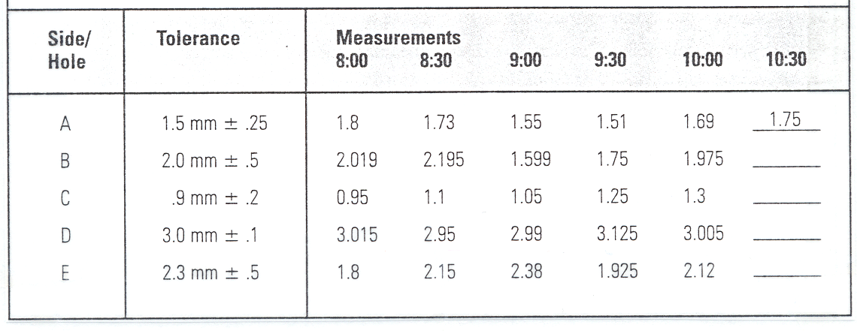

1. Write the following measurements in the column labeled 10:30. A co-worker has measured each area and is calling out each measurement to you so that you can record it on the inspection sheet.

a. Side A is one and seventy-five hundredths millimeters.
b. Side B is two and five thousandths millimeters.
c. Hole C is one and seven hundredths millimeters.
d. Side D is three and fourteen thousandths millimeters.
e. Hole E is two and one hundred twenty-nine thousandths millimeters.
2. Company policy requires the assembly line operator to shut down the line when the tolerances are above or below acceptable limits. At what times was the line shut down for:
Side A _________________________
Side D _________________________

Name ________________________________ Date _________________

Test of Skills for Competency M10

1. Use words to express the value of each decimal.
4.07 _____________________________________________________________________
15.38 ____________________________________________________________________
0.169 ____________________________________________________________________
7.205 ____________________________________________________________________
9.1 ______________________________________________________________________
12.86 ____________________________________________________________________

2. Write the decimal.
Two and four-tenths _______________
Three and thirty-six-hundredths _______________
Six-hundredths _______________
Four-thousandths _______________
Fourteen and two-hundred-twelve-thousandths _______________
Twenty-six and ninety-nine-hundredths _______________
Ninety-six-thousandths _______________
Nine-hundredths _______________

3. As a jewelry maker you use different lengths of wire. Your assistant is calling off the different sizes you need to cut. Write the sizes down in decimal form.
Thirty-one and two-tenths cm _______________
Two and nine-tenths cm _______________
Fifteen and forty-six-hundredths cm _______________
Three and nineteen-tenths cm _______________
Twenty-two and three-hundred-fifty-six-thousandths _______________

