WAGE Competency Curriculum Guide

WAGE Competency M20: Performing basic metric conversions involving weight, distance and volume.

NOTE: You will need to collect two additional documents that are similar in nature to the one provided in this lesson at Hook 1a. These should be collected from local employers that support your program. These two additional documents will be used in Hooks 2 and 3 and are not to be duplicates of the other two documents used in this lesson. DO NOT USE MATERIALS THAT ARE NOT RELEVANT TO THE WORKPLACE.

Hook 1a
Project an overhead transparency of the blueprint. Say, “Let’s pretend you are an experienced worker with a local company and you have been asked to help a new worker to convert the metric measurements on the blueprint. What are the thinking steps that you would want the new worker to use as he performs this task? What is the first thing that should be done? The second, and so on?”
Record all responses on a flip chart and save for later use.
Coach students during a brainstorming activity but do not offer suggestions.

Bridge
Acknowledge the responses offered; question students further to generate additional responses.
Ask, “Do you believe that these are the only thinking steps that should be used?” Pause. “Could there be more?”
Give students a copy of the “Mars Orbiter Lost over Metric Conversion.” (Page 1) Have students read the article. Ask students what problems might have arisen from this mistake. Point out that in addition to wasting millions of tax dollars, this situation could have endangered lives. Discuss other industries that use metric numbers. Point out that 99% of other countries use the metric system.
Say, “Now we are going to go to our lessons and list the thinking steps we should know and use. When we have finished our work, we will compare your answers that I have recorded on the flip chart to the ones we have learned.”
Book
Select a lesson (or lessons) from the wage curriculum Matrix or other source that best supports your needs. Spend ample time in the chosen lessons until you believe that each learner has mastered the skill. As you move through each lesson, be sure to emphasize the thinking steps that a learner must use to correctly apply this skill. Ensure that all thinking steps are properly sequenced during the learning and that each learner has had opportunities to practice each step in the application of the skill. Write the thinking steps identified by the lesson(s) in the sequential order they are to be used; you will use these again in Hooks 1b, 2, and 3.
Use the Blueprint Transparency and Making the Conversion.

Thinking Steps for Competency M20.
NOTE: If your chosen lesson(s) indicates a different set of thinking than these listed here, substitute those that was presented in the lesson(s).
- Know what you are converting – metric to English or English to metric.
- Be familiar with an English/Metric conversion chart.
- Do the computation.
- Be as exact and accurate as you can be.

Hook 1b
Get out the Blueprint Transparency, Making the Conversion, and the sheet of paper where you recorded learner responses in Hook 1a.
Say, “We are going to evaluate your answers. You gave me the following steps.” Post the sheet with responses on the wall. “Now, let’s look at the thinking steps that the lessons recommended we use.” Compare their responses to the given recommendations.
Example: Hand out a copy of the blueprint transparency that is in metric form. This print is clearly marked metric print. ask students what they would do if their job supervisor handed them this print and told them to use, but to change the dimensions to inches and feet. Tell students that the metric system is referred to as the System of International (SI) units, which is used worldwide. Tell them that they are going to learn to convert from metric (SI) to English and vice versa.
Say, “Now I am going to model for you the use of the thinking steps we learned as I follow the direction to complete this task. As I say the thinking step, you help me apply the skill at each step. Do you understand what we are going to do?” Address any concerns before moving ahead. Call out each thinking step and get the learners to assist you as you perform the task at each step.

Hook 2
Say, “Now that I have modeled how a new worker would use the thinking steps we learned when performing this task, are there any questions before you complete two more assignments?” Address all concerns before moving ahead.
Hand out a copy of Metric Conversion Activity that you have chosen for this exercise to each student.
Say, “Here is a worksheet where you will convert from English to metric. In this exercise, I want you to work alone and use the thinking steps you learned as you complete this task. When you have all finished, each of you will have a chance to model for the class the thinking steps we should use as we complete this task. I will ask you to model the steps for the class and tell us what we should do as we go through each step. Are there any questions about your task?” Address all concerns before moving ahead.
When all have finished, ask for a volunteer to model the application of thinking steps to the task. Pay attention to the proper sequence, the learner’s ability to model, and the actions that must take place at each step. Allow all who want to model the steps an opportunity to do so before moving ahead. Have the students turn in all work to you. Review the work and address any exceptions noted with the learner.

NOTE: Mastery of this competency is determined by the students’ work on Hook 2. Review or rework is necessary when a student has not demonstrated mastery at Hook 2. Mastery is defined as the task being performed correctly with zero mistakes. A WAGE certificate should not be granted without mastery on all competencies listed in the student’s Individualized Program Plan.

Hook 3
Compliment the class for all the good work done at Hook 2. Say, “For this last exercise, you will work in teams, like they do at the workplace. In the workplace, workers know that people who are working together usually do the best work. By working together, they are able to combine their skills, share in the work, and complete the job in the proper amount of time.
“Now, I want you to move into teams of at least three people and no more than five people. Your team will need a leader, so select a leader now.” Make note of the leader in each team. Try to see that all learners have an opportunity to serve as leader during the course of their study.
Hand out the third assignment, Group Work for Competency M20, selected for this exercise. Be sure to give only one copy to each team. Say, “Team leaders, I want you to assign the thinking steps to each member of your team. If there are more steps than members, give each member more than one step. Try your best to make your distribution of thinking steps as fair as possible.”
Say, “Working as a team, I want you to apply the thinking steps we learned to the task. Each of you will be doing a different step, so make sure to keep up with your work and your solutions. When all of your team members have completed their assignments, the team leader is to put all the work together into a completed task. Team leaders, you will present your team’s model of this task to the other teams in this class. Are there any questions?” Address all concerns before moving ahead.
When all the teams are finished, call for a volunteer leader to model the application of thinking steps to this task. Get the other teams to offer constructive criticism when appropriate. Strive to develop a level of competitiveness between teams. This will increase the bonds between team members and make the learning more fun. You might work up a recognition system for rewarding good work by each team. Be careful that your students do not get in the same team with each lesson.
NOTE: When it is impossible to use teams at Hook 3, usually due to an open-entry, open-exit class format, you will want to use peer tutors, paraprofessionals, or yourself as a supplement to the team. When conducted correctly, the concepts of interdependence can be reinforced when there are only two people assigned to the task.

Evaluation for M20:
85% on all worksheets
95% on Assessment for Competency M20

Resource Listing for M20:
http://www.masslive.com/news/pcommunity/editnasa.html
http://www.pueblo.gsa.gov/cgi-bin/pf.cgi
Brown, Walter C. Print Reading for Industry. Goodheart-Wilcox Company Inc. 1995.
Number Power, Level A. Chicago: Contemporary Books. 1999.
Proctor, Thomas E. Machine Trade Print. ATP Publishers, Inc. 1995
Taylor, David. Elementary Blueprint Reading for Machinists, 4th Edition. Chicago: Delmar Publishers. 1996.

Copyright © by Pulaski County Special School District Adult Education WAGE Training Program
No part of this curriculum may be reproduced in whole or in part, stored in a retrieval system, or transmitted in any form or by any means, electronic, mechanical, photocopying, recording or otherwise, without written permission from WAGE Training Program.
For permission information contact: WAGE Training Program, 4300 Haywood, North Little Rock, AR 72114.

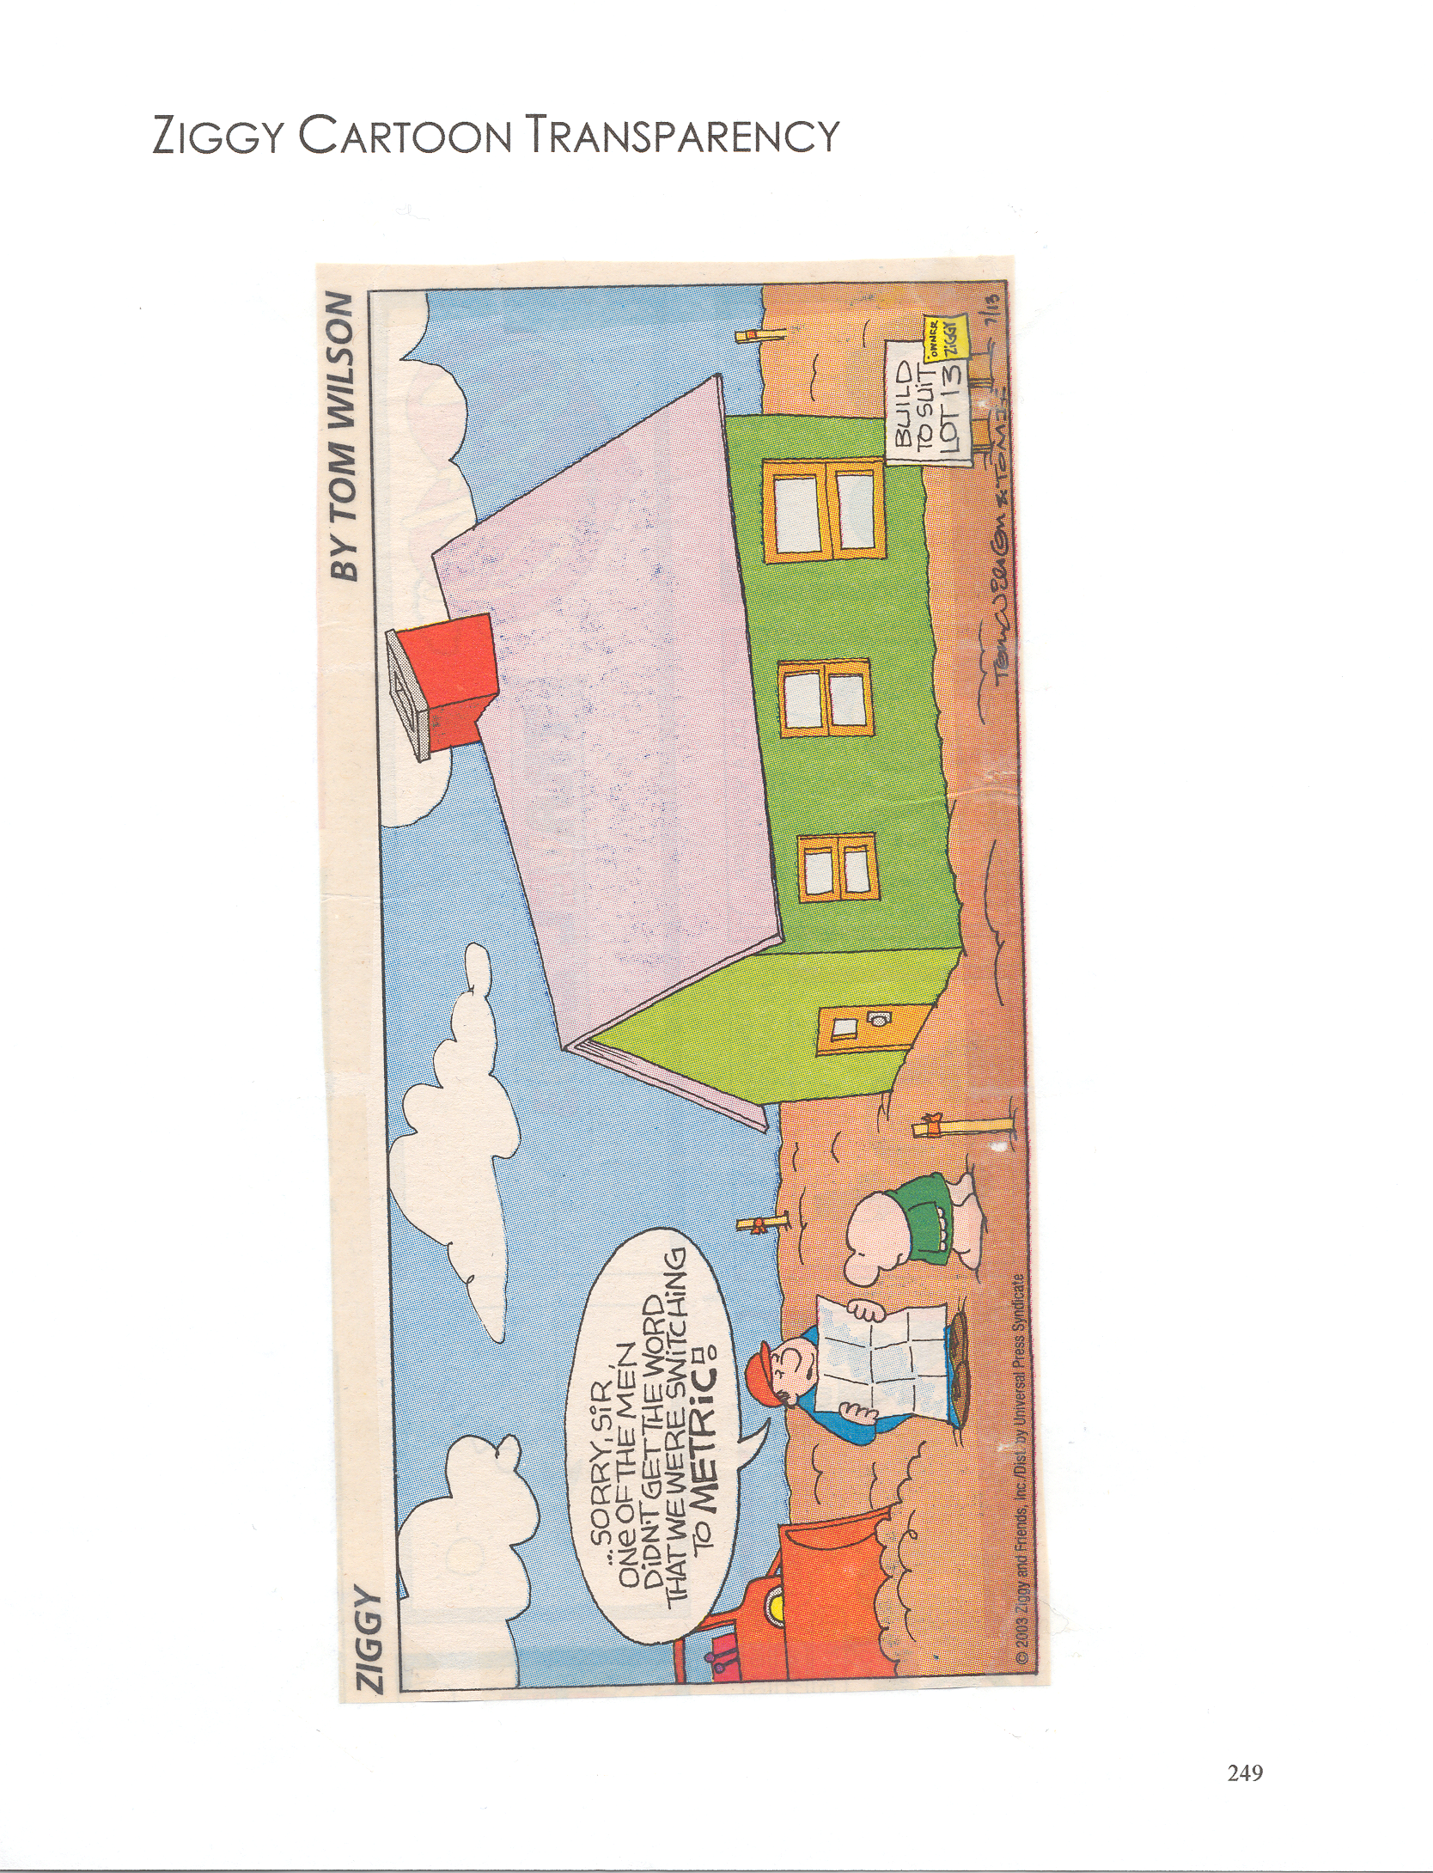

Off by a mile, er, kilometer
Sunday, October 3, 1999
It was an oops of interplanetary proportions, an error that proved your science teacher right — that those pesky formulas for converting English measurements to metric are important after all.
NASA learned that the hard way with the loss of its $125 million Mars Climate Orbiter last month. After a journey of 416 million miles (or 664 million kilometers), the spacecraft veered too close to the Red Planet's atmosphere on what should have been its first orbit and either burned up, broke apart or zoomed off into space.
The craft was off course because of a mix-up over English and metric measurements. A contractor, Lockheed Martin Astronautics, supplied acceleration data in the English unit of pounds of force, while NASA engineers assumed they were in metric newtons. Over the long trip through space, the difference between English and metric added up just enough to throw the craft slightly off course.
Clearly, Lockheed should have provided NASA with metric figures, as is common practice. But engineers at NASA's Jet Propulsion Laboratory certainly should have caught the mistake.
NASA's credo of "faster, smaller, cheaper" — a successful formula up until now for getting more science for far less money — should be changed to "faster, smaller, cheaper and metric."
The loss of the Mars Climate Observer, which was to have been the first complete weather satellite to orbit another planet, points to the folly of the United States being the only major nation still clinging to the outmoded and overly complex English measurement system.
Most of the scientific community uses the metric system. But the rocket scientists in the U.S. space industry, surprisingly, have traditionally used the English system. The space age is no place for a measurement system best left in the past.

Return to Today's News
Have something to say about this story? Shout it out loud in the Newswatch forum.
© 1999 UNION-NEWS. Used with permission.

http://www.masslive.com/news/pcommunity/editnasa.html

Blueprint Transparency

Making the Conversion
Most jobs require that you work in either English units or Metric units, but not both. It is necessary, however, on occasion to convert units from one system to another. Charts 1 and 2 show what the multiplier is for converting from English to Metric or vice versa. The table in Figure 1 illustrates some common conversions.
Common Conversions Between Standard English and Metric Units

SymbolWeight  - 1 ounce = 28.35 grams  - 1 pound = 453.59 grams  - 1 gram = 0.035 ounce  - 100 grams = 3.5 ounces  - 1000 grams = 2.2 pounds  - 1 kilogram = 35 ounces  - 1 kilogram = 2.2 pounds  Distance  - 1 inch = 2.5 centimeters  - 1 foot = 30 centimeters  - 1 millimeter = 0.04 inch  - 1 centimeter = 0.4 inch  - 1 meter = 3.3 feet  Figure 1 | Volume  - 1 milliliter = 1/5 teaspoon  - 1 milliliter = 0.03 fluid ounce  - 1 teaspoon = 5 milliliters  - 1 tablespoon = 15 milliliters  - 1 fluid ounce = 30 milliliters  - 1 fluid cup = 236.6 milliliters  - 1 quart = 946.4 milliliters  - 1 liter (1000 milliliters) = 34 fluid ounces  - 1 liter (1000 milliliters) = 4.2 cups  - 1 liter (1000 milliliters) = 2.1 fluid pints  - 1 liter (1000 milliliters) = 1.06 fluid quarts  - 1 liter (1000 milliliters) = 0.26 gallon  - 1 gallon = 3.8 liters |  | F  or many years now there has been debate over converting the United States to the metric systems. France developed the metric system in order to have simplified system of measurement. The majority of the countries of the world use the metric system. It is said to be easier to use because it is based on the decimal system. The decimal system uses the number 10. At this time the metric system is used in science, business and education in the United States. And there are no plans to convert to the metric system.  The following two charts show how to convert to metric if you know the measurements in English and vice versa. Use Chart 1 if you know the metric measurements and want to convert to English measurements. Use Chart 2 if you know the English measurements and want to find the metric measurements. Study the charts.  You would simply multiply the known measurement by the multiplier given and you will have the converted measurement. For example, let’s say you work for a gas station and the tank for regular gas holds 5,000 gallons. But the gas usage form you fill out asks for number of liters. To convert you would locate gallons in Chart 2 and use the multiplier in the middle column (3.8). Now multiply this number by the number of gallons:  3.8 x 5000 = 19000  You would fill out 19,000 liters on the gas usage form.  METRIC Measures Up  METRIC CONVERSION CARD  Approximate Conversions from Metric Measures  Symbol | When you Know
Multiply byTo Find
 | LENGTH (Distance)
0.04  0.4  3.3  1.1  0.6inches  inches  feet  yards  milesin  in  ft  yd  mi | mm  cm  m  m  km
AREAmillimeters
centimeters
meters
meters
kilometers
0.16  1.2  0.4  2.5square inches  square yards  square miles  acresin²  yd²  mi² | cm²  m²  km²  ha
MASS (Weight)square centimeters
square meters
square kilometers
hectares (10,000 m²)
0.035  2.2  1.1ounces  pounds  short tonsoz  lb | g  kg  t
VOLUMEgrams
kilograms
metric ton
(1,000 kg)
0.03  0.06  2.1  1.06  0.26  35.0  1.3fluid ounces  cubic inches  pints  quarts  gallons  cubic feet  cubic yardsfl oz  in³  pt  qt  gal  ft³  yd³ | mL  mL  L  L  L  m³  m³
milliliters
milliliters
liters
liters
liters
cubic meters
cubic metersChart 1
METRIC Measures Up
METRIC CONVERSION CARD
Approximate Conversions to Metric Measures
Multiply byTo FindSymbol | Symbol
LENGTH (Distance)When you Know
2.5  30.0  0.9  1.6centimeters  centimeters  meters  kilometerscm  cm  m  km | in  ft  yd  mi
AREAinches
feet
yards
miles
6.5  0.09  0.8  2.6  0.4square centimeters  square centimeters  square meters  square kilometers  hectarescm²  cm²  m²  km²  ha | in²  ft²  yd²  mi²
square inches  square feet  square yards  square miles  acres | MASS (Weight)
28  0.45  0.9grams  kilograms  metric tong  kg  t | oz  lb
VOLUMEounces
pounds
short tons
(2000 lb)
5  15  16  30  0.24  0.47  0.95  3.8  0.003  0.76milliliters  milliliters  milliliters  milliliters  liters  liters  liters  liters  cubic meters  cubic metersmL  mL  mL  mL  L  L  L  L  m³  m³ | tsp  Tbsp  in³  fl oz  c  pt  qt  gal  ft³  yd³
teaspoons
tablespoons
cubic inches
fluid ounces
cups
pints
quarts
gallons
cubic feet
cubic yardsChart 2
To convert you need to:
- know what you are converting – metric to English or English to metric.
- be familiar with an English/Metric conversion chart.
- do the computation.
- be as exact and accurate as you can be.

Name ____________________________________ Date _________________

Metric Conversion Activity

Group Names ___________________________________________________
Date _________________
Group Work for Competency M20

Name ____________________________________ Date ________________

Assessment for Competency M20
