WAGE Competency Curriculum Guide

WAGE Competency M7: Adding, subtracting, multiplying, and dividing common fractions to solve problems.

NOTE: You will need to collect two additional documents that are similar in nature to the one provided in this lesson at Hook 1a. These should be collected from local employers that support your program. These two additional documents will be used in Hooks 2 and 3 and are not to be duplicates of the other two documents used in this lesson. DO NOT USE MATERIALS THAT ARE NOT RELEVANT TO THE WORKPLACE.

Hook 1a
Write the word, “FRACTION”, on the flip chart. Say, “When might you need to perform common functions like addition, subtraction, multiplication, and division of fractions in a workplace situation?”
Record all responses on a flip chart and save for later use. Provide positive feedback to all respondents.
Coach students during a brainstorming activity but do not offer solutions.

Bridge
Acknowledge the good solutions offered; question students further to generate additional responses.
Ask, “Are those the only possible situations where you would use fractions in the workplace?” Pause. “Could there be more?”
Say, “Let’s imagine that you were working in a company that requires that you fill out your own time sheet weekly. It is possible that you would have to use fractions to calculate your hours accurately. What if you worked for a company that used fractions to figure inventory or other quantities of things? You may have to use multiplication and division of fractions to complete tasks asked of you.
Book
Select a lesson (or lessons) from the wage curriculum Matrix or other source that best supports your needs. Spend ample time in the chosen lessons until you believe that each learner has mastered the skill. As you move through each lesson, be sure to emphasize the thinking steps that a learner must use to correctly apply this skill. Ensure that all thinking steps are properly sequenced during the learning and that each learner has had opportunities to practice each step in the application of the skill. Write the thinking steps identified by the lesson(s) in the sequential order they are to be used; you will use these again in Hooks 1b, 2, and 3.
For this section, spend time summarizing the meaning of fractions and the functions one can complete with them. Include a discussion of the ideas: part, whole, the division line, the division symbol, multiplication symbols {x, *, ()}, addition symbols, subtraction symbol, common denominators, and least common multiples.
Thinking Steps for Competency M7:
NOTE: If your chosen lesson(s) indicates a different set of thinking than these listed here, substitute those that was presented in the lesson(s).

- Define the goal.
- Identify the steps one should follow.
- Name the items one needs to finish the task.
- Clear up any details not understood.

Hook 1b
Begin a discussion on fractions by asking, “How many of you can imagine saying, ‘I spent ½ the day in the file room, another ¼ of my day at the copier and 1/8 of the rest at lunch’? How would you add those fractions if someone asked you how much of your time you spent working?”
Take note of answers. Provide positive feedback to all respondents.
Ask, “In the lesson we talked about addition, multiplication, division and subtraction of fractions. Which would one want to use in our current situation?”
Again take note of the answers and listen to any other suggestions students make in their responses. Provide feedback, no matter what the answer. Be positive.
Example: Facilitate a discussion concerning fractions in the workplace. Point out the need for learning fractions and how to add, subtract, multiply, and divide fractions.
Say, “Now I am going to model for you the use of the thinking steps we learned as I perform the following operations. As I say the thinking step, you help me apply the skill at each step. Do you understand what we are going to do?” Address any concerns before moving ahead.
Call out each thinking step and get the learners to assist you as you perform the following math problems.
- If you worked 5/8 of the day how would you figure what part of the day you were at the dentist’s office?
- What if you received six boxes each ½ full of the products your company ordered? What is the easiest way to determine how much of the total shipment you received?
- What if you needed to divide an 8-foot pipe or a 12-foot board into four equal pieces? How would you do that using a fraction?
Model the thinking steps for the fractional parts for solving addition and subtraction problems.
  - Define the goal:
  - Identify the steps:
  - Name the items you need:
  - Clear up details:

Hook 2
Say, “That was great! Now that I have modeled the thinking steps we learned when working with fractions, are there any questions before you do some more work?” Address all concerns before moving ahead.
Hand out a copy of the worksheets that you have chosen for this exercise to each student.
Say, “Here are worksheets on each operation that is similar to the exercise I just modeled. I think it’s time for some independent practice. Remember the goal is to add, subtract, multiply and divide fractions. You will work alone and use the thinking steps you learned as you complete the worksheet. When you have all finished, each of you will have a chance to model for the class the thinking steps we should use as we worked on fractions. I will ask you to model the steps for the class and tell us what we should do as we go through each step. Are there any questions about your task?” At this point students who are unable to simplify should not be made to do so, that is not the focus of this lesson. Address all concerns before moving ahead.
Say, “This worksheet will give you the opportunity to add, subtract, multiply and divide fractions in the format that we just learned and practiced. Take a few minutes to complete the worksheet. Think about the thinking steps in regards to this worksheet. Ask yourself if you could answer each question.”
- Define the goal:
- Identify the steps:
- Name the items you need:
- Clear up any questions:
When all have finished, ask for a volunteer to model the application of thinking steps to the task to expand on how they determined their answers. Pay attention to the proper sequence, the learner’s ability to model, and the actions that must take place at each step. Allow all who want to model the steps an opportunity to do so before moving ahead. If you do not hear the answer you want continue to call on students until you do. If no student has the answer, then use a different problem to model the exercise again. Have the students turn in all work to you. Review the work and address any exceptions noted with the learner.

NOTE: Mastery of this competency is determined by the students’ work on Hook 2. Review or rework is necessary when a student has not demonstrated mastery at Hook 2. Mastery is defined as the task being performed correctly with zero mistakes. A WAGE certificate should not be granted without mastery on all competencies listed in the student’s Individualized Program Plan.

Hook 3
Compliment the class for all the good work done at Hook 2. Say, “For this last exercise, you will work in small groups, like they do at the workplace. In the workplace, workers know that people who are working together usually do the best work. By working together, they are able to combine their skills, share in the work, and complete the job in the proper amount of time.
“Now, I want you to move into teams of at least three people and no more than five people. Your team will need a leader, so select a leader now.” Make note of the leader in each team. Try to see that all learners have an opportunity to serve as leader during the course of their study.
Hand out the worksheet for group work selected for this exercise. Be sure to give only one copy to each team. Say, “Team leaders, I want you to assign the thinking steps to each member of your team. If there are more steps than members, give each member more than one step. Try your best to make your distribution of thinking steps as fair as possible.”
Say, “Working as a team, I want you to apply the thinking steps we learned to the task. Each of you will be doing a different step, so make sure to keep up with your work and your solutions. When all of your team members have completed their assignments, the team leader is to put all the work together into a completed task. Team leaders, you will present your team’s model of this task to the other teams in this class. Are there any questions?” Address all concerns before moving ahead.
When all the teams are finished, call for a volunteer leader to model the application of thinking steps to this task. Get the other teams to offer constructive criticism when appropriate. Strive to develop a level of competitiveness between teams. This will increase the bonds between team members and make the learning more fun. You might work up a recognition system for rewarding good work by each team. Be careful that your students do not get in the same team with each lesson.
NOTE: When it is impossible to use teams at Hook 3, usually due to an open-entry, open-exit class format, you will want to use peer tutors, paraprofessionals, or yourself as a supplement to the team. When conducted correctly, the concepts of interdependence can be reinforced when there are only two people assigned to the task.
Evaluation for M7:
Score 85% on all of the worksheets.
Resource Listing for M7:

Huffman, Harry, Ruth Twiss, Harold Williams. Performance Guide for Math for Business Careers, 4th edition. McGraw-Hill, 1977
Moore, Gary, Larry and Todd Sformo. Practical Problems in Mathematics for Automotive Technicians, Fifth Edition. New York: Delmar Publishers Inc. 1998.
Tussing, Ann K. U. (Ed.). Breakthrough to Math: Adding and Subtracting Fractions, Book 2. New Readers Press, 1978.
Tussing, Ann K. U. (Ed.). Breakthrough to Math: Multiplying and Dividing Fractions, Book 3. New Readers Press, 1978.
Tussing, Ann K. U. (Ed.). Breakthrough to Math: Word Problems, Book 6. New Readers Press, 1978.

Copyright © by Pulaski County Special School District Adult Education WAGE Training Program
No part of this curriculum may be reproduced in whole or in part, stored in a retrieval system, or transmitted in any form or by any means, electronic, mechanical, photocopying, recording or otherwise, without written permission from WAGE Training Program.
For permission information contact: WAGE Training Program, 4300 Haywood, North Little Rock, AR 72114.

Name _______________________________ Date __________________

FRACTION OPERATIONS
Directions: Perform the appropriate operation for each worksheet.

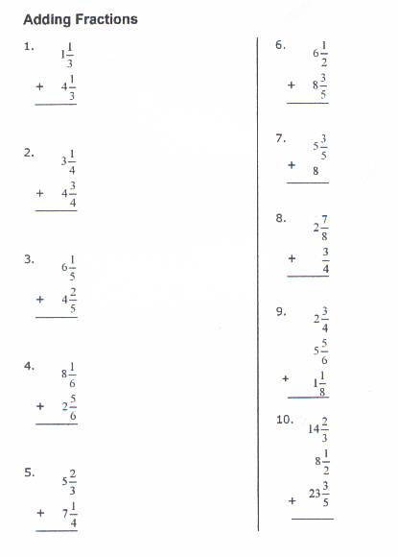
Adding Fractions

Name ______________________________ Date____________________

Subtracting Fractions
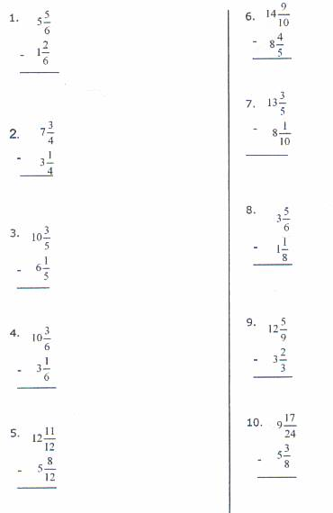

Name _________________________________ Date ________________
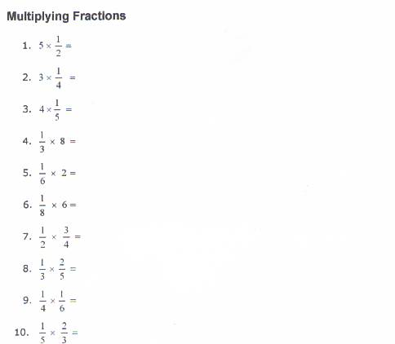

Name ______________________________________ Date ___________
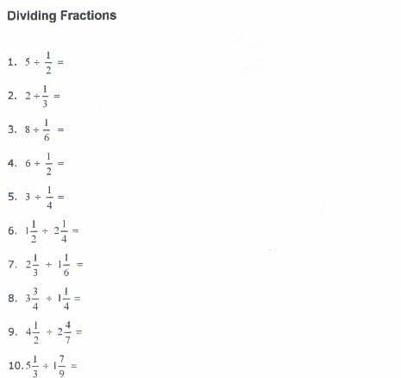

Name ______________________________________ Date ___________

GROUP WORK WITH FRACTIONS
DIRECTIONS: Working as a group, solve the following fraction problems.
_______ 1. John had a 30-inch pipe. He cut the pipe into pieces. The pieces were 4 11/16, 7 ⅝, 3 ½ and 9 inches. How much pipe does John have left?

_______ 2. Alexandra had 20 yards of cotton fabric. She made 3 curtains. Each curtain
used 4 ½ yards of fabric. How much did she have left?

_______ 3. There are 44 people working at the Plaza Office Building. On Tuesday, 3/4
of them worked overtime. How many worked overtime?

_______ 4. A pilot flew 350 miles in 3 ½ hours. How many miles per hour did she fly?

Name ____________________________________ Date _________________

Assessment for Competency M7
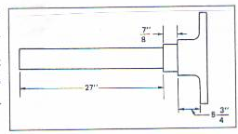
1. What is the overall length of the axle shaft shown in the drawing? _______________

2. If the 27-inch dimension of the axle shaft shown is changed to 16-9/16 inches, what is the overall length? _______________

3. A shaft with a 3/32-inch bushing measures 1-3/8 inches. What is the diameter of the shaft, in inches, without the bushing? _______________
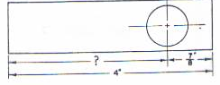
4. What is the missing dimension in this drawing?
_______________

5. What is the cost of 75-3/4 gallons of gasoline at $1.359 per gallon? _______________

6. What is the weight of the grease in a 216-liter drum if there are about 3-1/2 kilograms per liter? _______________

7. How many 3-7/8 long metal shims can be made from 20 metal strips, each 3 feet long?
_______________

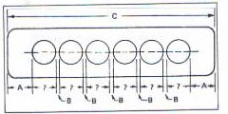
8. Distance A is 2-1/4 inches, distance B is 1-3/8 inches, and distance C is 36-1/8 inches. What is the diameter of each cylinder bore? _______________

