WAGE Competency Curriculum Guide

WAGE Competency M9: Carrying out arithmetic computations involving dollars and cents.

NOTE: You will need to collect two additional documents that are similar in nature to the one provided in this lesson at Hook 1a. These should be collected from local employers that support your program. These two additional documents will be used in Hooks 2 and 3 and are not to be duplicates of the other two documents used in this lesson. DO NOT USE MATERIALS THAT ARE NOT RELEVANT TO THE WORKPLACE.

Hook 1a
Ask, “How many of you work with money in some aspect of your job? What kind of jobs handle money?”
Record all responses on a flip chart and save for later use.
Coach students during a brainstorming activity but do not offer solutions.

Bridge
Acknowledge the good solutions offered; question students further to generate additional responses.
Ask, “Even if it were not a daily occurrence in the workplace, all of you will handle money at some time. Name some of those times when you would handle money outside of the workplace.”
Acknowledge any additional responses.
Say, “Now let’s imagine that you were working in a company as a manager. Every year the accounting office requires you to submit a budget for your staff. Would it be important to be able to accurately figure dollar amounts?”
Continue discussion.
Say, “Let’s look at how we would figure this budget for your department. Make sure that you incorporate the following thinking steps for this task.”
Thinking Steps
- Define the goal.
- Identify the steps one should follow.
- Name the items one needs to finish the task.
- Clear up any details not understood.

Book
Select a lesson (or lessons) from the wage curriculum Matrix or other source that best supports your needs. Spend ample time in the chosen lessons until you believe that each learner has mastered the skill. As you move through each lesson, be sure to emphasize the thinking steps that a learner must use to correctly apply this skill. Ensure that all thinking steps are properly sequenced during the learning and that each learner has had opportunities to practice each step in the application of the skill. Write the thinking steps identified by the lesson(s) in the sequential order they are to be used; you will use these again in Hooks 1b, 2, and 3.
Spend time defining the terms: $ sign, decimal point, and the two place system in money.
Thinking Steps for Competency M9:

NOTE: If your chosen lesson(s) indicates a different set of thinking than these listed here, substitute those that was presented in the lesson(s).
- Define the goal.
- Identify the steps one should follow.
- Name the items one needs to finish the task.
- Clear up any details not understood.

Hook 1b
Ask, “So if your department has six employees that are paid the same rate of $7.25 per hour 50 weeks a year how much should you put in the budget for their wages?”
Take note of answers and provide positive feedback.
Example: Lead a discussion on money and the importance of accurate accounting. Create a scenario in which the learner will understand the importance of and need for learning this skill.
Say, “Now I am going to model for you the use of the thinking steps we learned as I follow the directions to complete Worksheet A. As I say the thinking step, you help me apply the skill at each step. Do you understand what we are going to do?” Address any concerns before moving ahead.
Call out each thinking step and get the learners to assist you as you perform the task at each step.

Hook 2
Say, “That was great! Now that I have modeled the thinking steps we learned when performing this task, are there any questions before we move on?” Address all concerns before moving ahead.
Hand out a copy of Worksheet B that you have chosen for this exercise to each student.
Say, “Here is another worksheet that is similar to the one I just used as a model. It will give you the opportunity to figure with dollars and cents in the format that we just learned and practiced. In this exercise, I want you to work independently and use the thinking steps you learned as you work with money problems. Ask yourself if you could answer each question of the thinking steps. When you have all finished, each of you will have a chance to model for the class the thinking steps we should use for this skill. I will ask you to model the steps for the class and tell us what we should do as we go through each step. Are there any questions about your task?” Address all concerns before moving ahead.
When all have finished, ask for a volunteer to model the application of thinking steps to the task. Pay attention to the proper sequence, the learner’s ability to model, and the actions that must take place at each step. Allow all who want to model the steps an opportunity to do so before moving ahead. Have the students turn in all work to you. Review the work and address any exceptions noted with the learner.
NOTE: Mastery of this competency is determined by the students’ work on Hook 2. Review or rework is necessary when a student has not demonstrated mastery at Hook 2. Mastery is defined as the task being performed correctly with zero mistakes. A WAGE certificate should not be granted without mastery on all competencies listed in the student’s Individualized Program Plan.

Hook 3
Compliment the class for all the good work done at Hook 2. Say, “For this last exercise, you will work in teams, like they do at the workplace. In the workplace, workers know that people who are working together usually do the best work. By working together, they are able to combine their skills, share in the work, and complete the job in the proper amount of time.
“Now, I want you to move into teams of at least three people and no more than five people. Your team will need a leader, so select a leader now.” Make note of the leader in each team. Try to see that all learners have an opportunity to serve as leader during the course of their study.
Hand out the Worksheet C selected for this exercise. Be sure to give only one copy to each team. Say, “Team leaders, I want you to assign the thinking steps to each member of your team. If there are more steps than members, give each member more than one step. Try your best to make your distribution of thinking steps as fair as possible.”
Say, “Working as a team, I want you to apply the thinking steps we learned to the task. Each of you will be doing a different step, so make sure to keep up with your work and your solutions. When all of your team members have completed their assignments, the team leader is to put all the work together into a completed task. These exercises will be turned in so keep up with your work. Team leaders, you will present your team’s model of this task to the other teams in this class. Are there any questions?” Address all concerns before moving ahead.
When all the teams are finished, call for a volunteer leader to model the application of thinking steps to this task. Get the other teams to offer constructive criticism when appropriate. Strive to develop a level of competitiveness between teams. This will increase the bonds between team members and make the learning more fun. You might work up a recognition system for rewarding good work by each team. Be careful that your students do not get in the same team with each lesson.
NOTE: When it is impossible to use teams at Hook 3, usually due to an open-entry, open-exit class format, you will want to use peer tutors, paraprofessionals, or yourself as a supplement to the team. When conducted correctly, the concepts of interdependence can be reinforced when there are only two people assigned to the task.

Evaluation for M9:
Students will complete Competency M9 Test.

Resource Listing for M9:

Huffman, Harry, Ruth Twiss, Harold Williams. Performance Guide for Math for Business Careers, 4th edition. McGraw-Hill, 1977
Tussing, Ann K. U. (Ed.). Breakthrough to Math: Adding and Subtracting Fractions, Book 2. New Readers Press, 1978.
Tussing, Ann K. U. (Ed.). Breakthrough to Math: Multiplying and Dividing Fractions, Book 3. New Readers Press, 1978.
Tussing, Ann K. U. (Ed.). Breakthrough to Math: Word Problems, Book 6. New Readers Press, 1978.
Copyright © by Pulaski County Special School District Adult Education WAGE Training Program
No part of this curriculum may be reproduced in whole or in part, stored in a retrieval system, or transmitted in any form or by any means, electronic, mechanical, photocopying, recording or otherwise, without written permission from WAGE Training Program.
For permission information contact: WAGE Training Program, 4300 Haywood, North Little Rock, AR 72114.

Name _________________________________ Date ________________

Worksheet A
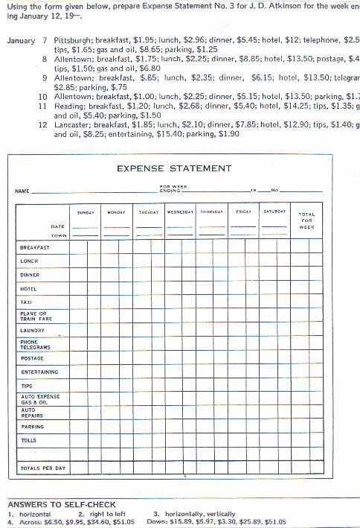

Name __________________________________ Date _______________

Worksheet B
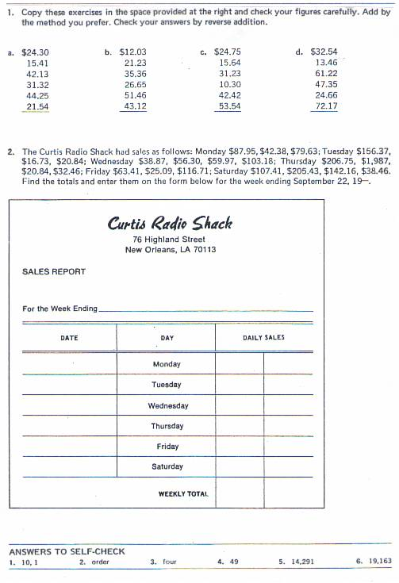

Name _____________________________________ Date ____________

Worksheet C
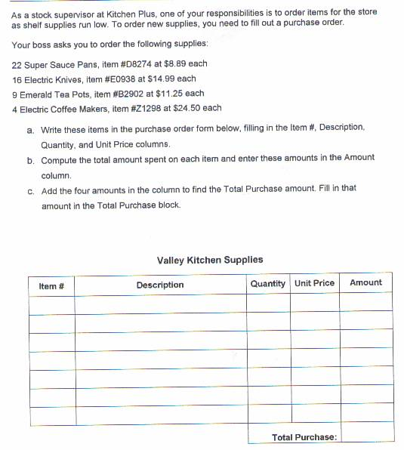

Name ________________________________ Date _________________
