WAGE Competency Curriculum Guide

WAGE Competency R13: Determining the presence of a defect or damage.

NOTE: You will need to collect two additional documents that are similar in nature to the one provided in this lesson at Hook 1a. These should be collected from local employers that support your program. These two additional documents will be used in Hooks 2 and 3 and are not to be duplicates of the other two documents used in this lesson. DO NOT USE MATERIALS THAT ARE NOT RELEVANT TO THE WORKPLACE.

Hook 1a
Project an overhead transparency of the Wiggy® voltage tester. Say, “Let’s pretend you are an experienced worker with Milton Electrical Contractors and you have been asked to help a new worker to check the voltage tester for damage or defect before using it. What are the thinking steps that you would want the new worker to use as she checked the instrument? What is the first thing that should be done? The second, and so on?”
Record all responses on a flip chart and save for later use.
Coach students during a brainstorming activity but do not offer suggestions.

Bridge
Acknowledge the responses offered; question students further to generate additional responses.
Ask, “Do you believe that these are the only thinking steps that should be used?” Pause. “Could there be more?”
Say, “Now we are going to go to our lessons and list the thinking steps we should know and use. When we have finished our work, we will compare your answers that I have recorded on the flip chart to the ones we have learned.”
Book
Select a lesson (or lessons) from the wage curriculum Matrix or other source that best supports your needs. Spend ample time in the chosen lessons until you believe that each learner has mastered the skill. As you move through each lesson, be sure to emphasize the thinking steps that a learner must use to correctly apply this skill. Ensure that all thinking steps are properly sequenced during the learning and that each learner has had opportunities to practice each step in the application of the skill. Write the thinking steps identified by the lesson(s) in the sequential order they are to be used; you will use these again in Hooks 1b, 2, and 3.
Use Checking for Defects or Damage and Wiggy® Voltage Tester.
Thinking Steps for Competency R13.
NOTE: If your chosen lesson(s) indicates a different set of thinking than these listed here, substitute those that was presented in the lesson(s).
- Identify the object that you are to check for damages or defects.
- Determine the types of possible defects or damage that may exist.
- Select the method or standard for checking for defects or damage.
- Perform the check and note any defect or damage.

Hook 1b
Get out the Checking for Defects or Damage, Wiggy® Voltage Tester, and the sheet of paper where you recorded learner responses in Hook 1a.
Say, “We are going to evaluate your answers. You gave me the following steps.” Post the sheet with responses on the wall. “Now, let’s look at the thinking steps that the lessons recommended we use.” Compare their responses to the given recommendations.
Example: Create a scenario in which the learner will visualize the situation and the need to learn the skill.
Say, “Now I am going to model for you the use of the thinking steps we learned as I follow the direction to complete this task. As I say the thinking step, you help me apply the skill at each step. Do you understand what we are going to do?” Address any concerns before moving ahead.
Call out each thinking step and get the learners to assist you as you perform the task at each step.

Hook 2
Say, “Now that I have modeled how a new worker would use the thinking steps we learned when performing this task, are there any questions before you complete two more assignments?” Address all concerns before moving ahead.
Hand out a copy of The Best Bolt Wins that you have chosen for this exercise to each student.
Say, “Here is another example of determining a defect or damage that is similar to the one I just used as a model. In this exercise, I want you to work alone and use the thinking steps you learned as you complete this task. When you have all finished, each of you will have a chance to model for the class the thinking steps we should use as we complete this task. I will ask you to model the steps for the class and tell us what we should do as we go through each step. Are there any questions about your task?” Address all concerns before moving ahead.
When all have finished, ask for a volunteer to model the application of thinking steps to the task. Pay attention to the proper sequence, the learner’s ability to model, and the actions that must take place at each step. Allow all who want to model the steps an opportunity to do so before moving ahead. Have the students turn in all work to you. Review the work and address any exceptions noted with the learner.
NOTE: Mastery of this competency is determined by the students’ work on Hook 2. Review or rework is necessary when a student has not demonstrated mastery at Hook 2. Mastery is defined as the task being performed correctly with zero mistakes. A WAGE certificate should not be granted without mastery on all competencies listed in the student’s Individualized Program Plan.

Hook 3
Compliment the class for all the good work done at Hook 2. Say, “For this last exercise, you will work in teams, like they do at the workplace. In the workplace, workers know that people who are working together usually do the best work. By working together, they are able to combine their skills, share in the work, and complete the job in the proper amount of time.
“Now, I want you to move into teams of at least three people and no more than five people. Your team will need a leader, so select a leader now.” Make note of the leader in each team. Try to see that all learners have an opportunity to serve as leader during the course of their study.
Hand out the third Group Work for Determining A Defect or Damage selected for this exercise. Be sure to give only one copy to each team. Say, “Team leaders, I want you to assign the thinking steps to each member of your team. If there are more steps than members, give each member more than one step. Try your best to make your distribution of thinking steps as fair as possible.”
Say, “Working as a team, I want you to apply the thinking steps we learned to the task. Each of you will be doing a different step, so make sure to keep up with your work and your solutions. When all of your team members have completed their assignments, the team leader is to put all the work together into a completed task. Team leaders, you will present your team’s model of this task to the other teams in this class. Are there any questions?” Address all concerns before moving ahead.
When all the teams are finished, call for a volunteer leader to model the application of thinking steps to this task. Get the other teams to offer constructive criticism when appropriate. Strive to develop a level of competitiveness between teams. This will increase the bonds between team members and make the learning more fun. You might work up a recognition system for rewarding good work by each team. Be careful that your students do not get in the same team with each lesson.

NOTE: When it is impossible to use teams at Hook 3, usually due to an open-entry, open-exit class format, you will want to use peer tutors, paraprofessionals, or yourself as a supplement to the team. When conducted correctly, the concepts of interdependence can be reinforced when there are only two people assigned to the task.

Evaluation for R13:
85% on all worksheets
95% on Assessment for Determining a Defect or Damage

Resource Listing for R13:
Teacher-generated Materials: Lil Williams
Electrical Trainee Guide. Prentice-Hall: New Jersey. 2000.

Copyright © by Pulaski County Special School District Adult Education WAGE Training Program
No part of this curriculum may be reproduced in whole or in part, stored in a retrieval system, or transmitted in any form or by any means, electronic, mechanical, photocopying, recording or otherwise, without written permission from WAGE Training Program.
For permission information contact: WAGE Training Program, 4300 Haywood, North Little Rock, AR 72114.

Wiggy® Voltage Tester

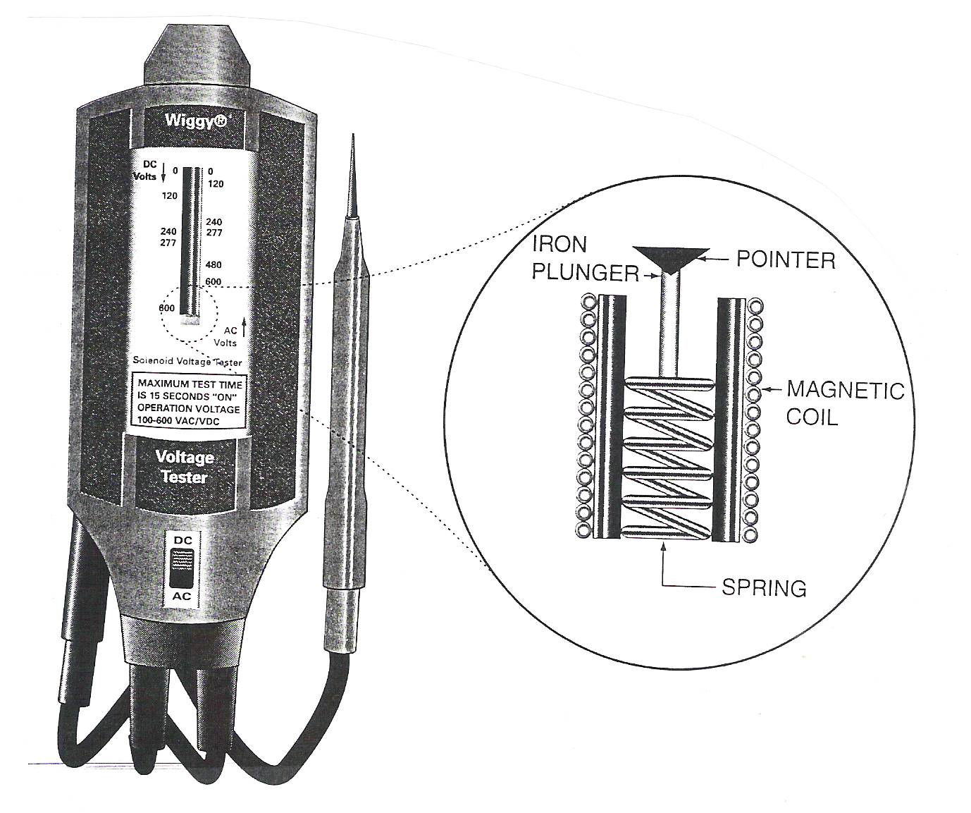

Checking for Defects or Damage

The new vacuum cleaner is humming along when all of a sudden it makes a loud noise and it stalls. You discover that the new vacuum cleaner is defective. A defect means that the machine has a fault that was built in at the factory – it may have been caused by human error or a faulty factory machine.

Your car is parked at the grocery store and someone carelessly lets a shopping cart loose. It rolls into your car causing a dent or damage. Damage occurs to an object that is free of defects; the harm comes after production of the object. Damage to a machine can occur due to poor maintenance, causing it to produce defective parts.

In factory settings, some employees check for defects or damage to objects being produced. Workers of all kind that deal with equipment will always want to check their equipment for defects and damage. For an electrician to neglect to check his voltage tester could mean the difference between life and death. Even in the home it is wise to check appliances and machines. A frayed wire to a lamp could result in a house fire.

In order to check for defects or damage you need to know what to look for. Defects are more difficult to spot than damage. Defects are often internal. Damage, on the other hand, is often very apparent as in the case of a dented car. To facilitate checking for defects or damage, the company may have a standard set up to compare the objects to. This could be a checklist of acceptable details or it could be a graphic of an acceptable object. Having both a checklist and picture is invaluable in checking for defects or damage. An office worker in checking the accuracy of his/her work can also use this procedure. For instance, a secretary can use a checklist of what is needed in a business letter along with a graphic of a proper business letter. After writing the letter she can compare it to her checklist and graphic. The letter is her product and the standard is her checklist. Any errors would be the “damage”.

STEPS FOR DETERMINING THE PRESENCE OF A DEFECT OR DAMAGE

- Identify the object that you are to check for damages or defects.
- Determine the types of possible defects or damage that may exist.
- Select the standard or method for checking for defects or damage.
- Perform the check and note any defect or damage.
Practice

Pretend you are an electrician for the Milton Electrical Contractors. You use the Wiggy® voltage tester to determine if there is energy in whatever you are working on. Because you know it is extremely important to check the voltage tester before doing any work, you will use the following standard to check the tester against.

Standard for Checking Voltage Tester
 Check for cracked casing or damaged insulation.
 Check the faceplate or the scale on the front of the tester for voltage capacity.
 Check probes for any damage.
 Check for obvious external damage.

Thinking steps for determining the presence of a defect or damage:

- Identify the object that you are to check for damages or defects.
__________________________________________________________________________
- Determine the types of possible defects or damage that may exist.
____________________________________________________________________________________________________________________________________________________________________________________
__________________________________________________________________________________________
- Select the standard or method for checking for defects or damage.
______________________________________________________________________________________________________________________________________________________________________________________________________________________________________________________________________________
- Perform the check and note any defect or damage.
______________________________________________________________________________________________________________________________________________________________________________________________________________________________________________________________________________

Name ________________________________________ Date _____________

The Best Bolt Wins

Fasteners are used extensively in the electrical craft. Both categories of fasteners – threaded and non-threaded – are used. It is especially important to select the best fasteners for the job. As an electrician for Wilton Electrical Contractors you have just received some bolts to use on your next job. The following is the standard that Wilton uses for installing fasteners.

INSTALLING FASTENERS
- Select the proper bolts or screws for the job.
- Check for damaged or dirty internal and external threads.
- Clean the bolt or screw threads.
- Insert the bolts through the predrilled holes and tighten by hand.

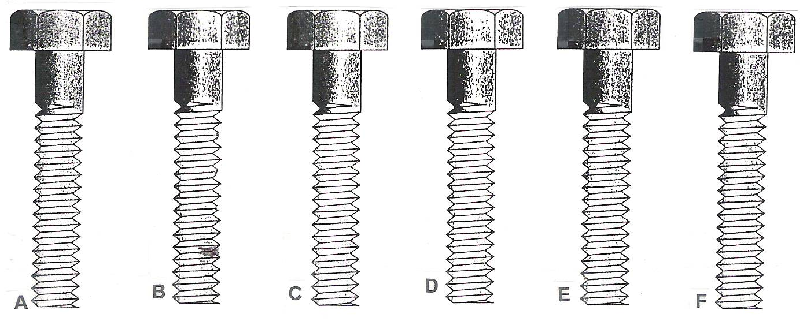
Use the thinking steps for determining a defect and damage to check out the following bolts. List the steps and information that you find.

- a.__________________________________________________________________________________________________________________________________________________________________________________________________________________________b.__________________________________________________________________________________________________________________________________________________________________________________________________________________________
c. ________________________________________________________________________
____________________________________________________________________________________________________________________________________________________
d. ________________________________________________________________________
____________________________________________________________________________________________________________________________________________________
Group Names ________________________________________________
Date ______________________
Group Work for Determining a Defect and Damage
Rivet guns are one of the essential tools for electricians. The general procedure to install blind rivets is as follows:

INSTALLATION OF BLIND RIVETS
- Select the correct length and diameter of blind rivet to be used.
- Select the appropriate drill bit for the size of rivet being used.
- Drill a hole through both parts being connected.
- Inspect the rivet gun for any defects that might make it unsafe for use.
- Place the rivet mandrel into the proper size setting tool.
- Insert the rivet end into the predrilled hole.
- Install the rivet by squeezing the handle of the rivet gun.
- Inspect the rivet to make sure the pieces are firmly riveted together and that the rivet is properly installed.

- According to the installation procedure there are two things that need to be checked for defect or damage. Name them.
__________________________________________________________________________________________________________________________________________________
- Study the picture of the rivet tool below and determine if there are any visible defects or damage. Use the thinking steps for determining a defect and damage.
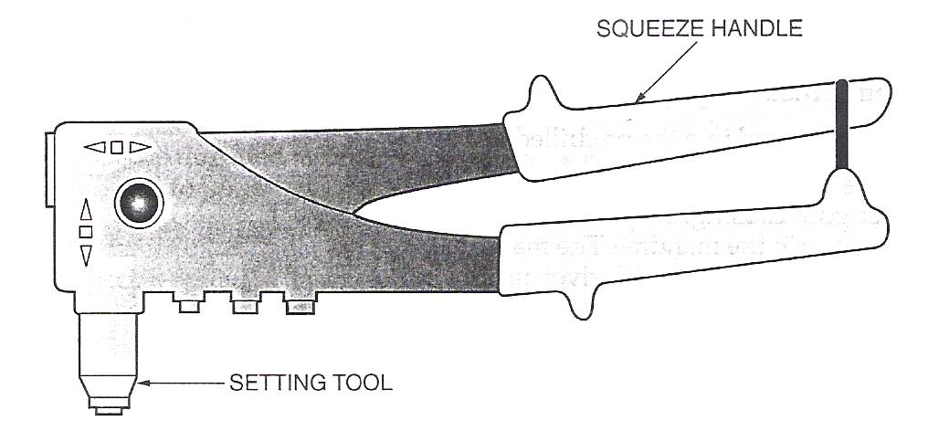

a.___________________________________________________________________________________________________________________________________________________________________________________________________________________________________
b.___________________________________________________________________________________________________________________________________________________________________________________________________________________________________
c. __________________________________________________________________________
________________________________________________________________________________________________________________________________________________________
d. __________________________________________________________________________
________________________________________________________________________________________________________________________________________________________
3. The first figure below shows properly installed blind rivets. Using this figure as a standard, compare the others to determine if there is a defect in the installation. Follow the thinking steps you have learned. Name the figures that are properly installed.
____________________________________________________________________________

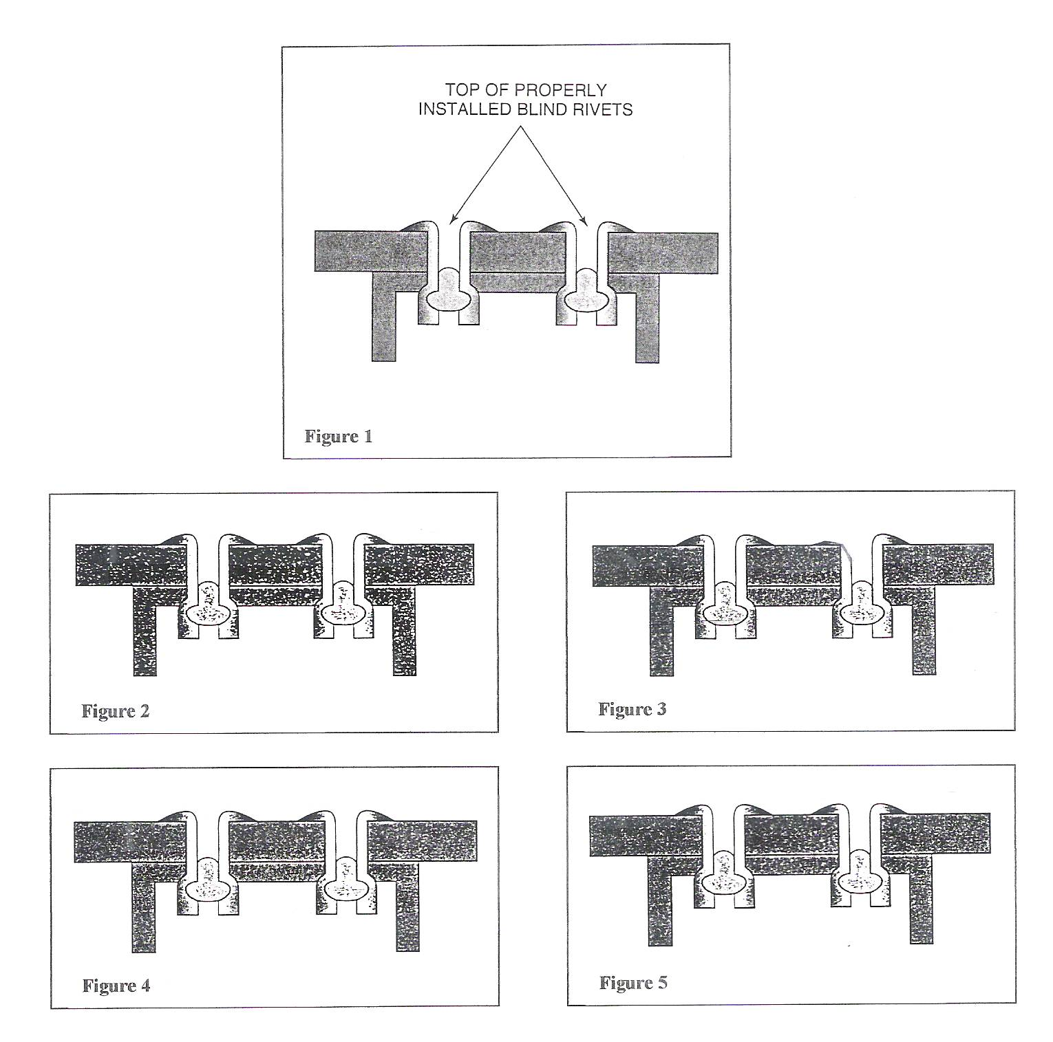

Name _____________________________________ Date ________________

Assessment for Determining a Defect or Damage

- List the thinking steps for determining a defect or damage.
a.______________________________________________________________________________________________________________________________________________________
b._______________________________________________________________________________________________________________________________________________________
c. __________________________________________________________________________
____________________________________________________________________________
d. __________________________________________________________________________
____________________________________________________________________________
- Let’s say a secretary typed the business letter below. Read the guidelines first. Then compare her work to the guidelines. Check off each step that she did correctly; then answer the questions.

Guidelines for Typing a Business Letter
  - Use business letterhead.
  - Below letterhead to the right, type date.
  - Below date, type person’s name and title, company’s name, and address.
  - Below address, type greetings.
  - Below greeting, begin typing text of letter.
  - Two lines below the last line of text, type closing salutation (yours truly)
  - Four lines below the salutation, type name of letter writer and his or her title.

  - Two lines below name, type your initials. (This identifies typist)

- Which of the eight guidelines did the secretary fail to follow?
_________________________________________________________________________

- Should she be required to retype the letter? Why or why not?
__________________________________________________________________________________________________________________________________________________

- Compare this procedure of finding errors in an office situation to determining defects and damage in a factory workplace. How are they alike and how are they different?

Office | Factory

