WAGE Competency Curriculum Guide

WAGE Competency R24: Applying information from tables, graphs or flow charts to locate malfunctions or selected actions.

NOTE: You will need to collect two additional documents that are similar in nature to the one provided in this lesson at Hook 1a. These should be collected from local employers that support your program. These two additional documents will be used in Hooks 2 and 3 and are not to be duplicates of the other two documents used in this lesson. DO NOT USE MATERIALS THAT ARE NOT RELEVANT TO THE WORKPLACE.

Hook 1a
Project an overhead transparency of the printer-troubleshooting table. Say, “Let’s pretend you are an office worker and you have been asked to help a new worker to find out why his printer will not work. Looking at the transparency, think about what are the steps that you would want the new worker to use as he looks for the problem? How might you use tables, graphs or flowcharts in a workplace to locate malfunctions? What is the first thing that should be done? The second, and so on?”
Record all responses on a flip chart and save for later use.
Coach students during a brainstorming activity but do not offer suggestions.

Bridge
Acknowledge the responses offered; question students further to generate additional responses.
Ask, “Do you believe that these are the only thinking steps that should be used?” Pause. “Could there be more?”
Say, “How many of you can say that you have had experience reading or creating tables, graphs or flowcharts? Let’s imagine that you are working in a company that requires you to troubleshoot malfunctions in a computer printer. It is possible that you would have to use a table, graph, or flowchart to locate these malfunctions. I want to look at some of the most common use of tables, graphs, and flowcharting and how you would use them to locate malfunctions or selected actions in the workplace. Now we are going to go to our lessons and list the thinking steps we should know and use. When we have finished our work, we will compare your answers that I have recorded on the flip chart to the ones we have learned.”
Book
Select a lesson (or lessons) from the wage curriculum Matrix or other source that best supports your needs. Spend ample time in the chosen lessons until you believe that each learner has mastered the skill. As you move through each lesson, be sure to emphasize the thinking steps that a learner must use to correctly apply this skill. Ensure that all thinking steps are properly sequenced during the learning and that each learner has had opportunities to practice each step in the application of the skill. Write the thinking steps identified by the lesson(s) in the sequential order they are to be used; you will use these again in Hooks 1b, 2, and 3.
Use Solving Problems with a Table for this lesson.
Thinking Steps for Competency R24.
NOTE: If your chosen lesson(s) indicates a different set of thinking than these listed here, substitute those that was presented in the lesson(s).
- Define the goal.
- Identify the steps.
- Name the items you need.
- Clear up details.

Hook 1b
Get out Solving Problems with a Table and the sheet of paper where you recorded learner responses in Hook 1a. Spend time explaining the meaning or purpose of using tables, graphs, or flowcharting and give examples.
Say, “We are going to evaluate your answers. You gave me the following steps.” Post the sheet with responses on the wall. “Now, let’s look at the thinking steps that the lessons recommended we use.” Compare their responses to the given recommendations.
Example: Use the troubleshooting table used with Competency R24 to get a good understanding of skill. Create a workplace scenario that would help the learner visualize the situation and the need to learn the skill.
Say, “Now I am going to model for you the use of the thinking steps we learned as I follow the direction to complete this task. As I say the thinking step, you help me apply the skill at each step. Do you understand what we are going to do?” Address any concerns before moving ahead.
Model the Practice part of the lesson. Call out each thinking step and get the learners to assist you as you perform the task at each step.

Hook 2
Say, “Now that I have modeled how a new worker would use the thinking steps we learned when performing this task, are there any questions before you complete two more assignments?” Address all concerns before moving ahead.
Hand out a copy of Using a Flow Chart that you have chosen for this exercise to each student.
Say, “Here is another activity that is similar to the one I just used as a model. In the lesson we used a table to troubleshoot malfunctions with a computer printer. In this exercise, you will be using a flowchart to troubleshoot a television. This worksheet will give you the experience in following directions and finding information found in tables, graphs or flowcharts and to put into practice what we just learned. I want you to work alone and use the thinking steps you learned as you complete this task.
Ask yourself if you could answer each question of the thinking steps:
- Define the goal: Locate problems and show or solve the problem easily through visual aids such as tables, graphs or flowcharts.
- Identify the steps: Read the directions, follow columns and rows carefully.
- Name the items you need: Ruler or straight edge to stay on task or to draw straight lines for graphs or flowcharts, pencil, pen and paper or graph paper.
- Clear up questions: Ask for help.
When you have all finished, each of you will have a chance to model for the class the thinking steps we should use as we complete this task. I will ask you to model the steps for the class and tell us what we should do as we go through each step. Are there any questions about your task?” Address all concerns before moving ahead.
When all have finished, ask for a volunteer to model the application of thinking steps to the task. Pay attention to the proper sequence, the learner’s ability to model, and the actions that must take place at each step. Allow all who want to model the steps an opportunity to do so before moving ahead. Have the students turn in all work to you. Review the work and address any exceptions noted with the learner.
NOTE: Mastery of this competency is determined by the students’ work on Hook 2. Review or rework is necessary when a student has not demonstrated mastery at Hook 2. Mastery is defined as the task being performed correctly with zero mistakes. A WAGE certificate should not be granted without mastery on all competencies listed in the student’s Individualized Program Plan.

Hook 3
Compliment the class for all the good work done at Hook 2. Say, “For this last exercise, you will work in teams, like they do at the workplace. In the workplace, workers know that people who are working together usually do the best work. By working together, they are able to combine their skills, share in the work, and complete the job in the proper amount of time.
“Now, I want you to move into teams of at least three people and no more than five people. Your team will need a leader, so select a leader now.” Make note of the leader in each team. Try to see that all learners have an opportunity to serve as leader during the course of their study.
Hand out the third document, Seeing the Connection, selected for this exercise. Be sure to give only one copy to each team. Say, “Team leaders, I want you to assign the thinking steps to each member of your team. If there are more steps than members, give each member more than one step. Try your best to make your distribution of thinking steps as fair as possible.”
Say, “Working as a team, I want you to apply the thinking steps we learned to the task. Each of you will be doing a different step, so make sure to keep up with your work and your solutions. When all of your team members have completed their assignments, the team leader is to put all the work together into a completed task. Team leaders, you will present your team’s model of this task to the other teams in this class. Are there any questions?” Address all concerns before moving ahead.
When all the teams are finished, call for a volunteer leader to model the application of thinking steps to this task. Get the other teams to offer constructive criticism when appropriate. Strive to develop a level of competitiveness between teams. This will increase the bonds between team members and make the learning more fun. You might work up a recognition system for rewarding good work by each team. Be careful that your students do not get in the same team with each lesson.
NOTE: When it is impossible to use teams at Hook 3, usually due to an open-entry, open-exit class format, you will want to use peer tutors, paraprofessionals, or yourself as a supplement to the team. When conducted correctly, the concepts of interdependence can be reinforced when there are only two people assigned to the task.
Evaluation for R24:
85% on all worksheets
90% on Final Assessment on Troubleshooting
Resource Listing for R24:
Echaore-Yoon, Susan. Reading Skills That Work: A Functional Approach for Life and Work. Chicago: Contemporary Books. 1991.
Copyright © by Pulaski County Special School District Adult Education WAGE Training Program
No part of this curriculum may be reproduced in whole or in part, stored in a retrieval system, or transmitted in any form or by any means, electronic, mechanical, photocopying, recording or otherwise, without written permission from WAGE Training Program.
For permission information contact: WAGE Training Program, 4300 Haywood, North Little Rock, AR 72114.

Solving Problems With a Table
Tables have many functions; one function is to troubleshoot or help you to solve an existing problem. Troubleshooting tables are found in the workplace and at home. These tables are used to give information when a machine breaks down or to solve some other problem.
The definition for troubleshooting is locating the trouble and making repairs or improvements. A troubleshooting table will follow a certain format. It will lists the problems that can happen and will list possible solutions to those problems. The causes and solutions may be listed separately or together. Usually the causes are simple and do not require a professional.
Troubleshooting tables often give several reasons why a problem might arise. It’s a good idea to check each suggested cause until you find the one that is creating your problem.
The troubleshooting table below combines the causes and solutions for a computer printer.
PROBLEM | POSSIBLE REASONS
Printer does not turn on. | - The power cord is not plugged into a power outlet.  - The power outlet is dead.  - The printer has a burned-out fuse
Printer does not start although it is on. | - The printer cannot receive data from computer because the Select button is not pressed.  - Ribbon may not be in place.  - The printer cable is not plugged into the correct port in the computer.  - Printer is out of paper, or paper is jammed.

Practice
Use the troubleshooting table to answer the following questions.

- As a worker leaves work, she accidentally pulls out the power cord from a printer. What will happen the next workday when the printer is turned on?
____________________________________________________________________________________________________________

- Maria is finding out why her printer won’t turn on. She plugs a radio into the same outlet that the printer is plugged into. The radio works. What else might be the problem?
____________________________________________________________________________________________________________

- Lionel used the printer all morning. After lunch he needs to print out more work. The printer is on, but it won’t start printing. The printer is not out of paper, and the paper is not jammed. What might be the cause of the problem?
  - ______________________________________________________________________________________________________
  - ______________________________________________________________________________________________________
  - ______________________________________________________________________________________________________

Name ___________________________________ Date __________________

Using a Flow Chart

A flow chart is a graphic chart that is used in the workplace and at home to illustrate sequenced steps of machine operations or other processes. Flow charts use codes and symbols as a “shorthand” way of explaining these operations or processes.

Look at the chart below of a familiar operation we do every day. Using the flow chart and symbols, answer the questions at the bottom of the chart. If the chart does not provide enough information, write “N/A” in the space provided.

Turn on TV
LEGEND
Start/Stop Point

One step in the process

Decision Point
Picture comes on
Picture is good
TV is plugged in
Picture is good
Picture comes on
Plug in
Call TV repairman
Adjust knobs
Watch program
NO
NO
NO
NO
NO
YES
YES
YES
YES
YES
Turning on the TV

- According to the chart, what is the first thing you do if you turn on the television and it does not come on?
_______________________________________________________
- If the television is plugged in and the picture still does not come on, what should you do?
_______________________________________________________
- Name three decision points in the flow chart.
_____________________________________________________________________________________________________________________________________________________________________
Group Names ___________________________________________________
Date_____________________
Seeing Connections
A diagram, by definition, is a graphic that explains and shows the relation of parts to each other. Diagrams are useful in the workplace and at home; they show us how systems work. A system is a group of items that work together to perform a function. For example, a telephone answering machine system is a system that allows the caller to leave a message when the person who is being called is not available.

The diagram that follows shows a telephone answering system. This system has six parts as shown.

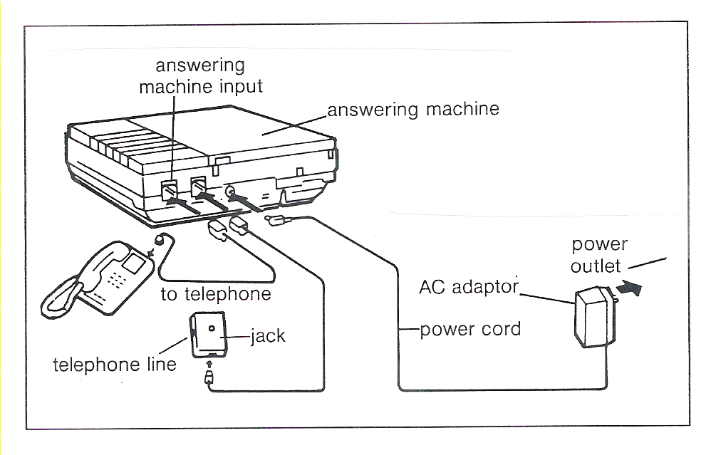

Practice

- What is the part that goes to the power outlet called? ______________________
- What part or parts is the phone directly connected to?
________________________________________________________________
- Suppose you pulled out the power cord. Do you think the phone would still work?
Why? ___________________________________________________________
________________________________________________________________
- Suppose you turned off the answering machine. Do you think the phone would still work? Why? ___________________________________________________
________________________________________________________________

Name _____________________________________ Date ________________

Final Assessment for Troubleshooting
Using the troubleshooting table for vacuum cleaners and graphics, answer the questions that follow.
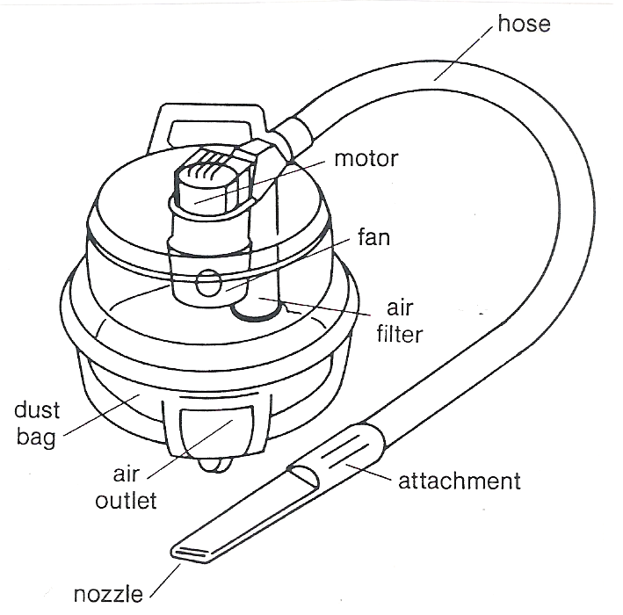
Vacuum Cleaner Troubleshooting  Possible Cause | Clean it out | Repair it | Replace it
Nozzle is blocked. | 
Hose is clogged. | 
Hose is leaking. |  |  | 
Dust bag is full. |  |  | 
Attachment is cracked. |  |  | 
Fan is blocked. | 
Air outlet is blocked. | 
Motor is damaged. |  |  | 
- Mr. Torres takes his vacuum cleaner to the shop. Its motor will not run. When the service technician turns it on, the motor runs. She cleans the machine. She tries the machine, and it cleans the way it should. What could be one possible reason that the machine didn’t work for Mr. Torres?
____________________________________________________________________________________________________________________________
- A service technician returns a vacuum cleaner to its owner. She tells the owner that four parts can get blocked or clogged easily. She shows the owner where the parts are and what to do if one of them gets jammed. Read the trouble-shooting chart to learn what the parts are. What are the parts?
____________________________________________________________________________________________________________________________
- Suppose you use the trouble-shooting chart to help you find the trouble with your vacuum cleaner. What would you do if:
  - the hose is leaking? __________________________________________
  - the air outlet is blocked? ______________________________________
  - the dust bag is full? __________________________________________
  - the motor is damaged? _______________________________________

