WAGE Competency Curriculum Guide

WAGE Competency R26: Identifying components within a schematic diagram.

NOTE: You will need to collect two additional documents that are similar in nature to the one provided in this lesson at Hook 1a. These should be collected from local employers that support your program. These two additional documents will be used in Hooks 2 and 3 and are not to be duplicates of the other two documents used in this lesson. DO NOT USE MATERIALS THAT ARE NOT RELEVANT TO THE WORKPLACE.

Hook 1a
Project an overhead transparency of electrical schematic diagram. Say, “Let’s pretend you are an experienced worker with a local electrical contractor and you have been asked to help a new worker to identify components in a schematic diagram. What are the thinking steps that you would want the new worker to use as she looks at the schematic diagram? What is the first thing that should be done? The second, and so on?”
Record all responses on a flip chart and save for later use.
Coach students during a brainstorming activity but do not offer suggestions.

Bridge
Acknowledge the responses offered; question students further to generate additional responses.
Ask, “Do you believe that these are the only thinking steps that should be used?” Pause. “Could there be more?”
Say, “Now we are going to go to our lessons and list the thinking steps we should know and use. When we have finished our work, we will compare your answers that I have recorded on the flip chart to the ones we have learned.”
Book
Select a lesson (or lessons) from the wage curriculum Matrix or other source that best supports your needs. Spend ample time in the chosen lessons until you believe that each learner has mastered the skill. As you move through each lesson, be sure to emphasize the thinking steps that a learner must use to correctly apply this skill. Ensure that all thinking steps are properly sequenced during the learning and that each learner has had opportunities to practice each step in the application of the skill. Write the thinking steps identified by the lesson(s) in the sequential order they are to be used; you will use these again in Hooks 1b, 2, and 3.
Use What Makes Up a Schematic Diagram? and electrical schematic diagram.
Thinking Steps for Competency R26.
NOTE: If your chosen lesson(s) indicates a different set of thinking than these listed here, substitute those that was presented in the lesson(s).

- Identify your purpose for using the schematic.
- Locate the legend and/or parts list.
- Identify the different parts of the schematic diagram.

Hook 1b
Get out the What Makes Up a Schematic Diagram?, electrical schematic diagram, and the sheet of paper where you recorded learner responses in Hook 1a.
Say, “We are going to evaluate your answers. You gave me the following steps.” Post the sheet with responses on the wall. “Now, let’s look at the thinking steps that the lessons recommended we use.” Compare their responses to the given recommendations.
Example: Use the electrical schematic diagram to model the skill for students.
Say, “Now I am going to model for you the use of the thinking steps we learned as I follow the direction to complete this task. As I say the thinking step, you help me apply the skill at each step. Do you understand what we are going to do?” Address any concerns before moving ahead.
Call out each thinking step and get the learners to assist you as you perform the task at each step.

Hook 2
Say, “Now that I have modeled how a new worker would use the thinking steps we learned when performing this task, are there any questions before you complete two more assignments?” Address all concerns before moving ahead.
Hand out a copy of Interpreting the Schematic Diagram that you have chosen for this exercise to each student.
Say, “Here is another diagram that is similar to the one I just used as a model. In this exercise, I want you to work alone and use the thinking steps you learned as you complete this task. When you have all finished, each of you will have a chance to model for the class the thinking steps we should use as we complete this task. I will ask you to model the steps for the class and tell us what we should do as we go through each step. Are there any questions about your task?” Address all concerns before moving ahead.
When all have finished, ask for a volunteer to model the application of thinking steps to the task. Pay attention to the proper sequence, the learner’s ability to model, and the actions that must take place at each step. Allow all who want to model the steps an opportunity to do so before moving ahead. Have the students turn in all work to you. Review the work and address any exceptions noted with the learner.
NOTE: Mastery of this competency is determined by the students’ work on Hook 2. Review or rework is necessary when a student has not demonstrated mastery at Hook 2. Mastery is defined as the task being performed correctly with zero mistakes. A WAGE certificate should not be granted without mastery on all competencies listed in the student’s Individualized Program Plan.

Hook 3
Compliment the class for all the good work done at Hook 2. Say, “For this last exercise, you will work in teams, like they do at the workplace. In the workplace, workers know that people who are working together usually do the best work. By working together, they are able to combine their skills, share in the work, and complete the job in the proper amount of time.
“Now, I want you to move into teams of at least three people and no more than five people. Your team will need a leader, so select a leader now.” Make note of the leader in each team. Try to see that all learners have an opportunity to serve as leader during the course of their study.
Hand out the third Group Work for Schematic Diagrams selected for this exercise. Be sure to give only one copy to each team. Say, “Team leaders, I want you to assign the thinking steps to each member of your team. If there are more steps than members, give each member more than one step. Try your best to make your distribution of thinking steps as fair as possible.”
Say, “Working as a team, I want you to apply the thinking steps we learned to the task. Each of you will be doing a different step, so make sure to keep up with your work and your solutions. When all of your team members have completed their assignments, the team leader is to put all the work together into a completed task. Team leaders, you will present your team’s model of this task to the other teams in this class. Are there any questions?” Address all concerns before moving ahead.
When all the teams are finished, call for a volunteer leader to model the application of thinking steps to this task. Get the other teams to offer constructive criticism when appropriate. Strive to develop a level of competitiveness between teams. This will increase the bonds between team members and make the learning more fun. You might work up a recognition system for rewarding good work by each team. Be careful that your students do not get in the same team with each lesson.

NOTE: When it is impossible to use teams at Hook 3, usually due to an open-entry, open-exit class format, you will want to use peer tutors, paraprofessionals, or yourself as a supplement to the team. When conducted correctly, the concepts of interdependence can be reinforced when there are only two people assigned to the task.

Evaluation for R26:
85% on all worksheets
95% on Assessment for Schematics

Resource Listing for R26:

Teacher-generated Materials: Lil Williams
Electrical Trainee Guide. Prentice-Hall: New Jersey. 2000.
Johnson, Richard J. Schematic Diagrams: The Basics of Interpretation and Use. Indianapolis: Prompt© Publications. 1994.
Copyright © by Pulaski County Special School District Adult Education WAGE Training Program
No part of this curriculum may be reproduced in whole or in part, stored in a retrieval system, or transmitted in any form or by any means, electronic, mechanical, photocopying, recording or otherwise, without written permission from WAGE Training Program.
For permission information contact: WAGE Training Program, 4300 Haywood, North Little Rock, AR 72114.

What Makes Up a Schematic?

What makes up a schematic? Good question, but to answer it we need to know what a schematic is. A schematic is in fact a type of diagram, that is a graphic that explains and shows the relation of parts to each other. Other diagrams include functional flow diagrams, block diagrams, and physical diagrams. The schematic diagram derives its name from the word, scheme. The schematic diagram shows the “scheme” of things with its major message being the purpose of the equipment and the scheme by which it achieves its purpose. In other words, the schematic presents in the simplest, most useful form, the components making up a circuit, how they are interconnected, and how the circuit functions. A schematic can also be mechanical which shows mechanical function. The electrical schematic diagram shows what parts are used and how they are connected; however, they do not explain the function of the unit. It is up to you to interpret the schematic diagram.

To interpret the schematic diagram, you need to be able to identify components within the schematic diagram. First rule is that the drawings are not drawn to scale and the components bear no necessary relation to their actual physical arrangement. Schematics do not show physical features. The following is a list of the components you will encounter in a schematic diagram:

- Power source | - Connections
- Letter Symbols | - Diode
- Grounds | - Resistors
- Capacitors | - Inductors
- Transformers | - Switches and Relays

Each component has its own symbol to make it unique. Clearly it would be difficult at best to memorize each symbol. Labeling and parts lists are used to make schematics easier to interpret. For example, the letter symbol R stands for a resistor, L for an inductor, etc. If there is more than one resistor, a number is used to identify each one, such as R1, R2, R3 and so on. Lines are used to represent connections. A zigzag line such as the following also indicates resistors:

The parts list is used to indicate the specifications of any or all of the components in it. Figure A illustrates a schematic and its parts list. Figure B illustrates what a schematic looks like if a parts list is not used.
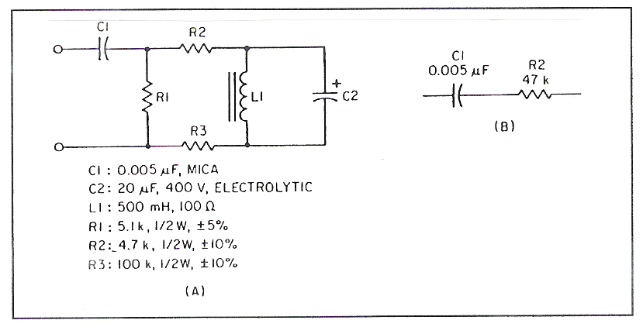

Labeling and the parts list are necessary in order for the reader to interpret the schematic diagram accurately. As symbols and lines will vary from drawing to drawing always check the symbol list or legend for the exact meaning of lines or symbols on the drawing with which you are working. The following represents some basic electrical lines:
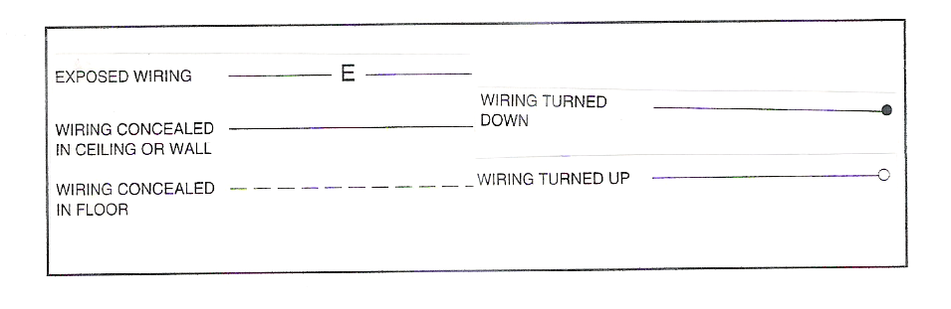

Reading a Schematic Diagram

Let’s think about what steps are needed to read a schematic diagram.

Step 1: Identify your purpose for using the schematic diagram.

You are an electrician and need to read the following schematic to complete your job.
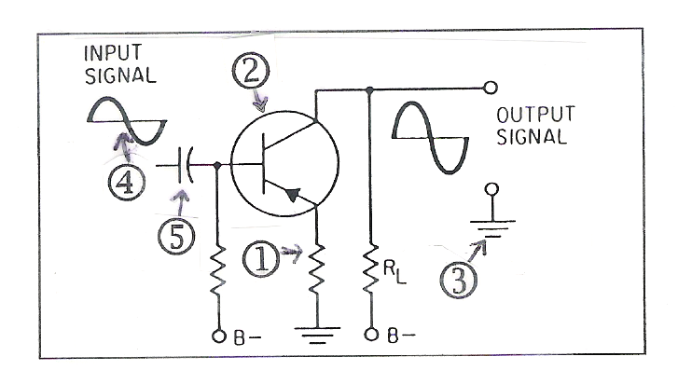

Step 2: Locate the legend and/or parts list.

The legend and parts list are included with the schematic diagram either on the same page or separate. The legend for the schematic diagram above follows:
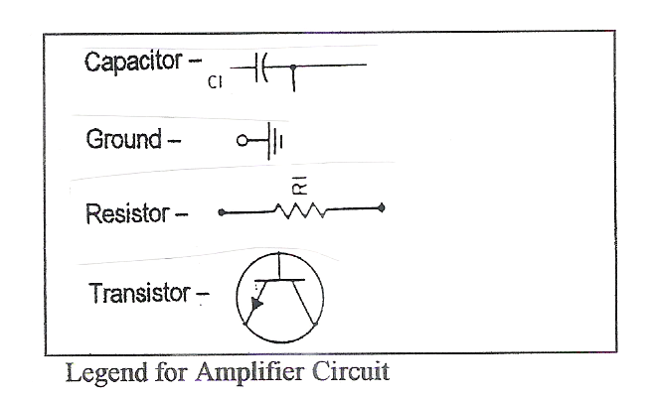

Step 3: Identify the different components of the schematic diagram.

Write the names of the numbered components.

- ______________________________
- ______________________________
- ______________________________
- ______________________________
- ______________________________

Electrical schematic diagram

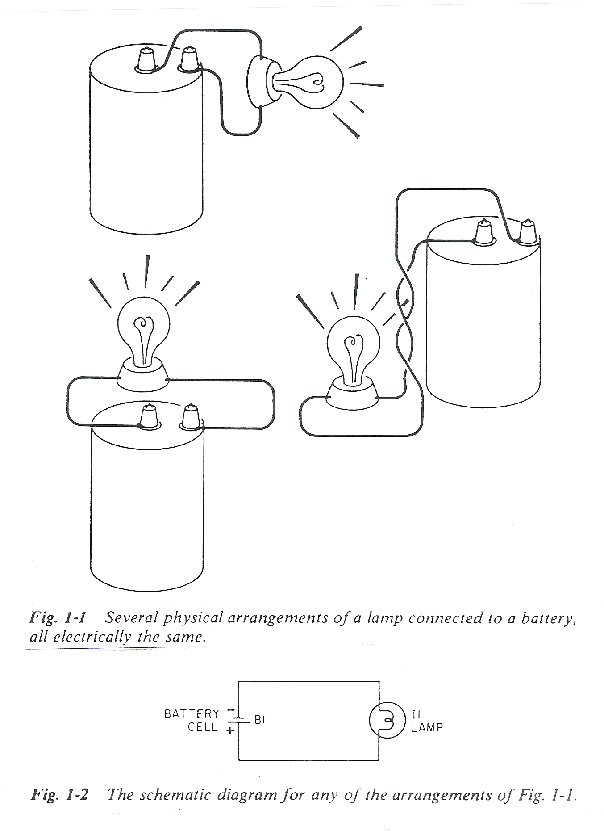

Name ___________________________________ Date __________________

Interpreting the Schematic Diagram

Push-pull amplifiers are used on audio output power amplifiers. The benefits of the push-pull amplifier are that two transistors share the load and the balanced configuration causes even-harmonic distortion to be cancelled out, lowering overall distortion. Study the schematic diagram for the push-pull amplifier below and answer the questions that follow.
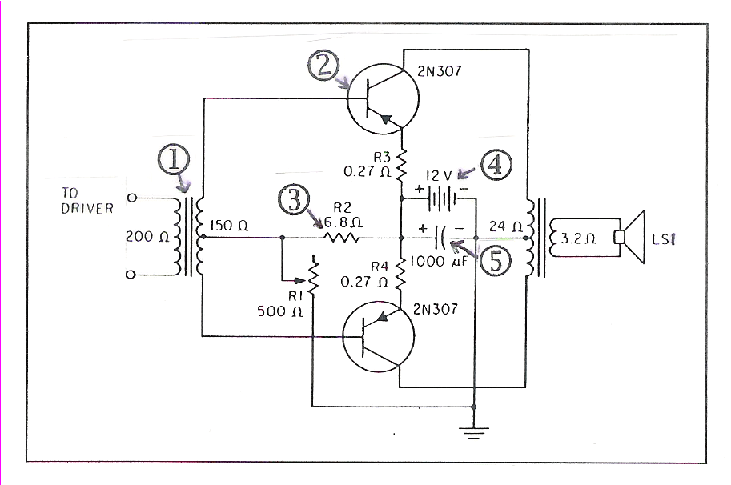
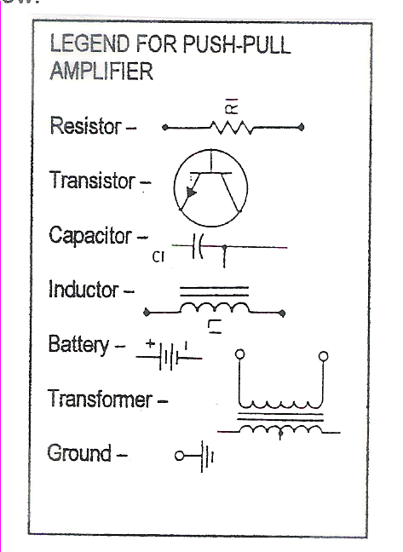

- Study the schematic diagram and legend above and write the names of the numbered components. Draw the component next to its name.

  - _________________________________
  - _________________________________
  - _________________________________
  - _________________________________
  - _________________________________

2. Draw the schematic symbol for the following:
Resistor Transformer Battery

3. List the thinking steps you used to identify the components of the schematic diagram.
____________________________________________________________________________________________________________________________________________________________________________________________________________________________________________________________________________________________________
Group Names _________________________________________________ Date ________________
Group Work for Schematic Diagrams
Another type of push-pull amplifier is the complementary-symmetry method of phase inversion. The schematic diagram for this type is shown below. Study it and the legend to answer the questions that follow.
1. Identify the numbered components of the schematic diagram above.
- _________________________________
- _________________________________
- _________________________________
- _________________________________
- _________________________________

2. What is the voltage of the battery source? _______________________

3. Using the legend above, create a simple schematic diagram for a battery and lamp.

Name ____________________________________ Date _________________

Assessment for Schematic Diagrams

Study the schematic diagram and legend below and answer the questions that follow.
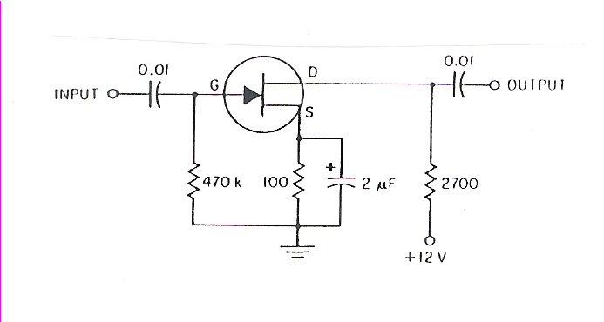
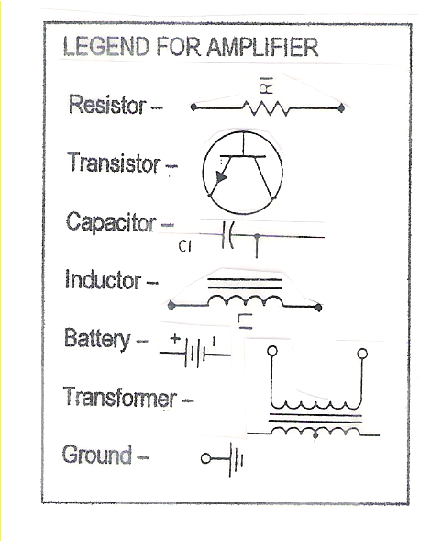
1. Name the numbered components of the schematic diagram.
- _________________________________
- _________________________________
- _________________________________
- _________________________________
- _________________________________

2. Define a schematic diagram and explain how it is used.
___________________________________________________________________________________________________________________________________________________________________________________________________________________________

3. Using the legend above, draw a simple schematic diagram for a lamp.

