WAGE Competency Curriculum Guide

WAGE Competency R29: Following sequenced illustrations as a guide.

NOTE: You will need to collect two additional documents that are similar in nature to the one provided in this lesson at Hook 1a. These should be collected from local employers that support your program. These two additional documents will be used in Hooks 2 and 3 and are not to be duplicates of the other two documents used in this lesson. DO NOT USE MATERIALS THAT ARE NOT RELEVANT TO THE WORKPLACE.

Hook 1a
Project an overhead transparency of how to thread a sewing machine needle. Say, “Let’s pretend you are an experienced worker with Oxford Clothing Inc. and you have been asked to help a new worker to thread her sewing machine. What are the thinking steps that you would want the new worker to use as she threads the machine? What is the first thing that should be done? The second and so on?”
Record all responses on a flip chart and save for later use.
Coach students during a brainstorming activity but do not offer suggestions.

Bridge
Acknowledge the responses offered; question students further to generate additional responses.
Ask, “Do you believe that these are the only thinking steps that should be used?” Pause. “Could there be more?”
Say, “Now we are going to go to our lessons and list the thinking steps we should know and use. When we have finished our work, we will compare your answers that I have recorded on the flip chart to the ones we have learned.”
Book
Select a lesson (or lessons) from the wage curriculum Matrix or other source that best supports your needs. Spend ample time in the chosen lessons until you believe that each learner has mastered the skill. As you move through each lesson, be sure to emphasize the thinking steps that a learner must use to correctly apply this skill. Ensure that all thinking steps are properly sequenced during the learning and that each learner has had opportunities to practice each step in the application of the skill. Write the thinking steps identified by the lesson(s) in the sequential order they are to be used; you will use these again in Hooks 1b, 2, and 3.
Use the lesson, Using Illustrations and To Thread the Needle in the Machines of Class 47W.
Thinking Steps for Competency R29.
NOTE: If your chosen lesson(s) indicates a different set of thinking than these listed here, substitute those that were presented in the lesson(s).
- Read the written instructions first.
- Identify parts or objects illustrated.
- Determine the order of operation or sequence of actions required by the task.
- Use the clues given, i.e. numbering of events, arrows, arrangement of objects, etc.
- Complete the task using the illustrations and written instructions.

Hook 1b
Get out the Using Illustrations, To Thread the Needle in the Machines of Class 47W and the sheet of paper where you recorded learner responses in Hook 1a.
Say, “We are going to evaluate your answers. You gave me the following steps.” Post the sheet with responses on the wall. “Now, let’s look at the thinking steps that the lessons recommended we use.” Compare their responses to the given recommendations.
Example: Use an example of illustrated instructions for completing a task.
Say, “Now I am going to model for you the use of the thinking steps we learned as I follow the direction to complete this task. As I say the thinking step, you help me apply the skill at each step. Do you understand what we are going to do?” Address any concerns before moving ahead. Call out each thinking step and get the learners to assist you as you perform the task at each step.

Hook 2
Say, “Now that I have modeled how a new worker would use the thinking steps we learned when performing this task, are there any questions before you complete two more assignments?” Address all concerns before moving ahead.
Hand out a copy of Following Illustrated Instructions that you have chosen for this exercise.
Say, “Here is another example of following illustrated instructions that is similar to the one I just used as a model. In this exercise, I want you to work alone and use the thinking steps you learned as you complete this task. When you have all finished, each of you will have a chance to model for the class the thinking steps we should use as we complete this task. I will ask you to model the steps for the class and tell us what we should do as we go through each step. Are there any questions about your task?” Address all concerns before moving ahead.
When all have finished, ask for a volunteer to model the application of thinking steps to the task. Pay attention to the proper sequence, the learner’s ability to model, and the actions that must take place at each step. Allow all who want to model the steps an opportunity to do so before moving ahead. Have the students turn in all work to you. Review the work and address any exceptions noted with the learner.
NOTE: Mastery of this competency is determined by the students’ work on Hook 2. Review or rework is necessary when a student has not demonstrated mastery at Hook 2. Mastery is defined as the task being performed correctly with zero mistakes. A WAGE certificate should not be granted without mastery on all competencies listed in the student’s Individualized Program Plan.

Hook 3
Compliment the class for all the good work done at Hook 2. Say, “For this last exercise, you will work in teams, like they do at the workplace. In the workplace, workers know that people who are working together usually do the best work. By working together, they are able to combine their skills, share in the work, and complete the job in the proper amount of time.
“Now, I want you to move into teams of at least three people and no more than five people. Your team will need a leader, so select a leader now.” Make note of the leader in each team. Try to see that all learners have an opportunity to serve as leader during the course of their study.
Hand out the third assignment, Group Work for Following Illustrated Instructions selected for this exercise. Be sure to give only one copy to each team. Say, “Team leaders, I want you to assign the thinking steps to each member of your team. If there are more steps than members, give each member more than one step. Try your best to make your distribution of thinking steps as fair as possible.”
Say, “Working as a team, I want you to apply the thinking steps we learned to the task. Each of you will be doing a different step, so make sure to keep up with your work and your solutions. When all of your team members have completed their assignments, the team leader is to put all the work together into a completed task. Team leaders, you will present your team’s model of this task to the other teams in this class. Are there any questions?” Address all concerns before moving ahead.
When all the teams are finished, call for a volunteer leader to model the application of thinking steps to this task. Get the other teams to offer constructive criticism when appropriate. Strive to develop a level of competitiveness between teams. This will increase the bonds between team members and make the learning more fun. You might work up a recognition system for rewarding good work by each team. Be careful that your students do not get in the same team with each lesson.
NOTE: When it is impossible to use teams at Hook 3, usually due to an open-entry, open-exit class format, you will want to use peer tutors, paraprofessionals, or yourself as a supplement to the team. When conducted correctly, the concepts of interdependence can be reinforced when there are only two people assigned to the task.

Evaluation for R29:
85% on all worksheets
95% on Assessment for Illustrated Instructions

Resource Listing for R29:
http://www.cuttersexchange.com/charts/SingerIndustrialInstructionManuals/46W%20&47W.pdf
Reader’s Digest: Complete Guide to Sewing. Reader’s Digest Association, Inc. 1976. P257.
Muratec Fax Handbook
Copyright © by Pulaski County Special School District Adult Education WAGE Training Program
No part of this curriculum may be reproduced in whole or in part, stored in a retrieval system, or transmitted in any form or by any means, electronic, mechanical, photocopying, recording or otherwise, without written permission from WAGE Training Program.
For permission information contact: WAGE Training Program, 4300 Haywood, North Little Rock, AR 72114.

Using Illustrations

One picture is worth a thousand words! This is oh so true in the workplace as well as at home. Looking at a picture can speed the process of understanding instructions or problem solving. Written instructions along with sequenced illustrations can be beneficial in getting the job done accurately and quickly. Illustrations usually are detailed and specific.

After reading the instructions, look at all the illustrations carefully before you begin your task. Follow these steps in order to ensure success in doing the task using illustrations.

- Read the written instructions first.
- Identify parts or objects illustrated.
- Determine the order of operation or sequence of actions required by the task.
- Use the clues given, i.e. numbering of events, arrows, arrangement of objects, etc.
- Complete the task using the illustrations and written instructions.

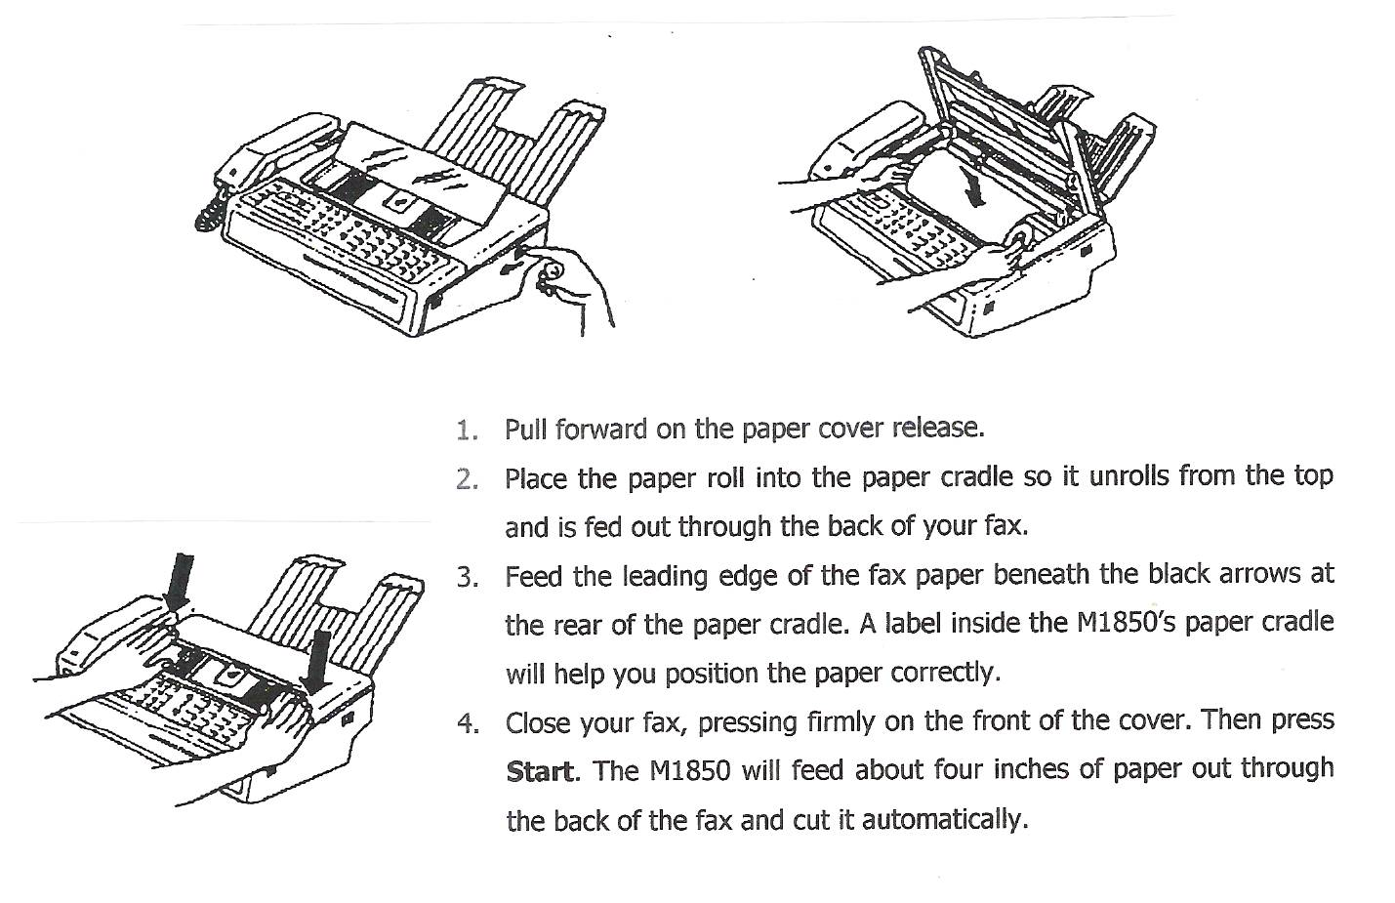
The following pictures illustrate how to install recording paper for a fax machine.
1
2
3

Illustrated instructions are a helpful tool in completing tasks in the workplace. Following the thinking steps listed in this lesson makes the task easier to complete.

To Thread the Needle in Machines of Class 47W
HOOK 1a, b
(See Fig. 9)

Pass the thread from the unwinder from back t front through the upper hole (1) in the pin on top of the machine, and from right to left through the lower hole (2) in the pin, from right to left through the hole (4), over the top into the thread retainer (5), down, under and from right to left between the tension discs (6), up into the fork (7) above the tension discs, into the hook of the wire controller spring (8), up through the wire thread guide (9), up and from right to left through the hole (10) in the end of the thread take-up lever, down through the wire guide (9) again, through the wire guides (12 and 13), into the thread guide (14) at the lower end of the needle bar and from left to right through the eye of the needle (15). Draw about two inches of thread through the eye of the needle with which to commence sewing.
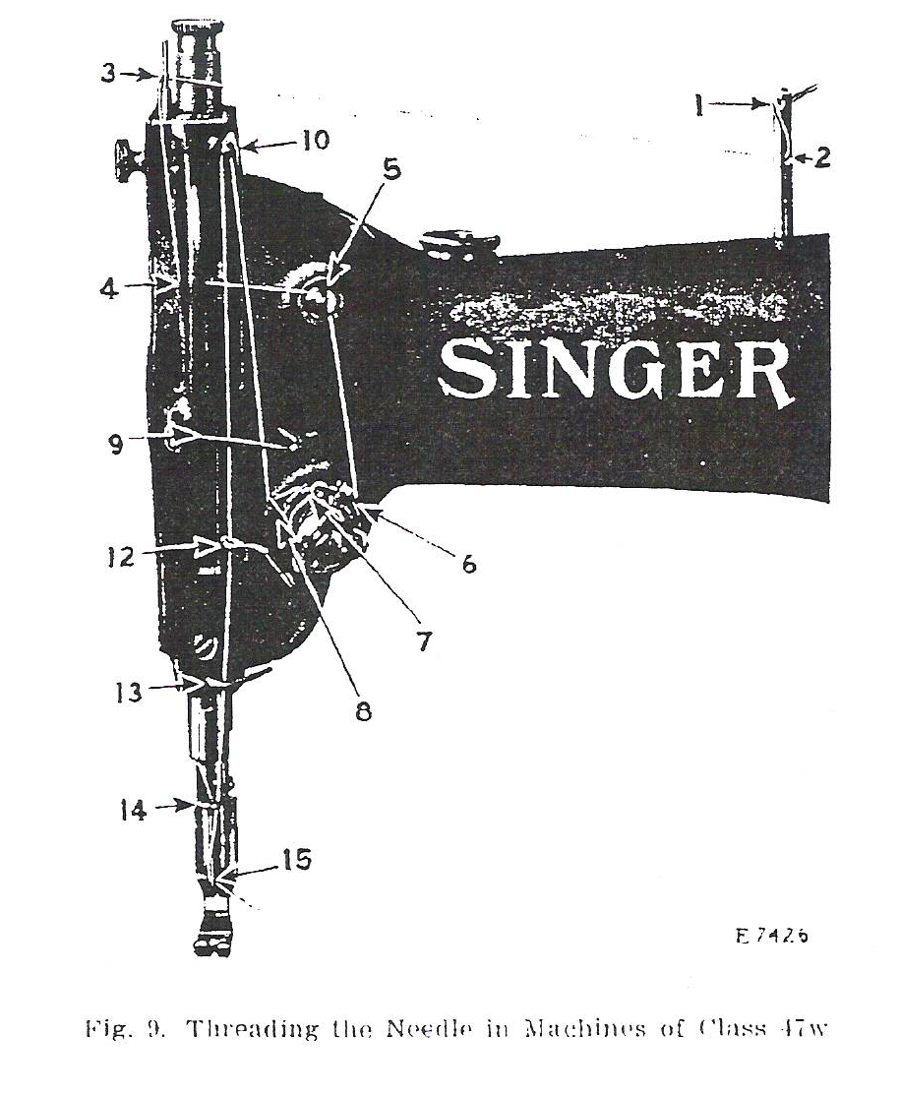

Note: When the thread is taken from a spool on the spool holder of the machine, omit the thread from the holes (1 and 2, Fig. 9) in the thread guide pin, and pass the thread directly from the spool through the thread guide (3, Fig. 9). The balance of the threading is the same as instructed.

On machines fitted with thread oiler, pass the thread back of the thread oiler guide.

Name ________________________________________ Date _____________
HOOK 2

Using Illustrated Instructions

Pretend you are a new seamstress at Oxford Clothing Inc. and you set in sleeves. Follow the illustrations below to complete the task. Use the thinking steps you have just learned about following sequenced illustrations as a guide.

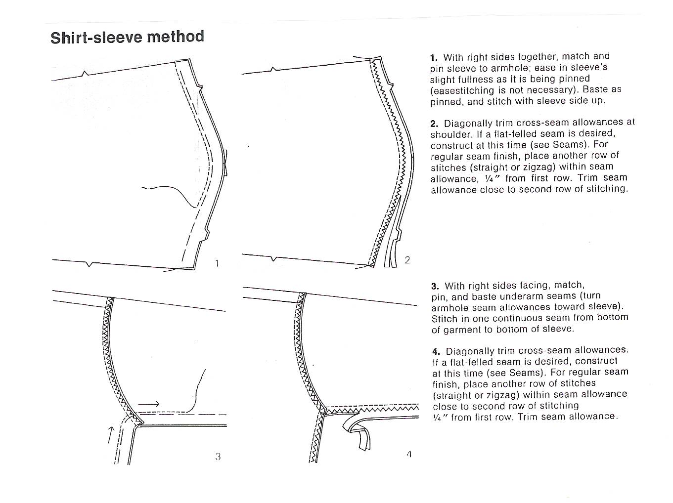
- __________________________________________________________________________________________________________________________________________________
- __________________________________________________________________________________________________________________________________________________
- __________________________________________________________________________________________________________________________________________________
- __________________________________________________________________________________________________________________________________________________
- __________________________________________________________________________________________________________________________________________________

Group Names _________________________________________________
HOOK 3
Date _____________________
Group Work for Following Illustrated Instructions
Pretend you are an employee of a company that does technical writing and illustrations. Your task is to write and illustrate in sequential drawings instructions on how to turn off a computer. Show each step with details. You are writing this for someone who has never turned off a computer the correct way. Use the space below.

Name ____________________________________ Date _________________
Assessment for Illustrated Instructions
It is the first day on the job and you need to send a fax but you are having trouble inserting the paper. Follow the instructions below for that task. List the thinking steps you have just learned to help you complete your task.


 
 
 
 
 

