WAGE Competency Curriculum Guide

WAGE Competency R32: Making inferences or drawing conclusions from printed media.

NOTE: You will need to collect two additional documents that are similar in nature to the one provided in this lesson at Hook 1a. These should be collected from local employers that support your program. These two additional documents will be used in Hooks 2 and 3 and are not to be duplicates of the other two documents used in this lesson. DO NOT USE MATERIALS THAT ARE NOT RELEVANT TO THE WORKPLACE.

Hook 1a
Project an overhead transparency of transparency for drawing conclusion. Say, “Let’s pretend you are an experienced worker with a local machine shop and you have been asked to help a new worker to clean up the area. To do this you need to read information on the cans of cleaner and draw conclusions from what you read. What are the thinking steps that you would want the new worker to use as he makes her decision? What is the first thing that should be done? The second, and so on?”
Record all responses on a flip chart and save for later use.
Coach students during a brainstorming activity but do not offer suggestions.

Bridge
Acknowledge the responses offered; question students further to generate additional responses.
Ask, “Do you believe that these are the only thinking steps that should be used?” Pause. “Could there be more?”
Say, “Now we are going to go to our lessons and list the thinking steps we should know and use. When we have finished our work, we will compare your answers that I have recorded on the flip chart to the ones we have learned.”
Book
Select a lesson (or lessons) from the wage curriculum Matrix or other source that best supports your needs. Spend ample time in the chosen lessons until you believe that each learner has mastered the skill. As you move through each lesson, be sure to emphasize the thinking steps that a learner must use to correctly apply this skill. Ensure that all thinking steps are properly sequenced during the learning and that each learner has had opportunities to practice each step in the application of the skill. Write the thinking steps identified by the lesson(s) in the sequential order they are to be used; you will use these again in Hooks 1b, 2, and 3.
Use Conclusions and drawing conclusions transparency.
Thinking Steps for Competency R32.
NOTE: If your chosen lesson(s) indicates a different set of thinking than these listed here, substitute those that was presented in the lesson(s).
- Identify the problem or situation.
- Gather your information.
- Examine the facts.
- Draw your conclusion.

Hook 1b
Get out the Conclusions, drawing conclusions transparency, and the sheet of paper where you recorded learner responses in Hook 1a.
Say, “We are going to evaluate your answers. You gave me the following steps.” Post the sheet with responses on the wall. “Now, let’s look at the thinking steps that the lessons recommended we use.” Compare their responses to the given recommendations.
Example: Create a scenario in which the learner will visualize the situation and the need to learn the skill.
Say, “Now I am going to model for you the use of the thinking steps we learned as I follow the direction to complete this task. As I say the thinking step, you help me apply the skill at each step. Do you understand what we are going to do?” Address any concerns before moving ahead.
Call out each thinking step and get the learners to assist you as you perform the task at each step.

Hook 2
Say, “Now that I have modeled how a new worker would use the thinking steps we learned when performing this task, are there any questions before you complete two more assignments?” Address all concerns before moving ahead.
Hand out a copy of Conclusions at Work that you have chosen for this exercise to each student.
Say, “Here is another situation that is similar to the one I just used as a model. In this exercise, I want you to work alone and use the thinking steps you learned as you complete this task. When you have all finished, each of you will have a chance to model for the class the thinking steps we should use as we complete this task. I will ask you to model the steps for the class and tell us what we should do as we go through each step. Are there any questions about your task?” Address all concerns before moving ahead.
When all have finished, ask for a volunteer to model the application of thinking steps to the task. Pay attention to the proper sequence, the learner’s ability to model, and the actions that must take place at each step. Allow all who want to model the steps an opportunity to do so before moving ahead. Have the students turn in all work to you. Review the work and address any exceptions noted with the learner.
NOTE: Mastery of this competency is determined by the students’ work on Hook 2. Review or rework is necessary when a student has not demonstrated mastery at Hook 2. Mastery is defined as the task being performed correctly with zero mistakes. A WAGE certificate should not be granted without mastery on all competencies listed in the student’s Individualized Program Plan.

Hook 3
Compliment the class for all the good work done at Hook 2. Say, “For this last exercise, you will work in teams, like they do at the workplace. In the workplace, workers know that people who are working together usually do the best work. By working together, they are able to combine their skills, share in the work, and complete the job in the proper amount of time.
“Now, I want you to move into teams of at least three people and no more than five people. Your team will need a leader, so select a leader now.” Make note of the leader in each team. Try to see that all learners have an opportunity to serve as leader during the course of their study.
Hand out the third assignment, Group Work for Drawing Conclusions, selected for this exercise. Be sure to give only one copy to each team. Say, “Team leaders, I want you to assign the thinking steps to each member of your team. If there are more steps than members, give each member more than one step. Try your best to make your distribution of thinking steps as fair as possible.”
Say, “Working as a team, I want you to apply the thinking steps we learned to the task. Each of you will be doing a different step, so make sure to keep up with your work and your solutions. When all of your team members have completed their assignments, the team leader is to put all the work together into a completed task. Team leaders, you will present your team’s model of this task to the other teams in this class. Are there any questions?” Address all concerns before moving ahead.
When all the teams are finished, call for a volunteer leader to model the application of thinking steps to this task. Get the other teams to offer constructive criticism when appropriate. Strive to develop a level of competitiveness between teams. This will increase the bonds between team members and make the learning more fun. You might work up a recognition system for rewarding good work by each team. Be careful that your students do not get in the same team with each lesson.

NOTE: When it is impossible to use teams at Hook 3, usually due to an open-entry, open-exit class format, you will want to use peer tutors, paraprofessionals, or yourself as a supplement to the team. When conducted correctly, the concepts of interdependence can be reinforced when there are only two people assigned to the task.

Evaluation for R32:
85% on all worksheets
95% on Assessment for Making Inferences

Resource Listing for R32:
Echaore-Yoon, Susan. Reading Skills That Work: A Functional Approach for Life and Work, Book Two. Chicago: Contemporary Books. 1991.
Golden, Bernice. Workplace Essential Skills: Reading. Contemporary Books. Public Broadcasting Service. 1999.
Strumpf, Lori. Essential Skills for the Workplace: Using Forms and Documents. Chicago: Contemporary Books. 1993.

Copyright © by Pulaski County Special School District Adult Education WAGE Training Program
No part of this curriculum may be reproduced in whole or in part, stored in a retrieval system, or transmitted in any form or by any means, electronic, mechanical, photocopying, recording or otherwise, without written permission from WAGE Training Program.
For permission information contact: WAGE Training Program, 4300 Haywood, North Little Rock, AR 72114.

Conclusions

A conclusion is the close of a decision or judgment after investigation or thought. To illustrate this idea, think about being in a bookstore to buy a book for entertainment purposes. How do you decide what book to buy? You may read the summary of each book you pick up. As you read the summaries you will make inferences or deduct certain ideas from them. This will help you make a decision or come to a conclusion about what book to buy. Drawing a conclusion is the final step you take when examining a problem or situation.

You’ll face many problems and questions, both in and out of the workplace, that won’t have standard answers. Your conclusions then will help you choose the best course of action to take.

Facts and Opinions

A reasonable conclusion should be supported with facts, so when we read text it is important to be able to separate fact from opinion. How are they different? An opinion is something that a person believes to be true. It is usually based on personal feelings and everyone has an opinion. For instance, the movie we saw was the greatest! Someone else may not have this opinion. A fact on the other hand is a statement that can be proved. It cost us $13.00 to see the movie. This is a fact; the tickets were $6.50 each.

Drawing Conclusions at Work

The ability to draw the best conclusion at work is a useful skill. Here is a strategy that can help you draw the best conclusions. Imagine that you’re trying to print a lesson plan on a computer printer. The computer screen shows this message: sending print job to printer; printing; print job completed. However, the printer does not work. Follow the steps to come to a conclusion:

- Identify the problem or situation.
Why isn’t the printer working?

- Gather your information.
Consider these sources:
- Your observations and past experiences (you didn’t hear the printer working while the computer screen said it was).
- Written materials – manuals, work procedures, etc.

- Examine the facts.
Get the facts about the printer from the troubleshooting chart in the printer manual.

- Draw your conclusion.
After checking the paper tray and the printer ribbon, you look at the select button and see the light next to it is not on. You push the button, the light comes on, and you try the printer again. It works!

Your conclusion that the select button was off thereby causing the printer not to print was a reasonable conclusion to come to.

BRIGHT
Aerosol

Active Components:
Ammonium Hydroxide, Silicone Dioxide, Isobutane White Foam
Completely soluble in water
Boiling Point: 200° F.

Uses:
Cleans metal and glass surfaces.
Use in normal ventilation.
Normal use does not require breathing mask.
Goggles should be worn to avoid eye contact.

Imagine that you work for a small machine shop. As part of your job, you help maintain and clean the equipment. You are asked to clean the metal surfaces on which parts are sorted and packed. You select an industrial cleaner from the storeroom.

Is BRIGHT Aerosol a good choice for the job?

What are two precautions that need to be taken?

Transparency: Drawing Conclusions

Name ___________________________________ Date __________________

Conclusions at Work

Pretend you are working in the human resource department of a local business. You are trying to decide whether or not to hire someone with a certificate. Read the excerpt below and answer the questions that follow.

Licensing: Certain jobs require you to be licensed by a local, state, or federal agency. These agencies want to be sure that you are experienced enough to do the job well. They want to be sure that you perform your work in a professional manner. Small-business owners often need to have a business license. Licensing is used to protect the public.
Licensing requirements differ from one job to another. They may include
- having certain levels of education,
- having on-the-job experience, and
- passing an examination.

Certification: Certificates prove that a student or a trainee has mastered certain skills. You may earn a certificate from your school, your training program, or your job. Sometimes a certificate is a step toward getting a license.

- How do licensing requirements protect the public?
______________________________________________________________________

- Why are licensing and certification requirements good for the employers?
____________________________________________________________________________________________________________________________________________

- What do you think a government agency could do if someone who is licensed or certified does not perform the work as well as required?
____________________________________________________________________________________________________________________________________________

- List the thinking steps you would use to come to a conclusion about hiring the certified applicant.
  - ___________________________________________________________________
  - ___________________________________________________________________
  - ___________________________________________________________________
  - ___________________________________________________________________

- What conclusion did you come to?
____________________________________________________________________________________________________________________________________________

Group Names ___________________________________________________ Date __________________

Group Work for Drawing Conclusions
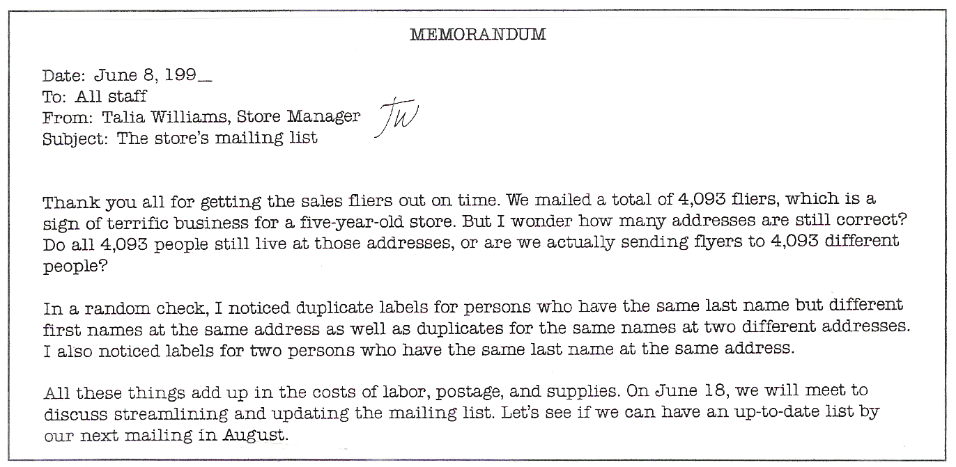
You are a salesperson at a music store. Your employer gives you the following memorandum about a workplace problem. Read the text, and then answer the questions.

- What is the problem?
______________________________________________________________________
- You can get three facts about the way in which duplicates were appearing. What are they?
  - ___________________________________________________________________
  - ___________________________________________________________________
  - ___________________________________________________________________
- Could the answers to the following questions provide relevant facts about the problem?
  - How often do customers on the mailing list actually shop at the store?
Yes No ____________________________________________________________
___________________________________________________________________
  - What are some ways in which other stores have updated their mailing lists?
Yes No ____________________________________________________________
___________________________________________________________________
- What conclusion would you come to about the mailing lists?
____________________________________________________________________________________________________________________________________________

Name _____________________________________ Date ________________

Assessment for Drawing Conclusion
Read the following scenario and answers the questions that follow.
Kim, an editor at a publishing company, works on one floor and the receptionist works on another floor. Kim must answer her calls by the fourth ring or her calls go back to the receptionist. Kim often misses her calls because she works at a computer away from her desk. Kim often does not get her messages until late in the day or sometimes not until the next day. This system does not work well for Kim or her company.
- What conclusion can you come to about the system in Kim’s company?
__________________________________________________________________________________________________________________________________________________

2. Name three facts about the system.
- ______________________________________________________________________
- ______________________________________________________________________
- ______________________________________________________________________

3. How would you solve the problem?
____________________________________________________________________________________________________________________________________________________________________________________________________________________________________________________________________________________________________

4. List the thinking steps for drawing conclusions.
  - ______________________________________________________________________
  - ______________________________________________________________________
  - ______________________________________________________________________
  - ______________________________________________________________________

