WAGE Competency Curriculum Guide

WAGE Competency R8: Cross-referencing within a document or program screens to locate information.

NOTE: You will need to collect two additional documents that are similar in nature to the one provided in this lesson at Hook 1a. These should be collected from local employers that support your program. These two additional documents will be used in Hooks 2 and 3 and are not to be duplicates of the other two documents used in this lesson. DO NOT USE MATERIALS THAT ARE NOT RELEVANT TO THE WORKPLACE.

Hook 1a
Project an overhead transparency of the text for replacing front parking, turn & side marker lights. Say, “Let’s pretend you are an experienced worker with Ryan’s Volkswagen Repair and you have been asked to help a new worker to read the manual on light replacement. The text has a cross-reference. What are the thinking steps that you would want the new worker to use as he reads the text with the cross-reference? What is the first thing that should be done? The second, and so on?”
Record all responses on a flip chart and save for later use.
Coach students during a brainstorming activity but do not offer suggestions.

Bridge
Acknowledge the responses offered; question students further to generate additional responses.
Ask, “Do you believe that these are the only thinking steps that should be used?” Pause. “Could there be more?”
Say, “Now we are going to go to our lessons and list the thinking steps we should know and use. When we have finished our work, we will compare your answers that I have recorded on the flip chart to the ones we have learned.”
Book
Select a lesson (or lessons) from the wage curriculum Matrix or other source that best supports your needs. Spend ample time in the chosen lessons until you believe that each learner has mastered the skill. As you move through each lesson, be sure to emphasize the thinking steps that a learner must use to correctly apply this skill. Ensure that all thinking steps are properly sequenced during the learning and that each learner has had opportunities to practice each step in the application of the skill. Write the thinking steps identified by the lesson(s) in the sequential order they are to be used; you will use these again in Hooks 1b, 2, and 3.
Use Cross-Referencing and Front Parking, Turn & Side Marker Lights.

Thinking Steps for Competency R8.
NOTE: If your chosen lesson(s) indicates a different set of thinking than these listed here, substitute those that was presented in the lesson(s).
- Know what information you are looking for so you won’t waste time looking at a cross-reference that does not have the information you need.
- Be familiar with the elements of the cross-reference and what they indicate.
- Be familiar with the pointers to a cross-reference, such as See or a hyperlink.
- Go to the cross-reference and obtain the information you need.

Hook 1b
Get out Cross-Referencing, Front Parking, Turn & Side Marker Lights and the sheet of paper where you recorded learner responses in Hook 1a.
Say, “We are going to evaluate your answers. You gave me the following steps.” Post the sheet with responses on the wall. “Now, let’s look at the thinking steps that the lessons recommended we use.” Compare their responses to the given recommendations.
Example: Create a scenario in which the learner will visualize the situation and the need to learn this skill.
Say, “Now I am going to model for you the use of the thinking steps we learned as I follow the direction to complete this task. As I say the thinking step, you help me apply the skill at each step. Do you understand what we are going to do?” Address any concerns before moving ahead.
Call out each thinking step and get the learners to assist you as you perform the task at each step.

Hook 2
Say, “Now that I have modeled how a new worker would use the thinking steps we learned when performing this task, are there any questions before you complete two more assignments?” Address all concerns before moving ahead.
Hand out a copy of Headlight Replacement that you have chosen for this exercise to each student.
Say, “Here is an assignment that is similar to the one I just used as a model. In this exercise, I want you to work alone and use the thinking steps you learned as you complete this task. When you have all finished, each of you will have a chance to model for the class the thinking steps we should use as we complete this task. I will ask you to model the steps for the class and tell us what we should do as we go through each step. Are there any questions about your task?” Address all concerns before moving ahead.
When all have finished, ask for a volunteer to model the application of thinking steps to the task. Pay attention to the proper sequence, the learner’s ability to model, and the actions that must take place at each step. Allow all who want to model the steps an opportunity to do so before moving ahead. Have the students turn in all work to you. Review the work and address any exceptions noted with the learner.
NOTE: Mastery of this competency is determined by the students’ work on Hook 2. Review or rework is necessary when a student has not demonstrated mastery at Hook 2. Mastery is defined as the task being performed correctly with zero mistakes. A WAGE certificate should not be granted without mastery on all competencies listed in the student’s Individualized Program Plan.

Hook 3
Compliment the class for all the good work done at Hook 2. Say, “For this last exercise, you will work in teams, like they do at the workplace. In the workplace, workers know that people who are working together usually do the best work. By working together, they are able to combine their skills, share in the work, and complete the job in the proper amount of time.
“Now, I want you to move into teams of at least three people and no more than five people. Your team will need a leader, so select a leader now.” Make note of the leader in each team. Try to see that all learners have an opportunity to serve as leader during the course of their study.
Hand out the third assignment, Group Work for Cross-Referencing, selected for this exercise. Be sure to give only one copy to each team. Say, “Team leaders, I want you to assign the thinking steps to each member of your team. If there are more steps than members, give each member more than one step. Try your best to make your distribution of thinking steps as fair as possible.”
Say, “Working as a team, I want you to apply the thinking steps we learned to the task. Each of you will be doing a different step, so make sure to keep up with your work and your solutions. When all of your team members have completed their assignments, the team leader is to put all the work together into a completed task. Team leaders, you will present your team’s model of this task to the other teams in this class. Are there any questions?” Address all concerns before moving ahead.
When all the teams are finished, call for a volunteer leader to model the application of thinking steps to this task. Get the other teams to offer constructive criticism when appropriate. Strive to develop a level of competitiveness between teams. This will increase the bonds between team members and make the learning more fun. You might work up a recognition system for rewarding good work by each team. Be careful that your students do not get in the same team with each lesson.

NOTE: When it is impossible to use teams at Hook 3, usually due to an open-entry, open-exit class format, you will want to use peer tutors, paraprofessionals, or yourself as a supplement to the team. When conducted correctly, the concepts of interdependence can be reinforced when there are only two people assigned to the task.

Evaluation for R8:
85% on all worksheets
95% on Assessment for Cross-Referencing

Resource Listing for R8:
http://www.io.com/~hcexres/tcm1603/acchtml/cross.html
Electrical Trainee Guide. Prentice-Hall: New Jersey. 2000.
Jorgensen, Eric. Volkswagen Service/Repair Handbook: Beetle, Super Beetle, Karmann Ghia/1961-1974. Los Angeles: Clymer Publications. 1971, 1974.
Microsoft Excel Help. Quick Calculations on a worksheet
Copyright © by Pulaski County Special School District Adult Education WAGE Training Program
No part of this curriculum may be reproduced in whole or in part, stored in a retrieval system, or transmitted in any form or by any means, electronic, mechanical, photocopying, recording or otherwise, without written permission from WAGE Training Program.
For permission information contact: WAGE Training Program, 4300 Haywood, North Little Rock, AR 72114.

Cross-Referencing

Have you ever read a topic and felt there was more information? You just know there is related material. Generally, this is true. The related material will be cross-referenced. A cross-reference indicates that there is more information on the topic either in the same document or in other information sources.

Cross-references point the reader to more basic information or to more advanced information. They also point to related materials, other topics on the same subject. For instance, if you are reading about how to copy files with the DOS COPY command, the text may cross-reference the DISKCOPY command and the XCOPY command. The latter two would be related information.

Cross-references should contain the following elements:
- Name of the source being referenced – this can be the title or a general subject reference.
- Page number or figure number
- Subject matter of the cross-reference – this is useful in order to see if you want to go to that particular reference.

A cross-reference can be an internal or external reference. Internal references point to information in the same document or reference book. An external reference refers to information found in other documents or reference books.

You find a cross-reference by looking for pointers such as the word See or Refer to. For instance, cross-references found in an index or in a document have See next to it, i. e. Wages. See Salary. For an internal reference you would indicate the page number or range such as the following:

For details on creating and formatting graphics and then incorporating them into reports, see “Graphics,” pages 7-1 to 7-10.
OR
For an illustration of the components of a table, refer to Figure 3. Pay particular attention to how items in the columns and how the columns align with the column headings.

External cross-references point to the title of the section, book, or magazine. It may look similar to the following:

For details on creating and formatting graphics and then incorporating them into reports, see “Graphics” in TCM1603 Course Guide.
OR
For tips on adding graphics to a report, see “Brighten Up That Monthly Report!” in the July 1995 issue of the Office Information Newsletter.

Cross-references used in online writings are indicated by hyperlinks that are underlined or colored blue. Clicking on these hyperlinks will take you to that text. Look at the following example:

For more information on fibromyalgia, see www.arthritisfoundation.com.

Cross-references are another tool to enable readers to better understand and get the most out of what they are reading, especially in the workplace. To use cross-references effectively, use the following steps:

- Know what information you are looking for so you won’t waste time looking at a cross-reference that does not have the information you need.
- Be familiar with the elements of the cross-reference and what they indicate.
- Be familiar with the pointers to a cross-reference, such as See or a hyperlink.
- Go to the cross-reference and obtain the information you need.

Front Parking, Turn & Side Marker Lights

Light placement differs with year. On 1961-1966 models, the front parking lights are located in the headlight assemblies and are accessible once the assembly is removed. See Headlight Replacement. Turn signal lights are located in a fender-mounted assembly. To replace a lamp, remove the screw securing the lens and lift the lens off. See Figure 29. Replace the lamp and lens. There are no side marker lights on 1961 through 1966 cars.
On 1967-1974 models, front parking, turn and side marker lights are located in the same fender mounted assembly. To replace any of the lamps, remove 2 screws securing the lens and lift it off. Replace the lamp and secure the lens. See Figure 30.

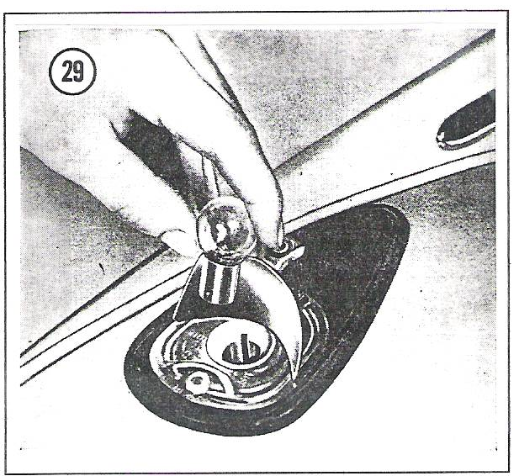
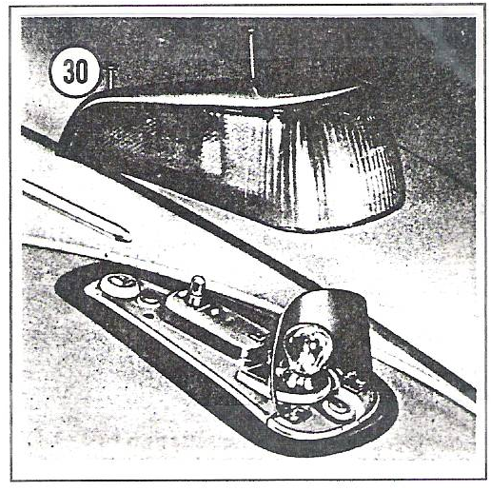

Figure 30
Figure 29

Name ___________________________________ Date __________________

Headlight Replacement (1961-1966)

Beetle & Karmann Ghia
- Loosen large screw at bottom of the trim ring. See Figure 19. Pull entire headlight assembly out as shown in Figure 20, and disconnect the cable.
- Disconnect parking light cables.
- Unscrew the parking light socket.
- Remove the headlight retaining springs as shown in Figure 21.
- Withdraw the retaining spring and remove the headlight.
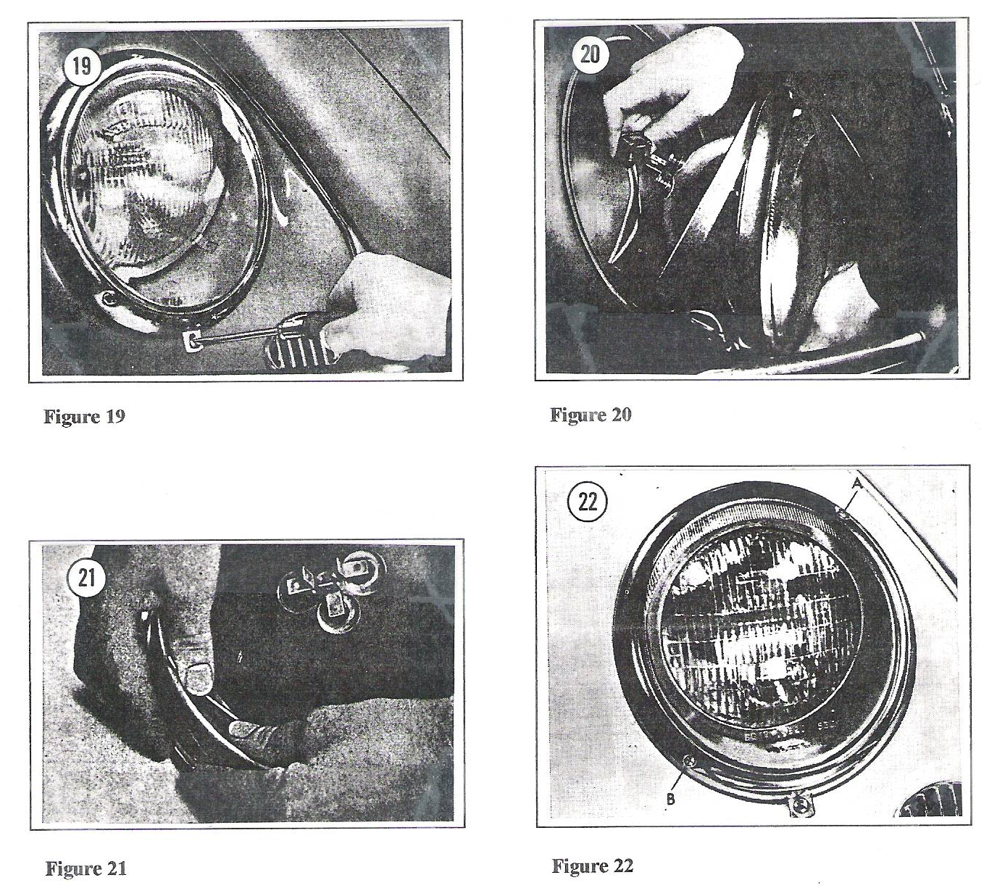
- Installation is the reverse of these steps. Adjust headlights according to local traffic regulations. Adjusting screws are shown in Figure 22.

You are one of the mechanics at Ryan’s Volkswagen Repair. You are working with the headlights. Answer the following questions.

- Use the thinking steps for cross-referencing to show how to pull out the entire headlight.
  - ________________________________________________________________________________________________________________________________
  - ________________________________________________________________________________________________________________________________
  - ________________________________________________________________________________________________________________________________
  - ________________________________________________________________________________________________________________________________
- Which figure shows how to remove the retaining springs? ____________________
- The headlights need adjusting. Where do you look? _________________________
- How would you install a headlight? ______________________________________
__________________________________________________________________

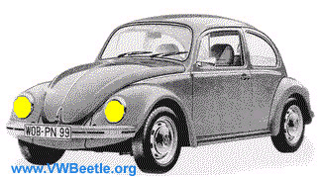

Group Names ______________________________ Date ______________

Group Work for Cross-Referencing

As the bookkeeper for Ryan’s Volkswagen Repair, you use Microsoft Excel to keep the books. You are training an assistant bookkeeper on how to create a formula by using Microsoft Excel Help. Study the text below. Use the thinking steps for cross-referencing to answer the questions that follow.
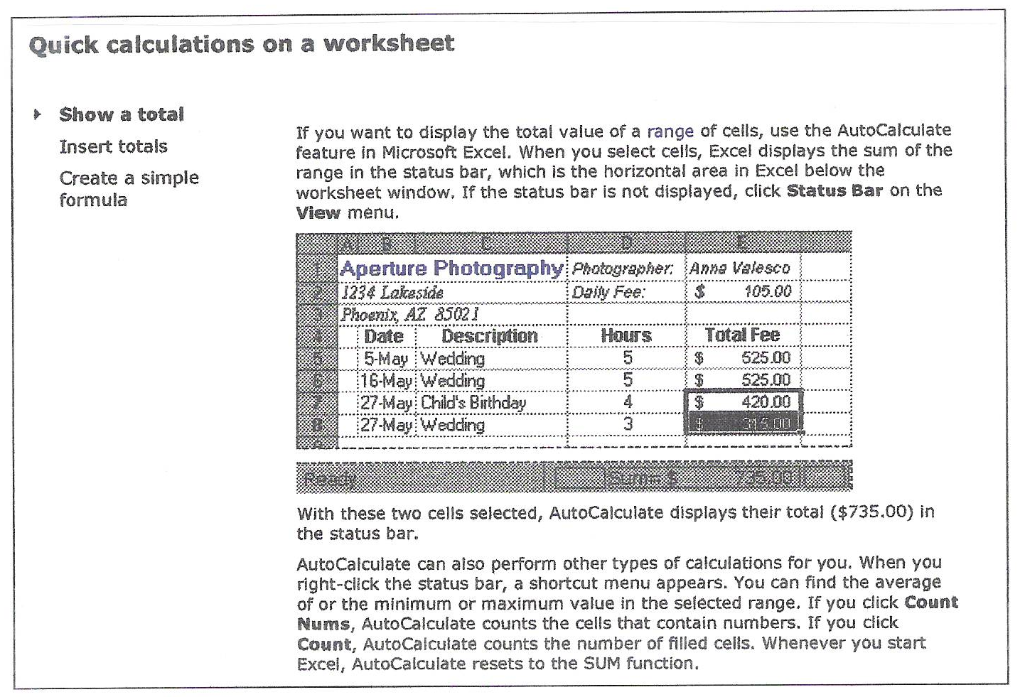

- After getting into Microsoft Excel Help you are directed to the page shown above. But this is not what you need exactly. Looking at the hyperlinks to the left, which one would you choose? _____________________________________________
- Justify your answer. ________________________________________________
________________________________________________________________
- What type of pointer is this? __________________________________________

The worksheet below is the cross-reference that you need. Answer the questions that follow.

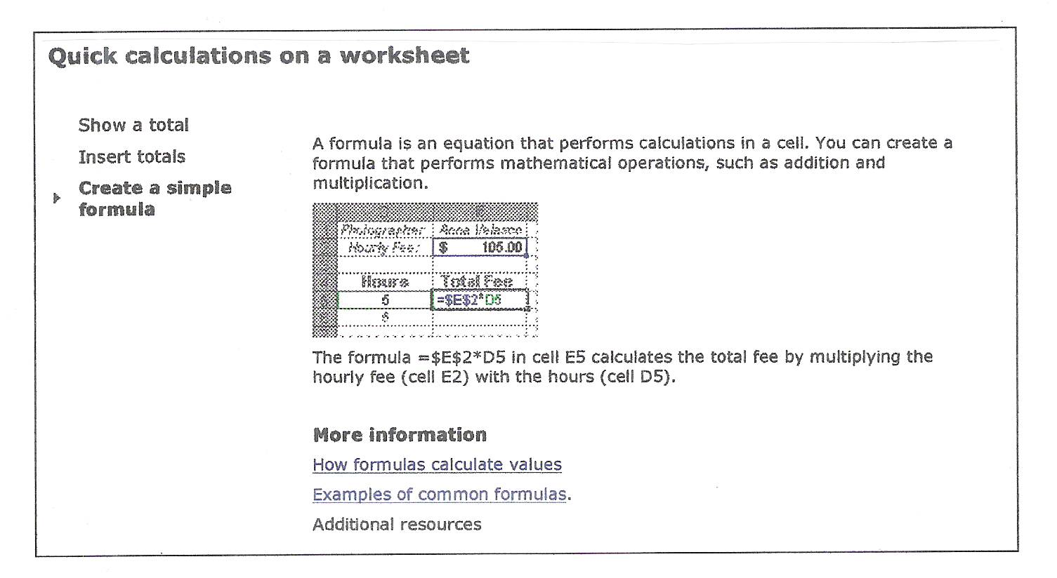

- Use the thinking steps for cross-referencing to create a simple formula.
  - ____________________________________________________________________________________________________________________________
  - ____________________________________________________________________________________________________________________________
  - ____________________________________________________________________________________________________________________________
  - ____________________________________________________________________________________________________________________________
- Name a hyperlink where she could go to get more information.
____________________________________________________________________________________

- The new assistant needs to see examples of formulas. Where could they go?
____________________________________________________________________________________

Name ___________________________________ Date __________________

Assessment for Cross-Referencing

As an electrician you need to know about conduit. Read the following text and answer the questions that follow.

  - Types of Conduit

There are many types of conduit used in the construction industry. The size of conduit to be used is determined by engineering specifications, local codes, and the NEC. Refer to NEC Chapter 9, Tables 1 through 8 and Appendix C for conduit fill with various conductors. There are several common types of conduit to examine.

- You need to find out about conduit fill. List the thinking steps for cross-referencing to find out the information you need.

  - ________________________________________________________________________________________________________________________________
  - ________________________________________________________________________________________________________________________________
  - ________________________________________________________________________________________________________________________________
  - ________________________________________________________________________________________________________________________________
- Is this an internal or external cross-reference? Explain. _______________________
___________________________________________________________________
3. Create an example of an internal cross-reference.
___________________________________________________________________
___________________________________________________________________ ___________________________________________________________________
___________________________________________________________________
4. Name three elements of a cross-reference.
a. _________________________________________________________________
b. _________________________________________________________________
c. _________________________________________________________________

