WAGE Competency Curriculum Guide

WAGE Competency W3: Writing symbols accurately.

NOTE: You will need to collect two additional documents that are similar in nature to the one provided in this lesson at Hook 1a. These should be collected from local employers that support your program. These two additional documents will be used in Hooks 2 and 3 and are not to be duplicates of the other two documents used in this lesson. DO NOT USE MATERIALS THAT ARE NOT RELEVANT TO THE WORKPLACE.

Hook 1a
Project an overhead transparency of the symbol transparency. Say, “Let’s pretend you are a travel agent with a local travel agency and you have been asked to help a new agent to fill out the bill for a client. The new agent has forgotten the symbol for percent. What are the thinking steps that you would want the new agent to use as she fills out the bill using symbols? What is the first thing that should be done? The second, and so on?”
Record all responses on a flip chart and save for later use.
Coach students during a brainstorming activity but do not offer suggestions.

Bridge
Acknowledge the responses offered; question students further to generate additional responses.
Ask, “Do you believe that these are the only thinking steps that should be used?” Pause. “Could there be more?”
Say, “Now we are going to go to our lessons and list the thinking steps we should know and use. When we have finished our work, we will compare your answers that I have recorded on the flip chart to the ones we have learned.”
Book
Select a lesson (or lessons) from the wage curriculum Matrix or other source that best supports your needs. Spend ample time in the chosen lessons until you believe that each learner has mastered the skill. As you move through each lesson, be sure to emphasize the thinking steps that a learner must use to correctly apply this skill. Ensure that all thinking steps are properly sequenced during the learning and that each learner has had opportunities to practice each step in the application of the skill. Write the thinking steps identified by the lesson(s) in the sequential order they are to be used; you will use these again in Hooks 1b, 2, and 3.
Use the symbol transparency and Writing Symbols.
Thinking Steps for Competency W3.
NOTE: If your chosen lesson(s) indicates a different set of thinking than these listed here, substitute those that was presented in the lesson(s).
- Be familiar with the symbols of your workplace.
- Know what the symbols stand for.
- Select the correct symbol to use for the situation.
- Write the symbols accurately.

Hook 1b
Get out the symbol transparency, Writing Symbols, and the sheet of paper where you recorded learner responses in Hook 1a.
Say, “We are going to evaluate your answers. You gave me the following steps.” Post the sheet with responses on the wall. “Now, let’s look at the thinking steps that the lessons recommended we use.” Compare their responses to the given recommendations.
Example: Use the symbol transparency to model the skill of writing symbols accurately.
Say, “Now I am going to model for you the use of the thinking steps we learned as I follow the direction to complete this task. As I say the thinking step, you help me apply the skill at each step. Do you understand what we are going to do?” Address any concerns before moving ahead.
Call out each thinking step and get the learners to assist you as you perform the task at each step.

Hook 2
Say, “Now that I have modeled how a new worker would use the thinking steps we learned when performing this task, are there any questions before you complete two more assignments?” Address all concerns before moving ahead.
Hand out a copy of Writing Symbols in the Workplace that you have chosen for this exercise to each student.
Say, “Here is another situation that is similar to the one I just used as a model. In this exercise, I want you to work alone and use the thinking steps you learned as you complete this task. When you have all finished, each of you will have a chance to model for the class the thinking steps we should use as we complete this task. I will ask you to model the steps for the class and tell us what we should do as we go through each step. Are there any questions about your task?” Address all concerns before moving ahead.
When all have finished, ask for a volunteer to model the application of thinking steps to the task. Pay attention to the proper sequence, the learner’s ability to model, and the actions that must take place at each step. Allow all who want to model the steps an opportunity to do so before moving ahead. Have the students turn in all work to you. Review the work and address any exceptions noted with the learner.
NOTE: Mastery of this competency is determined by the students’ work on Hook 2. Review or rework is necessary when a student has not demonstrated mastery at Hook 2. Mastery is defined as the task being performed correctly with zero mistakes. A WAGE certificate should not be granted without mastery on all competencies listed in the student’s Individualized Program Plan.

Hook 3
Compliment the class for all the good work done at Hook 2. Say, “For this last exercise, you will work in teams, like they do at the workplace. In the workplace, workers know that people who are working together usually do the best work. By working together, they are able to combine their skills, share in the work, and complete the job in the proper amount of time.
“Now, I want you to move into teams of at least three people and no more than five people. Your team will need a leader, so select a leader now.” Make note of the leader in each team. Try to see that all learners have an opportunity to serve as leader during the course of their study.
Hand out the third assignment, Group Work for Writing Symbols, selected for this exercise. Be sure to give only one copy to each team. Say, “Team leaders, I want you to assign the thinking steps to each member of your team. If there are more steps than members, give each member more than one step. Try your best to make your distribution of thinking steps as fair as possible.”
Say, “Working as a team, I want you to apply the thinking steps we learned to the task. Each of you will be doing a different step, so make sure to keep up with your work and your solutions. When all of your team members have completed their assignments, the team leader is to put all the work together into a completed task. Team leaders, you will present your team’s model of this task to the other teams in this class. Are there any questions?” Address all concerns before moving ahead.
When all the teams are finished, call for a volunteer leader to model the application of thinking steps to this task. Get the other teams to offer constructive criticism when appropriate. Strive to develop a level of competitiveness between teams. This will increase the bonds between team members and make the learning more fun. You might work up a recognition system for rewarding good work by each team. Be careful that your students do not get in the same team with each lesson.
NOTE: When it is impossible to use teams at Hook 3, usually due to an open-entry, open-exit class format, you will want to use peer tutors, paraprofessionals, or yourself as a supplement to the team. When conducted correctly, the concepts of interdependence can be reinforced when there are only two people assigned to the task.

Evaluation for W3:
85% on all worksheets
95% on Assessment for Writing Symbols

Resource Listing for W3:
Teacher-generated Materials: Lil Williams
Strumpf, Lori and Beth Blanchard-Smith. Essential Skills for the Workplace: Improving Workplace Performance. Chicago: Contemporary Books. 1993.
The Communication Handbook for School-to-Work. Cincinnati: South-Western Educational Publishing. 1997.

Copyright © by Pulaski County Special School District Adult Education WAGE Training Program
No part of this curriculum may be reproduced in whole or in part, stored in a retrieval system, or transmitted in any form or by any means, electronic, mechanical, photocopying, recording or otherwise, without written permission from WAGE Training Program.
For permission information contact: WAGE Training Program, 4300 Haywood, North Little Rock, AR 72114.

Writing Symbols

We all have experience in reading symbols. One such case would be trying to read a prescription you just received from the doctor. We are all familiar with a “doctor’s handwriting”. How crucial do you suppose it is for the doctor to write the symbols accurately? Your health may depend on it. Just as the doctor needs to write symbols correctly, it is also important in other workplaces. Take for instance the waiter who has just taken your order. In order for you to receive your favorite food, the waiter has to write the order correctly, including any work symbols, so that the cook can read it.

Each workplace has its own set of symbols. If you are a new employee, you should make it a priority to learn the technical words, abbreviations, and symbols of your job. Master what each symbol stands for and practice writing each symbol.

The following is a nurse’s notes about a patient who is complaining of pain and wants more medication.
Date | Hour | Code | Notations
10/20/03 | 0900 | N | Morphine 2 mg given in IVP for pain in lower left leg for pain and abdominal discomfort.

Notice the symbols in bold letters. To write these correctly the nurse would:

- Know the symbols of her workplace.
- Know what the symbols stood for.
- Select the correct symbol to use for the situation.
- Write the symbols accurately.

The mg is a symbol for a dosage of medicine. What do you suppose would happen if the nurse wrote “mg” wrong? You are right if you said it could possibly hurt the patient.

An IVP is the symbol for intravenous delivery of medication. The medicine is not given by a shot but through the veins.

The N is a code unique to that hospital. What do you think it represents?

Clearly, in the medical workplace it is crucial to get the symbols correct. Lives depend on it. In other workplaces, writing symbols accurately is important in order to get the job done right.

Billing Information | Transportation Air/Ground | Accommodations Hotel/Motel | Meals B/L/D | Activity Car Rental
Cost | $823 | $360
% Commission | 9% | 12%
Amount billed | $74.07
Total | $74.07

Name ____________________________________ Date _________________

Writing Symbols in the Workplace

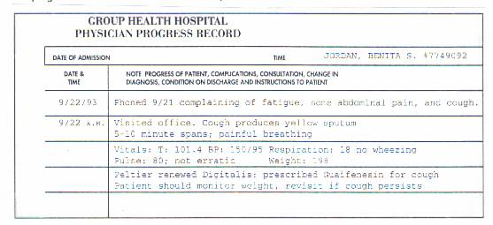
Pretend you are an LPN (licensed practical nurse) for a local hospital. Study the patient progress record below and answer the questions that follow.

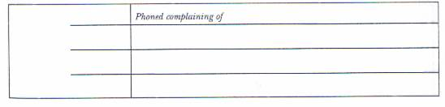
1. You are to add information to the patient’s record. Decide what information to add. List it below. Write symbols accurately.

2. List the thinking steps you would use to accurately write workplace symbols.
- ______________________________________________________________
- ______________________________________________________________
- ______________________________________________________________
- ______________________________________________________________

Group Names ___________________________________________________
Date _______________________

Group Work for Writing Symbols

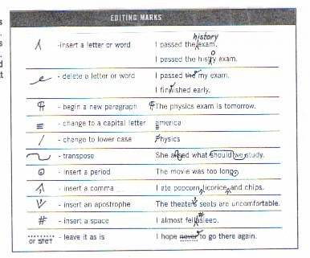
Another workplace that uses symbols is the world of writing. Writers use editing symbols when they revise their work. Study the editing marks and then use them to edit the text below.

If you use a computer grammar checker, weigh every suggested change carefully, and and don’t consider it a substitute for acareful edit For example, many Grammar checkers will suggest replacing every sngle example of passive voice. It is good to avoid using the passive voice, but there are times when it makes sense. review the rules, and make your own decision.

Now list the thinking steps for writing symbols accurately.
1. __________________________________________________________________________
2. _________________________________________________________________________
3. _________________________________________________________________________
4. _________________________________________________________________________

Name _____________________________________ Date ________________

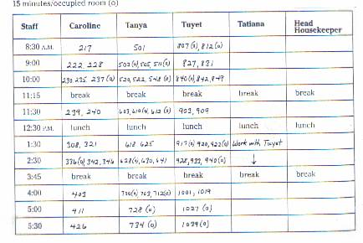
Assessment for Writing Symbols
Study the head housekeeping schedule above. Note the two symbols used. Answer the questions below.

1. Write the two symbols and what they stand for.
__________________________________________________________________________________________________________________________________________________
2. There is a problem today. Caroline is ill. Your job as head housekeeper is to plan the cleaning schedule. Decide who will take on Caroline’s rooms. Complete the schedule for the person you choose, remember to use the symbols.
3. Now, you need to complete your own schedule. Include the following:
- inspect eight clean rooms (15 minutes per room)
- begin to train a new housekeeper (about 2-1/2 hours with you)
- select a new vacuum cleaner for the hotel (15 minutes)

