WAGE Competency Curriculum Guide

WAGE Competency W7: Recording essential information in phrases or simple sentences accurately and precisely.

NOTE: You will need to collect two additional documents that are similar in nature to the one provided in this lesson at Hook 1a. These should be collected from local employers that support your program. These two additional documents will be used in Hooks 2 and 3 and are not to be duplicates of the other two documents used in this lesson. DO NOT USE MATERIALS THAT ARE NOT RELEVANT TO THE WORKPLACE.

Hook 1a
Project an overhead transparency of telephone message. Say, “Let’s pretend you are an experienced worker with local company and you have been asked to help a new worker to answer the phone and take messages. What are the thinking steps that you would want the new worker to use as she answered the phone? What is the first thing that should be done? The second and so on?”
Record all responses on a flip chart and save for later use.
Coach students during a brainstorming activity but do not offer suggestions.

Bridge
Acknowledge the responses offered; question students further to generate additional responses.
Ask, “Do you believe that these are the only thinking steps that should be used?” Pause. “Could there be more?”
Say, “Now we are going to go to our lessons and list the thinking steps we should know and use. When we have finished our work, we will compare your answers that I have recorded on the flip chart to the ones we have learned.”
Book
Select a lesson (or lessons) from the wage curriculum Matrix or other source that best supports your needs. Spend ample time in the chosen lessons until you believe that each learner has mastered the skill. As you move through each lesson, be sure to emphasize the thinking steps that a learner must use to correctly apply this skill. Ensure that all thinking steps are properly sequenced during the learning and that each learner has had opportunities to practice each step in the application of the skill. Write the thinking steps identified by the lesson(s) in the sequential order they are to be used; you will use these again in Hooks 1b, 2, and 3.
Use the telephone message transparency and Recording Information Simply.
Thinking Steps for Competency W7.
NOTE: If your chosen lesson(s) indicates a different set of thinking than these listed here, substitute those that was presented in the lesson(s).
- Repeat the instructions, i.e. caller’s name, phone number, key points of the message.
- Clarify the instructions with questions.
- Write the instructions on a message form.

Hook 1b
Get out the telephone message transparence, Recording Information Simply, and the sheet of paper where you recorded learner responses in Hook 1a.
Say, “We are going to evaluate your answers. You gave me the following steps.” Post the sheet with responses on the wall. “Now, let’s look at the thinking steps that the lessons recommended we use.” Compare their responses to the given recommendations.
Example: Create a scenario in which the learner will visualize the situation and the need to learn the skill.
Say, “Now I am going to model for you the use of the thinking steps we learned as I follow the direction to complete this task. As I say the thinking step, you help me apply the skill at each step. Do you understand what we are going to do?” Address any concerns before moving ahead.
Call out each thinking step and get the learners to assist you as you perform the task at each step.

Hook 2
Say, “Now that I have modeled how a new worker would use the thinking steps we learned when performing this task, are there any questions before you complete two more assignments?” Address all concerns before moving ahead.
Hand out a copy of Getting the Message you have chosen for this exercise to each student.
Say, “Here is another situation that is similar to the one I just used as a model. In this exercise, I want you to work alone and use the thinking steps you learned as you complete this task. When you have all finished, each of you will have a chance to model for the class the thinking steps we should use as we complete this task. I will ask you to model the steps for the class and tell us what we should do as we go through each step. Are there any questions about your task?” Address all concerns before moving ahead.
When all have finished, ask for a volunteer to model the application of thinking steps to the task. Pay attention to the proper sequence, the learner’s ability to model, and the actions that must take place at each step. Allow all who want to model the steps an opportunity to do so before moving ahead. Have the students turn in all work to you. Review the work and address any exceptions noted with the learner.
NOTE: Mastery of this competency is determined by the students’ work on Hook 2. Review or rework is necessary when a student has not demonstrated mastery at Hook 2. Mastery is defined as the task being performed correctly with zero mistakes. A WAGE certificate should not be granted without mastery on all competencies listed in the student’s Individualized Program Plan.

Hook 3
Compliment the class for all the good work done at Hook 2. Say, “For this last exercise, you will work in teams, like they do at the workplace. In the workplace, workers know that people who are working together usually do the best work. By working together, they are able to combine their skills, share in the work, and complete the job in the proper amount of time.
“Now, I want you to move into teams of at least three people and no more than five people. Your team will need a leader, so select a leader now.” Make note of the leader in each team. Try to see that all learners have an opportunity to serve as leader during the course of their study.
Hand out the third assignment, Group Work for Messages, selected for this exercise. Be sure to give only one copy to each team. Say, “Team leaders, I want you to assign the thinking steps to each member of your team. If there are more steps than members, give each member more than one step. Try your best to make your distribution of thinking steps as fair as possible.”
Say, “Working as a team, I want you to apply the thinking steps we learned to the task. Each of you will be doing a different step, so make sure to keep up with your work and your solutions. When all of your team members have completed their assignments, the team leader is to put all the work together into a completed task. Team leaders, you will present your team’s model of this task to the other teams in this class. Are there any questions?” Address all concerns before moving ahead.
When all the teams are finished, call for a volunteer leader to model the application of thinking steps to this task. Get the other teams to offer constructive criticism when appropriate. Strive to develop a level of competitiveness between teams. This will increase the bonds between team members and make the learning more fun. You might work up a recognition system for rewarding good work by each team. Be careful that your students do not get in the same team with each lesson.
NOTE: When it is impossible to use teams at Hook 3, usually due to an open-entry, open-exit class format, you will want to use peer tutors, paraprofessionals, or yourself as a supplement to the team. When conducted correctly, the concepts of interdependence can be reinforced when there are only two people assigned to the task.

Evaluation for W7:
85% on worksheets
95% on Assessment for Recording Information in Simple Sentences

Resource Listing for W7:
Harrington, Karen. Golden, Bernice. Workplace Essential Skills: Communication & Writing. Contemporary Books. Public Broadcasting Service. 1999.
Millan, Ana Maria and Marisela Toselli. On the Job: English for Secretaries and Administrative Personnel. Spain: McGraw-Hill. 1996.
Strumpf, Lori. Essential Skills for the Workplace: Obtaining Information and Using Resources. Chicago: Contemporary Books. 1993.

Copyright © by Pulaski County Special School District Adult Education WAGE Training Program
No part of this curriculum may be reproduced in whole or in part, stored in a retrieval system, or transmitted in any form or by any means, electronic, mechanical, photocopying, recording or otherwise, without written permission from WAGE Training Program.
For permission information contact: WAGE Training Program, 4300 Haywood, North Little Rock, AR 72114.

Recording Information Simply

Recording information can be tricky. Information can be recorded in a variety of ways. Take the waitress. The information, your order, needs to be taken down in a very simple way. In order for your order to be correct it must be written accurately. Another common way to take down information is to take a message for someone whether in your office or at your home. This lesson will deal mainly with taking messages.

A message usually involves two people – the sender and the receiver. It is imperative to get the information written down quickly and correctly. For instance if you are taking the message, it has to be written down at the very moment it is taken or it may not reach its destination! The information that you need to record is usually verbal. The message will consist of the names of people, name of company, the date and time, phone or fax numbers as well as the message itself. After taking the message it is important to verify the information. Giving your boss the wrong number or name may not put you in good with him.

When you write a telephone message you do not have to write in complex sentences, phrases or simple sentences will do. Listen for key points. The important thing is to get the information down accurately and quickly.

Let’s review the message.

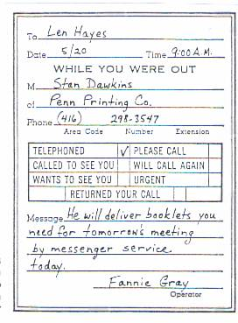
The most essential information in a phone message is the caller’s name and phone number. Make sure these are written correctly. Ask the caller to repeat name and number. By asking questions you clarify or make the message clear. Telephone messages often answer the five questions: who, what, when, where, why, how.

Use the message to answer the following:
Who ___________________________________
What __________________________________
When __________________________________
Why ___________________________________
How ___________________________________

Most businesses have telephone message forms to be filled out. This ensures that there is a written form of the message. There are two copies of the message – an original and a carbon copy. The original goes to the receiver and the carbon copy stays with the office.

To sum up, the following steps will help to write accurate messages quickly.

- Repeat the information, i.e. caller’s name, phone number, key points of the message.
- Clarify the information with questions.
- Write the information on a message form.
Telephone Message Transparency

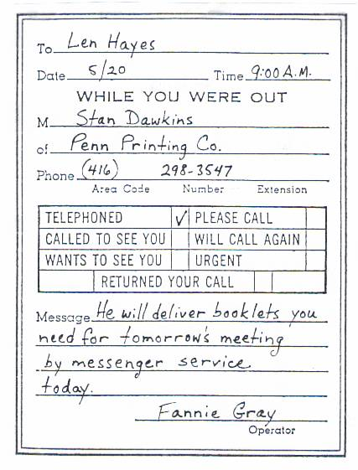

Name _____________________________________ Date ________________

Getting the Message

Read the following dialogue and answer the questions.
R: Southern Mississippi Corporation. Good Morning.

C: Good morning. Mr. Dean Jenkins, please.

R: I’m sorry, madam, Mr. Jenkins’s not in. Would you like to leave a message?

C: Yes, please. Tell him I’m calling from Mr. Fillmore’s office to confirm the appointment for tomorrow at 8:15 a.m.

R: Could you repeat the time please?

C: Tomorrow morning at 8:15.

R: All right, madam. I’ll tell Mr. Jenkins as soon as he arrives.

- Who called? ______________________________________________________
- To whom? _______________________________________________________
- When? What time? ________________________________________________
- What did he/she say? ______________________________________________
________________________________________________________________
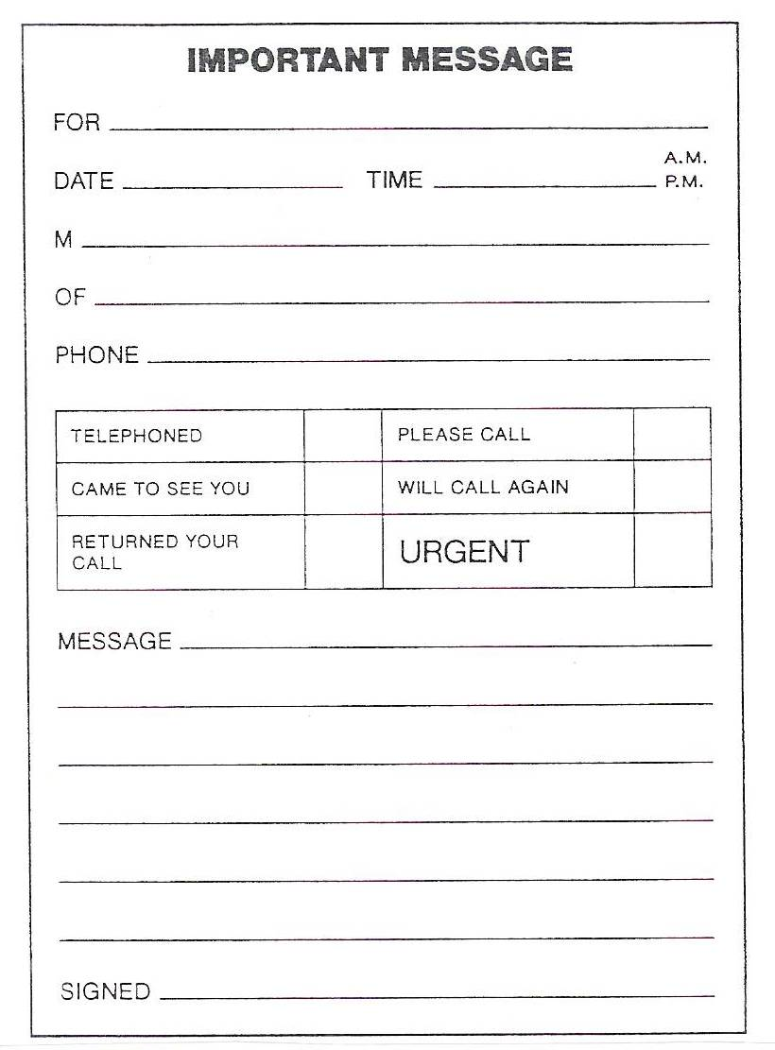
- Now fill out the telephone message form.

Group Names ___________________________________________________
Date ____________________

Group Work for Messages

Read the dialogue and answer the questions.
S: Good afternoon, sir. May I help you?

V: I’d like to talk to Mrs. Johnson, please.

S: What is it about, sir?

V: About her life insurance.

S: I’m afraid she’s busy at the moment, sir. May I have your name and phone number? She’ll call you later in the evening.

V: David Holschtein, from F&F Insurance Ltd.

S: Could you spell your surname, sir?

V: H O L S C H T E I N, Holschtein.

S: And your phone number?

V: 3309077

S: 3309077. Is that correct?

V: Yes, madam. Please, tell her it’s an urgent matter.

1. List the thinking steps for taking accurate messages.
- ______________________________________________________________________________________________________
- ______________________________________________________________________________________________________
- ____________________________________________________________________

2. Fill in the telephone message form, using the information from the dialogue.

Name ______________________________________ Date _______________

Assessment for Messages

- You are not going to work today. Leave a message on the answering machine at work using one of the following reasons for your absence. Write the message on the form.

  - You are ill in bed.
  - You have to travel out of town because of personal reasons.
  - You have just had an accident.

2. What is essential information?
____________________________________________________________________________

3. How do you clarify information?
____________________________________________________________________________

4. Using your information in the message, answer the five questions that a message should answer.
Who ________________________________________________________________________________
What ________________________________________________________________________________
When ________________________________________________________________________________
Why ________________________________________________________________________________
How ________________________________________________________________________________

5. List the thinking steps you would use for taking messages.
- ______________________________________________________________________
- ______________________________________________________________________
- ______________________________________________________________________

