WAGE Competency Curriculum Guide

WAGE Competency W8: Transferring numbers, codes, dates, and figures from written sources onto appropriate sections or a form.

NOTE: You will need to collect two additional documents that are similar in nature to the one provided in this lesson at Hook 1a. These should be collected from local employers that support your program. These two additional documents will be used in Hooks 2 and 3 and are not to be duplicates of the other two documents used in this lesson. DO NOT USE MATERIALS THAT ARE NOT RELEVANT TO THE WORKPLACE.

Hook 1a
Project an overhead transparency of Cut Size and Large Size Sheeter Production form used by paper manufacturers like Georgia-Pacific. Say, “Let’s pretend you are an experienced worker with the local paper manufacturer and you have been asked to help a new worker to transfer information from job tickets and computer screens onto the appropriate sections of this form. What are the thinking steps that you would want the new worker to use as he transferred numbers, codes, and dates from the job ticket or computer screen to the appropriate sections of this form? What is the first thing that should be done? The second, and so on?”
Record all responses on a flip chart and save for later use.
Coach students during a brainstorming activity but do not offer suggestions.

Bridge
Acknowledge the responses offered; question students further to generate additional responses.
Ask, “Do you believe that these are the only thinking steps that should be used?” Pause. “Could there be more?”
Say, “Now we are going to go to our lessons and list the thinking steps we should know and use. When we have finished our work, we will compare your answers that I have recorded on the flip chart to the ones we have learned.”
Book
Select a lesson (or lessons) from the wage curriculum Matrix or other source that best supports your needs. Spend ample time in the chosen lessons until you believe that each learner has mastered the skill. As you move through each lesson, be sure to emphasize the thinking steps that a learner must use to correctly apply this skill. Ensure that all thinking steps are properly sequenced during the learning and that each learner has had opportunities to practice each step in the application of the skill. Write the thinking steps identified by the lesson(s) in the sequential order they are to be used; you will use these again in Hooks 1b, 2, and 3.
Use the transparency of Cut Size and Large Size Sheeter Production form and Transferring Information.
Thinking Steps for Competency W8.
NOTE: If your chosen lesson(s) indicates a different set of thinking than these listed here, substitute those that was presented in the lesson(s).
- Read the title of the form to be used.
- Familiarize yourself with the various sections of the form.
- Determine what information you will be entering onto the form.
- Locate the needed information from its original source.
- Transfer the needed information onto the appropriate section of the form.

Hook 1b
Get out the transparency of Cut Size and Large Size Sheeter Production form, Transferring Information, and the sheet of paper where you recorded learner responses in Hook 1a.
Say, “We are going to evaluate your answers. You gave me the following steps.” Post the sheet with responses on the wall. “Now, let’s look at the thinking steps that the lessons recommended we use.” Compare their responses to the given recommendations.
Example: You have been asked to transfer job ticket information from production line number 8 onto the Cut Size and Larger Size sheeter Production form. This is to include all work done on 1-13-94
Say, “Now I am going to model for you the use of the thinking steps we learned as I follow the direction to complete this task. As I say the thinking step, you help me apply the skill at each step. Do you understand what we are going to do?” Address any concerns before moving ahead.
Call out each thinking step and get the learners to assist you as you perform the task at each step.

Hook 2
Say, “Now that I have modeled how a new worker would use the thinking steps we learned when performing this task, are there any questions before you complete two more assignments?” Address all concerns before moving ahead.
Hand out a copy of Transferring the Numbers that you have chosen for this exercise to each student.
Say, “Here is another situation that is similar to the one I just used as a model. In this exercise, I want you to work alone and use the thinking steps you learned as you complete this task. When you have all finished, each of you will have a chance to model for the class the thinking steps we should use as we complete this task. I will ask you to model the steps for the class and tell us what we should do as we go through each step. Are there any questions about your task?” Address all concerns before moving ahead.
When all have finished, ask for a volunteer to model the application of thinking steps to the task. Pay attention to the proper sequence, the learner’s ability to model, and the actions that must take place at each step. Allow all who want to model the steps an opportunity to do so before moving ahead. Have the students turn in all work to you. Review the work and address any exceptions noted with the learner.
NOTE: Mastery of this competency is determined by the students’ work on Hook 2. Review or rework is necessary when a student has not demonstrated mastery at Hook 2. Mastery is defined as the task being performed correctly with zero mistakes. A WAGE certificate should not be granted without mastery on all competencies listed in the student’s Individualized Program Plan.

Hook 3
Compliment the class for all the good work done at Hook 2. Say, “For this last exercise, you will work in teams, like they do at the workplace. In the workplace, workers know that people who are working together usually do the best work. By working together, they are able to combine their skills, share in the work, and complete the job in the proper amount of time.
“Now, I want you to move into teams of at least three people and no more than five people. Your team will need a leader, so select a leader now.” Make note of the leader in each team. Try to see that all learners have an opportunity to serve as leader during the course of their study.
Hand out the third assignment, Group Work for Transferring Information Onto a Form, selected for this exercise. Be sure to give only one copy to each team. Say, “Team leaders, I want you to assign the thinking steps to each member of your team. If there are more steps than members, give each member more than one step. Try your best to make your distribution of thinking steps as fair as possible.”
Say, “Working as a team, I want you to apply the thinking steps we learned to the task. Each of you will be doing a different step, so make sure to keep up with your work and your solutions. When all of your team members have completed their assignments, the team leader is to put all the work together into a completed task. Team leaders, you will present your team’s model of this task to the other teams in this class. Are there any questions?” Address all concerns before moving ahead.
When all the teams are finished, call for a volunteer leader to model the application of thinking steps to this task. Get the other teams to offer constructive criticism when appropriate. Strive to develop a level of competitiveness between teams. This will increase the bonds between team members and make the learning more fun. You might work up a recognition system for rewarding good work by each team. Be careful that your students do not get in the same team with each lesson.
NOTE: When it is impossible to use teams at Hook 3, usually due to an open-entry, open-exit class format, you will want to use peer tutors, paraprofessionals, or yourself as a supplement to the team. When conducted correctly, the concepts of interdependence can be reinforced when there are only two people assigned to the task.

Evaluation for W8:
85% on all worksheets
95% on Assessment for Transferring Information

Resource Listing for W8:
Strumpf, Lori. Essential Skills for the Workplace: Using Forms and Documents. Chicago: Contemporary Books. 1993.

Copyright © by Pulaski County Special School District Adult Education WAGE Training Program
No part of this curriculum may be reproduced in whole or in part, stored in a retrieval system, or transmitted in any form or by any means, electronic, mechanical, photocopying, recording or otherwise, without written permission from WAGE Training Program.
For permission information contact: WAGE Training Program, 4300 Haywood, North Little Rock, AR 72114.

Transparency for Competency W8
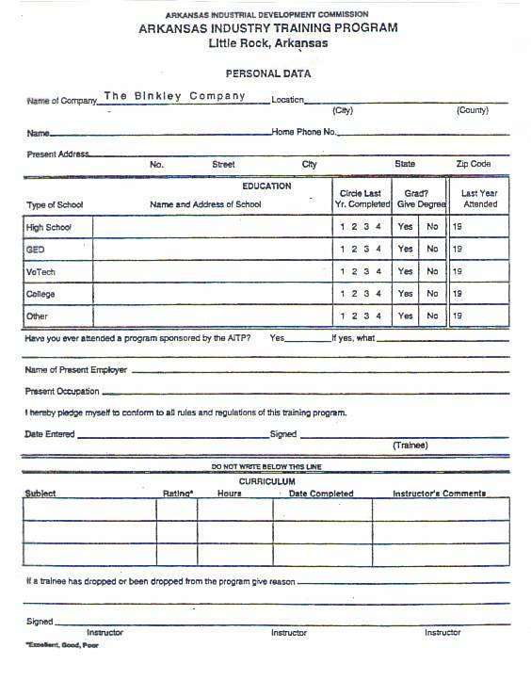

Transferring Information

Paperwork, paperwork, paperwork! It is everywhere in the workplace. Reports, forms, documents all comprise the paperwork we are bombarded with. This lesson will concentrate on forms and how to transfer information from one or more sources onto the form.

First, let’s look at the information. In this case we are concerned with numbers, codes, dates, and figures. The source of this information can be from another completed form or the computer screen. It could be a document or a report.

Next we want to look at the form that we are transferring information to. It is always advisable to familiarize yourself with any form that your company has, especially those that you work with. Study each section of the form. What is required to go in the sections?

After careful study of each document we can now merge information onto the form. Let’s look at the following scenario to illustrate the steps for transferring information onto a form.

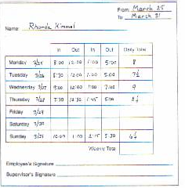
Rhonda is filling out her weekly time sheet. Before she can get paid she has to transfer the information to an official time sheet. First, she changes her hours to decimal form. Then, she transfers them from her weekly time sheet to the official time sheet.

Step One: Locate the needed information from its original source.
In this case, we will look at Rhonda’s weekly time sheet to the right.
Step Two: Read the title of the form to be used.
The title of the form that the information is being transferred to is the official time sheet.
Step Three: Familiarize yourself with the various sections of the form.
Study the time sheet to determine what information is needed.
Step Four: Determine what information you will be entering onto the form.
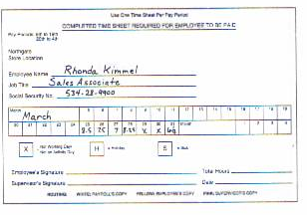
Rhonda needs to put in her personal information, then, she needs to transfer the dates and figures from her weekly time sheet.
Step Five: Transfer the needed Information onto the appropriate section of the form.
Now Rhonda can transfer the information, taking care to copy the numbers exactly. Always check to see that the numbers are correct. Review the form after completion to determine if there are any errors. Make any corrections before turning the form in.

Name ____________________________________ Date _________________

Transferring the Numbers

Look at the information provided. Then fill in the form. Note: In recording a time, please use MILITARY time.

Group Names ___________________________________________________

Date _______________________

Group Work for Transferring Information onto a Form

Alberto owns an auto repair shop. He has ordered some supplies from Ace Business Supply. Ace has shipped the merchandise and now needs to complete an invoice for Alberto. Use the information below to answer the questions.

UFD p106
1. List the thinking steps you would use to transfer information.
- ________________________________________________________________________________________
- ________________________________________________________________________________________
- ________________________________________________________________________________________
- ____________________________________________________________________________________________
- ______________________________________________________________________

2. Use the Fax Order Form that Alberto sent to Ace to complete the Ace invoice.

UFD p 107

Name ______________________________________ Date _______________

Assessment for Transferring Information onto a Form

Use the following ad to answer the questions. Remember to check the information that you transfer for accuracy. Mistakes cost money!

UFD p97

1. Use the information from the ad to place an order for the following on the order form below.
- 5 – 1” black binders with label holders (200 sheets)

- 28 – ½” light blue binders without label holders (110 sheets)

- 3 – 2” black binders with label holders (425 sheets)

2. List the thinking steps you would use for this skill.
a. _________________________________
_________________________________
_________________________________
- _________________________________
_________________________________
_________________________________
- _______________________________________________________________________________________________________
- ______________________________________________________________________
- ______________________________________________________________________

Qty. | Unit  (each, doz, etc.) | Reliable Stock # | Color  (please specify) | Description | Unit Price | Total

