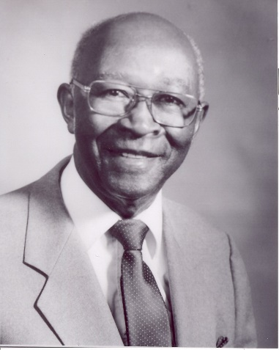
Dr. Luther H. Black Scholarship

Application Form
For
Arkansas High School Diploma Graduates

1. Personal Information
Name: _____________________________________________ Phone: (___) ______-_________
Permanent Address: ______________________________________________________________
Current Address: _________________________________________________________________
Date of Birth: _________________ Age: ____ Sex:__________ SSN: ________________________

Parents______ Guardian______ Spouse ______ (Check appropriate designation)
Name: __________________________________________________________________________
Address: ________________________________________________________________________
Number of Dependents: ___________
Occupation of Parents/Guardian/Spouse: ______________________________________________

2. Educational Experiences
List Adult Education Center(s) attended:
Name: _________________________________________________________________________
Location Date/Year
Name: _________________________________________________________________________
Location Date/Year
Date of Graduation: _________________________________________

3. Professional Plans
Post-secondary institution planning to attend:
Name: _________________________________________________________________________
Location Date/Year:
Classification for the coming year:
Beginning Freshman _____ Continuing Student _____
(Must have cumulative GPA of 2.5)
Major area of study: ______________________________________________________________
Minor area of study (if applicable): __________________________________________________
Degree/License/Certificate expected: ________________________________________________
If you are pursuing an education degree and professional licensure, what grade level and/or subject matter do you plan to teach? ___________________________________________
Do you plan to teach in Arkansas? Yes _____ No _____

4. Financial Information
Are you currently employed? Yes _____ No _____
If yes, what is your anticipated gross monthly income? ____________________________________
Have you applied for any other types of financial aid (such as work/study, loans, or grants)?
Yes _____ No _____
If yes, have you received approval? Yes _____ No _____
Other sources of Income: _________________________________________

5. References (to be submitted with application)
- Letter from the current director and/or teacher explaining why this applicant should
receive the Dr. Luther H. Black Scholarship;
- Letter from the applicant explaining what obtaining the Arkansas High School
Diploma (GED) has meant to you;
- Copy of the applicant's Arkansas High School Diploma (GED).

Signatures

Applicant's Signature: _________________________________________Date: _______________
Sponsor's Signature: __________________________________________Date: _______________
Administrator's Signature: _____________________________________ Date: _______________

